Model：BL4QL-L
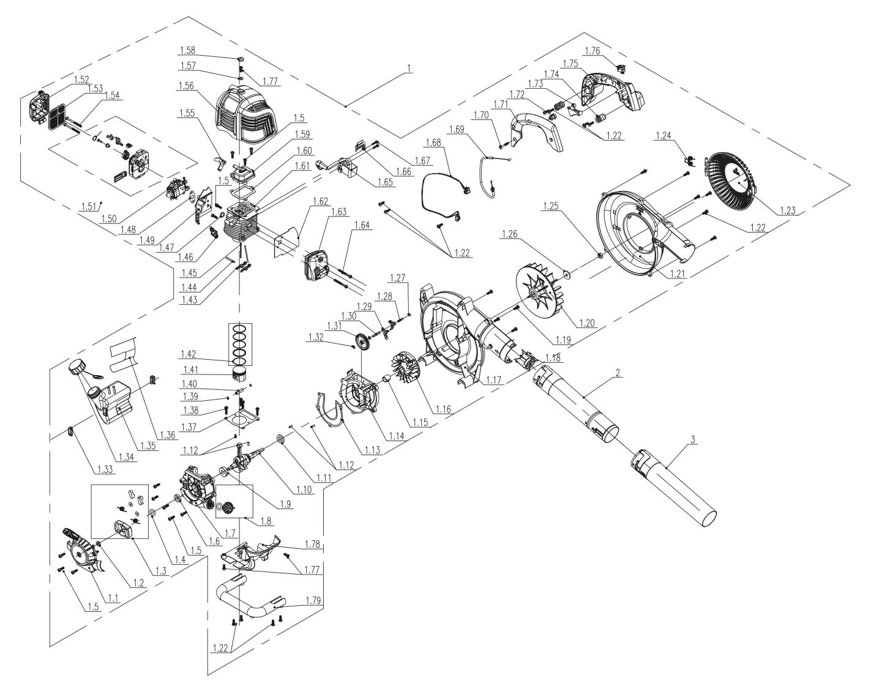
NO. | PART# | Description | Qty. | Model No. Applied
1 | 103001000345 | Engine 26.5CC | 1 | BL4QL-L
1.1 | 199096000128 | Recoil assembly | 1 | GTC4QL-L、GTS4QL-L、CSP4QL-L、BLV4QL-M、BL4QL-L
1.2 | 8NA-08D03 | Nut M8 | 1 | GTC4QL-L、GTS4QL-L、GTS4QL-M2、GTBCU4QL-M、CSP4QL-L、BLV4QL-M、TL4QL-L1、BL4QL-L
1.3 | 9440-987104-0000010 | Starter pawl assembly | 1 | BL4QL-L、GTC4QL-L、GTS4QL-L、GTS4QL-M2、GTBCU4QL-M、CSP4QL-L
1.4 | 8321-931302-0000000 | Washer | 1 | BL4QL-L、BLV4QL-M、GTS4QL-M2、GTBCU4QL-M、CSP4QL-L、HTX2-M-0、HTX2-M、S2K3B2-01、HTPX2-M-0、HTX5-M-0、GTC4QL-L、GTS4QL-L
1.5 | 207421000003 | Screw M5*16 | 13 | HT4QL-L、ACSP01、HT4QL-L、HT4QL-L、BLV4QL-M、BL4QL-L、CSP4QL-L、ACSP01、GTC4QL-L、GTS4QL-L、GTS4QL-M2、GTBCU4QL-M
1.6 | 8208-982001-0000010 | Oil seal | 1 | GTC4QL-L、GTS4QL-L、GTS4QL-M2、GTBCU4QL-M、CSP4QL-L、BL4QL-L、BLV4QL-M、HT4QL-L
1.7 | 201126000108 | Crankcase | 1 | GTC4QL-L、GTS4QL-L、CSP4QL-L、BL4QL-L
1.8 | 199999001396 | Oil dipstick | 1 | GTC4QL-L、GTS4QL-L、GTS4QL-M2、GTBCU4QL-M、CSP4QL-L、HT4QL-L、BLV4QL-M、BL4QL-L
1.9 | 207390200006 | Bearing 6001 | 1 | GTC4QL-L、GTS4QL-L、GTS4QL-M2、GTBCU4QL-M、HT4QL-L、CSP4QL-L、BL4QL-L
1.10 | 8606-950201-0000000 | Crank shaft | 1 | BLV4QL-M、BL4QL-L
1.11 | 8208-981503-0100020 | Oil seal | 1 | BL4QL-L、CS4QL-L1、BLV4QL-M、CS4QL-L3、TL4QL-L1、BLB4QL-M、GTS4QL-M2、GTBCU4QL-M、GTC4QL-L、GTS4QL-L、CSP4QL-L、HT4QL-L
1.12 | 8PC40-10D | Cylindrical Pin | 4 | GTC4QL-L、GTS4QL-L、CSP4QL-L、HT4QL-L、BLV4QL-M、GTS4QL-M2、GTBCU4QL-M、BL4QL-L
1.13 | 299999000483 | Crankcase gasket | 1 | HT4QL-L、BL4QL-L、GTC4QL-L、GTS4QL-L、GTS4QL-M2、GTBCU4QL-M、CSP4QL-L、BLV4QL-M
1.14 | 201126000107 | Front crankcase | 1 | GTC4QL-L、BL4QL-L、HT4QL-L、GTS4QL-L、CSP4QL-L
1.15 | 8334-982001-0000000 | Shaft sleeve | 1 | BL4QL-L、BLV4QL-M、CSP4QL-L、GTC4QL-L、GTS4QL-L、GTS4QL-M2、GTBCU4QL-M
1.16 | 201088000018 | Flywheel | 1 | GTC4QL-L、GTS4QL-L、GTS4QL-M2、GTBCU4QL-M、CSP4QL-L、BLV4QL-M、BL4QL-L
1.17 | 202016004929 | Volute /Engine side | 1 | BL4QL-L
1.18 | 202037000006 | Retainer | 1 | BLV4QL-M、BL4QL-L
1.19 | 8SJJD05-25D | Screw T25 M5*25 | 4 | BL4QL-L、BLV4QL-M、GTBCU4QL-M、CSP4QL-L、GTS4QL-L、HT4QL-L
1.20 | 207109900127 | Fan blade | 1 | BL4QL-L、BLV4QL-M
1.21 | 202016004939 | Volute / Fan side | 1 | BL4QL-L
1.22 | 8SJJB50-16D | Screw ST5*16 | 17 | BLB4QL-M、BLV4QL-M、BL4QL-L、HT4QL-L
1.23 | 202030001352 | Intake cover | 1 | BLV4QL-M、BL4QL-L
1.24 | 8342-950202-0000000 | Return spring | 1 | BLV4QL-M、BL4QL-L
1.25 | 8NA-08D02 | Nut M8*1 | 1 | BL4QL-L、BLV4QL-M
1.26 | 8202-967402-0000000 | Flat Washer | 1 | BL4QL-L、GTS4QL-M2、GTBCU4QL-M、CSP4QL-L、HT4QL-L、BLV4QL-M、GTC4QL-L、GTS4QL-L
1.27 | 8SHCD06-05D | Screw M6*5 | 1 | GTC4QL-L、GTS4QL-L、BLB4QL-M、TL4QL-L1、CS4QL-L3、CS4QL-L1、BL4QL-L、HT4QL-L、BLV4QL-M、GTS4QL-M2、GTBCU4QL-M、CSP4QL-L
1.28 | 8086-981503-0000000 | Pin Shaft | 1 | BLB4QL-M、HT4QL-L、CS4QL-L1、TL4QL-L1、BLV4QL-M、BL4QL-L、CS4QL-L3、CSP4QL-L、GTC4QL-L、GTS4QL-L、GTS4QL-M2、GTBCU4QL-M
1.29 | 8188-981501-0000000 | Lower rocker arm | 2 | GTC4QL-L、GTS4QL-L、GTS4QL-M2、GTBCU4QL-M、HT4QL-L、CSP4QL-L、TL4QL-L1、BLB4QL-M、BL4QL-L、BLV4QL-M、CS4QL-L3、CS4QL-L1
1.30 | 201026000354 | Shaft | 1 | BL4QL-L、TL4QL-L1、HT4QL-L、GTC4QL-L、GTS4QL-L、CSP4QL-L
1.31 | 202002000047 | Gear | 1 | GTC4QL-L、GTS4QL-L、GTS4QL-M2、GTBCU4QL-M、CSP4QL-L、BLV4QL-M、BL4QL-L、HT4QL-L、BLB4QL-M、CS4QL-L1、CS4QL-L3
1.32 | 8208-981502-0000000 | Cam washer | 2 | TL4QL-L1、BL4QL-L、CSP4QL-L、GTC4QL-L、GTS4QL-L、HT4QL-L、BLV4QL-M、GTS4QL-M2、GTBCU4QL-M
1.33 | 202017000069 | A/V rubber | 2 | HT4QL-L、BL4QL-L、GTC4QL-L、GTS4QL-L、GTS4QL-M2、GTBCU4QL-M、CSP4QL-L、BLV4QL-M
1.34 | 199123000525 | Fuel tank cap assembly | 1 | HT4QL-L、BLV4QL-M、BL4QL-L、BLB4QL-M、GTS4QL-M2、GTBCU4QL-M、GTC4QL-L、GTS4QL-L、CSP4QL-L
1.35 | 199124000253 | Fuel tank assembly | 1 | CSP4QL-L、BLV4QL-M、BL4QL-L、GTC4QL-L、GTS4QL-L
1.36 | 8322-982001-0000010 | Fuel tank Insulation film | 1 | BLV4QL-M、BL4QL-L、GTC4QL-L、GTS4QL-L、CSP4QL-L、HT4QL-L
1.37 | 8341-981501-0000010 | Cylinder gasket | 1 | GTC4QL-L、GTS4QL-L、GTS4QL-M2、GTBCU4QL-M、CSP4QL-L、BL4QL-L、HT4QL-L、BLV4QL-M
1.38 | 8SJJD05-20D | Screw T25 M5*20 | 4 | BLV4QL-M、HT4QL-L、CSP4QL-L、GTC4QL-L、GTS4QL-L、GTS4QL-M2、GTBCU4QL-M、HT4QL-L、GTBCU4QL-M、GTS4QL-M2、GTBCX6-M-0、CS4QL-L1、CS4QL-L3、BL4QL-L、CS4QL-L1、CS4QL-L3
1.39 | 8204-981001-0000000 | Piston pin retaining ring | 2 | BL4QL-L、HT4QL-L、BLV4QL-M、GTC4QL-L、GTS4QL-L、GTS4QL-M2、GTBCU4QL-M、CSP4QL-L
1.40 | 8605-982001-0000000 | Piston pin 25.5mm | 1 | BL4QL-L、GTC4QL-L、GTS4QL-L、CSP4QL-L、HT4QL-L
1.41 | 201109000039 | Piston 26CC | 1 | GTC4QL-L、GTS4QL-L、CSP4QL-L、HT4QL-L、BL4QL-L
1.42 | 201110000044 | Piston ring 26cc | 1 | GTC4QL-L、GTS4QL-L、CSP4QL-L、HT4QL-L、BL4QL-L
1.43 | 8188-981503-0000000 | Rocker arm assembly | 2 | GTC4QL-L、GTS4QL-L、GTS4QL-M2、GTBCU4QL-M、CSP4QL-L、HT4QL-L、BLV4QL-M、BL4QL-L、CS4QL-L1、CS4QL-L3、TL4QL-L1、BLB4QL-M
1.44 | 8086-981502-0000000 | Pin Shaft | 1 | HT4QL-L、BLV4QL-M、BL4QL-L、GTS4QL-L、GTS4QL-M2、GTBCU4QL-M、CSP4QL-L、GTC4QL-L
1.45 | 8087-981501-0000000 | Tappet | 2 | BL4QL-L、HT4QL-L、BLV4QL-M、GTC4QL-L、GTS4QL-L、GTS4QL-M2、GTBCU4QL-M、CSP4QL-L
1.46 | CMR5H | Spark plug | 1 | GTC4QL-L、GTS4QL-L、GTS4QL-M2、GTBCU4QL-M、CSP4QL-L、HT4QL-L、BLV4QL-M、BL4QL-L、TL4QL-L1
1.47 | 299999000412 | Gasket | 1 | HT4QL-L、BLV4QL-M、BL4QL-L、GTC4QL-L、GTS4QL-L、GTS4QL-M2、GTBCU4QL-M、CSP4QL-L
1.48 | 8341-981503-0000010 | Intake gasket | 1 | BL4QL-L、GTS4QL-M2、GTBCU4QL-M、HT4QL-L、BLV4QL-M
1.49 | 202094000293 | Pipe | 1 | BLV4QL-M、BL4QL-L
1.50 | 199064000073 | Carburetor | 1 | GTC4QL-L、GTS4QL-L、CSP4QL-L、BL4QL-L
1.51 | 199999001395 | Choke assembly | 1 | BL4QL-L、BLV4QL-M
1.52 | 202083001017 | Air filter cover | 1 | BLV4QL-M、BL4QL-L
1.53 | 8326-950201-0000010 | Air filter | 1 | BLV4QL-M、BL4QL-L
1.54 | 8SJJD05-55D | Screw T25 M5*55 | 2 | GTC4QL-L、GTS4QL-L、GTS4QL-M2、GTBCU4QL-M、CSP4QL-L、TL4QL-L1、BLV4QL-M、BL4QL-L、HT4QL-L、BLB4QL-M
1.55 | 202094000222 | Pipe | 1 | TL4QL-L1、BL4QL-L、BLV4QL-M、GTC4QL-L、GTS4QL-L、GTS4QL-M2、GTBCU4QL-M、CSP4QL-L、HT4QL-L
1.56 | 202030001699 | Engine cover | 1 | BLV4QL-M、BL4QL-L
1.57 | 9341-923002-0000000 | Flat Washer M5 | 1 | BL4QL-L、BLV4QL-M、GTS4QL-M2、GTBCU4QL-M、CSP4QL-L、GTC4QL-L、GTS4QL-L
1.58 | 8208-982003-0000020 | Rubber plug | 1 | TL4QL-L1、BL4QL-L、BLV4QL-M、GTBCU4QL-M、CSP4QL-L、GTC4QL-L、GTS4QL-L、GTS4QL-M2、HT4QL-L
1.59 | 8602-981503-0000000 | Valve cover | 1 | BLV4QL-M、BL4QL-L、HT4QL-L、GTBCU4QL-M、CSP4QL-L、GTC4QL-L、GTS4QL-L、GTS4QL-M2
1.60 | 299999000408 | Valve cover gasket | 1 | BLV4QL-M、BL4QL-L
1.61 | 199999001376 | Cylinder head assembly | 1 | CSP4QL-L、GTC4QL-L、GTS4QL-L、HT4QL-L、BL4QL-L
1.62 | 8341-982003-0000010 | Muffler gasket | 1 | BLV4QL-M、BL4QL-L
1.63 | 199113000045 | Muffler | 1 | BL4QL-L、BLV4QL-M
1.64 | 8SJJD05-45D | Screw T25 M5*45 | 2 | BLV4QL-M、BL4QL-L、GTC4QL-L、GTS4QL-L、GTS4QL-M2、GTBCU4QL-M、HT4QL-L、CSP4QL-L
1.65 | 199037000050 | Ignition coil | 1 | GTS4QL-L、CSP4QL-L、HT4QL-L、BL4QL-L、GTC4QL-L
1.66 | 8181-950204-0000000 | Draught board | 1 | BL4QL-L、HT4QL-L、BLV4QL-M、GTC4QL-L、GTS4QL-L、GTS4QL-M2、GTBCU4QL-M、CSP4QL-L
1.67 | 8SJJD04-16D | Screw T20 M4*16 | 2 | CSP4QL-L、HT4QL-L、BLV4QL-M、BL4QL-L、GTBCU4QL-M、BLB4QL-M、GTC4QL-L、GTS4QL-L、GTS4QL-M2
1.68 | 8422-950203-0000010 | Kill wire | 1 | BL4QL-L
1.69 | 199081000123 | Throttle cable | 1 | BLV4QL-M、BL4QL-L
1.70 | 8SJJB50-30D | Screw ST5*30 | 1 | CS4QL-L1、CS4QL-L3、CS4QL-L1、CS4QL-L3、BL4QL-L、BLV4QL-M
1.71 | 202024002262 | Handle | 1 | BLV4QL-M、BL4QL-L
1.72 | 202017000055 | A/V rubber | 1 | BL4QL-L、BLV4QL-M
1.73 | 202004000961 | Trigger | 1 | BLV4QL-M、BL4QL-L
1.74 | 8342-950201-0000000 | Damping torsion spring | 2 | BLV4QL-M、BL4QL-L
1.75 | 202024002263 | Handle | 1 | BLV4QL-M、BL4QL-L
1.76 | 207180200046 | Kill switch | 1 | CS4QL-L1、CS4QL-L3、TL4QL-L1、HT4QL-L、GTS4QL-L、GTS4QL-M2、BLV4QL-M、BL4QL-L、BLB4QL-M、CSP4QL-L、GTC4QL-L
1.77 | 8SJJD05-12D | Screw T25 M5*12 | 3 | CS4QL-L1、HT4QL-L、HT4QL-L、GTC4QL-L、GTS4QL-L、CSP4QL-L、BL4QL-L、TL4QL-L1、CS4QL-L3、GTS4QL-M2、GTBCU4QL-M、CS4QL-L1、CS4QL-L3、BLB4QL-M、BLV4QL-M
1.78 | 202030001470 | Shroud cover | 1 | BL4QL-L、BLV4QL-M
1.79 | 202024002119 | Handle | 1 | BLV4QL-M、BL4QL-L
2 | 8062-950201-0000110 | Upper blower tube | 1 | BL4QL-L、BLV4QL-M
3 | 202094000299 | Lower blower tube | 1 | BLV4QL-M、BL4QL-L

