Model：BLB4QL-M
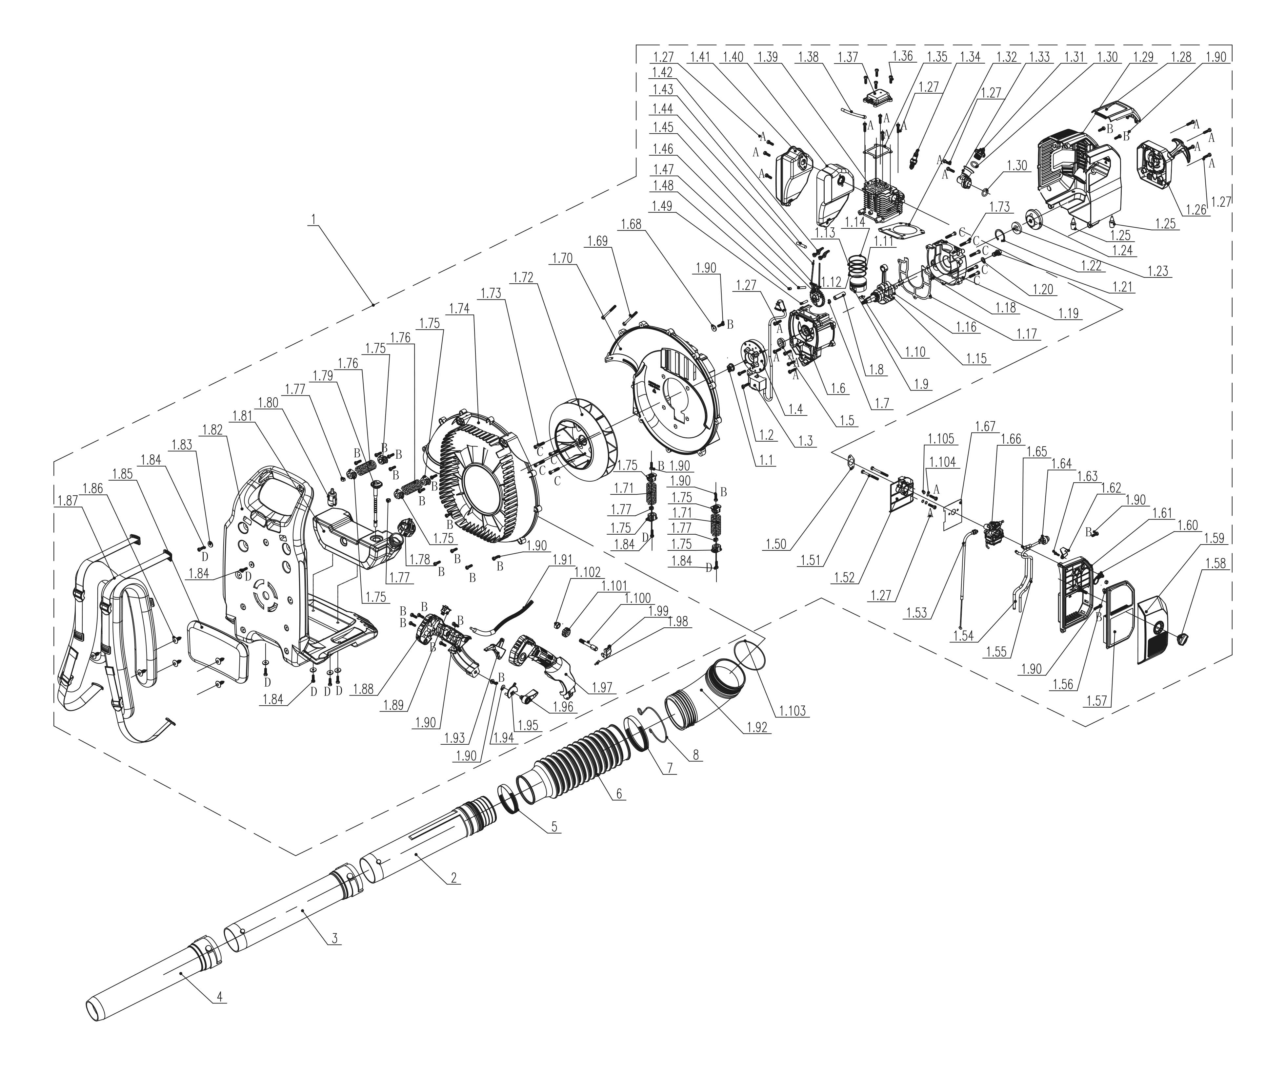
NO. | PART# | Description | Qty. | Model No. Applied
1 | 103001000417 | Engine 49CC | 1 | BLB4QL-M
1.1 | 8NG-10D01 | Nut M10*1.25 | 1 | BLB4QL-M,TL4QL-L1,CS4QL-L1,CS4QL-L3
1.2 | 8SJJD04-16D | Screw T20 M4*16 | 2 | BLB4QL-M,HT4QL-L,CSP4QL-L,GTC4QL-L,GTS4QL-L,GTS4QL-M2,GTBCU4QL-M,BLV4QL-M,BL4QL-L
1.4 | 201088000024 | Flywheel | 1 | BLB4QL-M
1.5 | 8208-981503-0100020 | Oil seal | 1 | BLB4QL-M,CS4QL-L1,BL4QL-L,GTS4QL-M2,GTBCU4QL-M,GTC4QL-L,GTS4QL-L,CS4QL-L3,BLV4QL-M,CSP4QL-L,HT4QL-L,TL4QL-L1
1.6 | 201126000085 | Crankcase | 1 | BLB4QL-M
1.7 | 8204-966001-0000000 | Retaining ring | 1 | CS4QL-L1,CS4QL-L3,BLB4QL-M,TL4QL-L1
1.8 | 8605-966001-0000000 | Pin | 1 | TL4QL-L1,CS4QL-L1,BLB4QL-M,CS4QL-L3
1.10 | 8DJE-00008 | Key | 1 | CS4QL-L1,CS4QL-L3,BLB4QL-M,TL4QL-L1
1.15 | 201038000021 | Crank shaft | 1 | BLB4QL-M
1.16 | 8BC-321509-WG02 | Bearing 6002 | 1 | BLB4QL-M,CS4QL-L1,CS4QL-L3
1.17 | 202183000027 | Gasket | 1 | BLB4QL-M
1.18 | 8PC40-08D | Cylindrical Pin | 4 | CS4QL-L1,CS4QL-L3,BLB4QL-M,TL4QL-L1
1.19 | 201126000084 | Crankcase | 1 | BLB4QL-M
1.20 | 8202-986501-0000000 | Oil drain bolt gasket | 1 | BLB4QL-M
1.21 | 8216-986501-0000000 | Oil drain bolt | 1 | BLB4QL-M
1.22 | 8CA-32B | Hole circlip | 1 | PAX2125-M2-0,PAX2115-M2-0,TL4QL-L1,BLB4QL-M,TLX6-L-0,TL4QL-L1
1.23 | 207290100010 | Oil seal | 1 | TL4QL-L1,BLB4QL-M
1.25 | 202017000097 | A/V rubber | 2 | BLB4QL-M
1.27 | 207220500010 | Screw M5*20 | 20 | BLB4QL-M
1.28 | 202030001971 | Shroud cover | 1 | BLB4QL-M
1.29 | 202190000002 | Outer cover | 1 | BLB4QL-M
1.30 | 8208-340105-0000020 | O-ring | 2 | CSP4QL-L,BLV4QL-M,BL4QL-L,GTS4QL-M2,GTBCU4QL-M,HT4QL-L,GTC4QL-L,GTS4QL-L,TL4QL-L1,BLB4QL-M
1.31 | 202165000585 | Fuel tank cap | 1 | CSP4QL-L,HT4QL-L,BLV4QL-M,BL4QL-L,GTC4QL-L,GTS4QL-L,GTS4QL-M2,GTBCU4QL-M,BLB4QL-M
1.32 | 299999000428 | Cylinder gasket | 1 | CS4QL-L3,BLB4QL-M,CS4QL-L1
1.33 | 202094000283 | Pipe | 1 | BLB4QL-M
1.34 | CMR5H | Spark plug
1.35 | 8341-966005-0000020 | Valve cover gasket | 1 | BLB4QL-M
1.36 | 8SJJD05-16D | Screw T25 M5*16 | 4 | BLB4QL-M,CS4QL-L1,CS4QL-L3
1.37 | 201181000002 | Valve cover | 1 | BLB4QL-M
1.38 | 202999002071 | Breather pipe | 1 | BLB4QL-M
1.39 | 201163000047 | Cylinder | 1 | CS4QL-L1,CS4QL-L3,BLB4QL-M
1.40 | 201058000276 | Muffler gasket | 1 | BLB4QL-M
1.41 | 199113000049 | Muffler | 1 | BLB4QL-M
1.42 | 8188-981503-0000000 | Rocker arm assembly | 2 | CS4QL-L1,GTC4QL-L,GTS4QL-L,CS4QL-L3,BL4QL-L,HT4QL-L,BLV4QL-M,BLB4QL-M,GTS4QL-M2,GTBCU4QL-M,CSP4QL-L,TL4QL-L1
1.43 | 8086-966001-0000000 | Upper rocker arm pin | 1 | BLB4QL-M,CS4QL-L1,CS4QL-L3,TL4QL-L1
1.44 | 201091000057 | Rod | 2 | CS4QL-L3,BLB4QL-M,CS4QL-L1
1.45 | 8188-981501-0000000 | Lower rocker arm | 2 | GTC4QL-L,GTS4QL-L,CSP4QL-L,TL4QL-L1,GTS4QL-M2,GTBCU4QL-M,HT4QL-L,BLV4QL-M,BL4QL-L,CS4QL-L1,BLB4QL-M,CS4QL-L3
1.46 | 202002000047 | Gear | 1 | GTS4QL-M2,GTBCU4QL-M,CSP4QL-L,HT4QL-L,BLV4QL-M,GTC4QL-L,GTS4QL-L,BL4QL-L,BLB4QL-M,CS4QL-L1,CS4QL-L3
1.47 | 8086-981503-0000000 | Pin Shaft | 1 | BLB4QL-M,TL4QL-L1,CS4QL-L1,CS4QL-L3,HT4QL-L,BLV4QL-M,GTS4QL-M2,GTBCU4QL-M,CSP4QL-L,BL4QL-L,GTC4QL-L,GTS4QL-L
1.48 | 8SHCD06-05D | Screw M6*5 | 1 | BLB4QL-M,CS4QL-L3,TL4QL-L1,BL4QL-L,CS4QL-L1,HT4QL-L,BLV4QL-M,GTC4QL-L,GTS4QL-L,GTS4QL-M2,GTBCU4QL-M,CSP4QL-L
1.49 | 201026000501 | Shaft | 1 | BLB4QL-M
1.50 | 202999002084 | Insulator gasket | 1 | BLB4QL-M
1.51 | 207430100007 | Bolt M5*55 | 2 | BLB4QL-M
1.52 | 202090000292 | Insulator | 1 | BLB4QL-M
1-53 | A073002-005 | Cable assembly | 1 | BLB4QL-M
1.54 | 302000037 | Fuel pipe | 1 | BLB4QL-M
1.55 | 234-1005 | Fuel pipe | 1 | BLV4QL-M,BL4QL-L,CS4QL-L1,CS4QL-L3,CS4QL-L1,CS4QL-L3,GTS4QL-M2,GTBCU4QL-M,BLB4QL-M,HT4QL-L,TL4QL-L1,GTC4QL-L,GTS4QL-L,CSP4QL-L
1.56 | 8NA-05D | Nut M5 | 2 | STE12-L,BLB4QL-M,BLV4QL-M,BL4QL-L,BLAX5-M,BLAX5-M-0,BLAGTX5-M,CSPX5-M-0,CSPE6.5-M,HTX5-M-0
1.58 | 202028000184 | Knob | 1 | TL4QL-L1,BLB4QL-M
1.59 | 202186000003 | Air filter cover | 1 | BLB4QL-M
1.60 | 202187000003 | Choke plate | 1 | BLB4QL-M
1.61 | 202185000003 | Air filter backing plate | 1 | BLB4QL-M
1.62 | 202188000003 | Choke handle | 1 | BLB4QL-M
1.63 | 8SNAA35-14D | Self-tapping screw ST3.5*14 | 1 | HTX5-M-0,BLB4QL-M
1.65 | 234-1004 | Fuel line | 1 | HT4QL-L,BLB4QL-M,GTC4QL-L,GTS4QL-L,CSP4QL-L,BLV4QL-M,BL4QL-L,CS4QL-L1,CS4QL-L3,GTS4QL-M2,GTBCU4QL-M,TL4QL-L1,HT4QL-L
1.67 | 202999002083 | Carburetor gasket | 1 | BLB4QL-M
1.68 | 8202-462203-0000030 | Washer | 1 | BLB4QL-M
1.69 | 8SJJD05-55D | Screw T25 M5*55 | 2 | GTC4QL-L,GTS4QL-L,HT4QL-L,GTS4QL-M2,GTBCU4QL-M,BLV4QL-M,CSP4QL-L,BL4QL-L,TL4QL-L1,BLB4QL-M
1.70 | 202016004709 | Volute engine side | 1 | BLB4QL-M
1.71 | 207010100093 | A/V spring | 2 | BLB4QL-M
1.72 | 207100100036 | Fan blade | 1 | BLB4QL-M
1.73 | 207220500009 | Screw M6*30 | 9 | BLB4QL-M
1.74 | 202016004708 | Volute | 1 | BLB4QL-M
1.75 | 202071000037 | Locating block | 8 | BLB4QL-M
1.76 | 207010100098 | A/v spring | 2 | BLB4QL-M
1.77 | 8NA-06D | Nut M6 | 5 | BLB4QL-M,TL4QL-L1,GTC4QL-L,GTS4QL-L,CSP4QL-L,GTBCU4QL-M,GTBCX6-M-0,GTS4QL-M2,STX2-L,GTS4QL-M2
1.78 | 199123000525 | Fuel tank cap assembly | 1 | BLV4QL-M,BL4QL-L,HT4QL-L,GTS4QL-M2,GTBCU4QL-M,BLB4QL-M,GTC4QL-L,GTS4QL-L,CSP4QL-L
1.79 | 202999002070 | Fuel pipe | 1 | BLB4QL-M
1.80 | 202999002007 | Fuel filter | 1 | CS4QL-L1,CS4QL-L3,BLB4QL-M
1.81 | 199124000251 | Fuel tank assembly | 1 | BLB4QL-M
1.82 | 202090000293 | Frame | 1 | BLB4QL-M
1.83 | 8WF-06D03 | Flat Washer | 6 | HPWE13-L,BLB4QL-M
1.84 | 207220500011 | Screw M6*14 | 6 | BLB4QL-M
1.85 | 201999001539 | Small back cushion | 1 | BLB4QL-M
1.86 | 202110000037 | Clasp | 6 | BLB4QL-M
1.87 | 202039000004 | Strap | 1 | BLB4QL-M
1.88 | 202024003098 | Handle | 1 | BLB4QL-M
1.90 | 8SJJB50-16D | Screw ST5*16 | 24 | BLB4QL-M,BL4QL-L,BLV4QL-M,HT4QL-L
1.91 | 201999001537 | Kill wire | 1 | BLB4QL-M
1.92 | 202094000284 | Pipe | 1 | BLB4QL-M
1.93 | 202004001242 | Trigger | 1 | BLB4QL-M
1.94 | 8321-526301-0000000 | Flat Washer | 1 | BLAX6-M-0,BLAX2-M-0,BLAX2-M,BLAGTX2-M,S2K2B1-03,S2K3B2-01,BLAX2-M3,BLB4QL-M
1.95 | 202043000147 | Push button | 1 | BLB4QL-M
1.96 | 202004001243 | Trigger | 1 | BLB4QL-M
1.97 | 202024003099 | Handle | 1 | BLB4QL-M
1.98 | 8086-650204-0000000 | Cylindrical Pin | 1 | BLB4QL-M,CSPX2-M-0,HTPX2-M-0,CSPE6.5-M,CSPX5-M-0
1.99 | 202026000261 | Push Button | 1 | CSPX5-M-0,CSPX2-M-0,HTPX2-M-0,CSPE6.5-M,BLB4QL-M
1.100 | 207221100010 | Bolt M8 | 1 | BLB4QL-M
1.101 | 8313-910801-0000110 | Quick clamp knob | 1 | BLB4QL-M
1.102 | 8NA-08D | Nut M8 | 1 | BLB4QL-M,STMG-L,SDE15-L,STE15-M,STE15-M1,STX2-M,LSPG-L3,LSPG-L2,LSSG-M1,LSPG-M7,LSPG-M4,LSPG-M6,LSPG-M3,LSPG-M5
1.103 | 207270200057 | O-ring | 1 | BLB4QL-M
1.104 | 8WS-05D | Spring washer | 2 | BLB4QL-M
1.105 | 8WF-05D | Flat Washer | 2 | ACSP01,BLB4QL-M
2 | 202094000286 | Pipe | 1 | BLB4QL-M
3 | 202094000287 | Pipe | 1 | BLB4QL-M
4 | 202094000288 | Pipe | 1 | BLB4QL-M
5 | 299999000477 | Clamp | 1 | BLB4QL-M
6 | 202094000285 | Hose | 1 | BLB4QL-M
7 | 299999000476 | Clamp | 1 | BLB4QL-M
8 | 202999002059 | Spring clamp | 1 | BLB4QL-M

