Model：CS4QL-L1
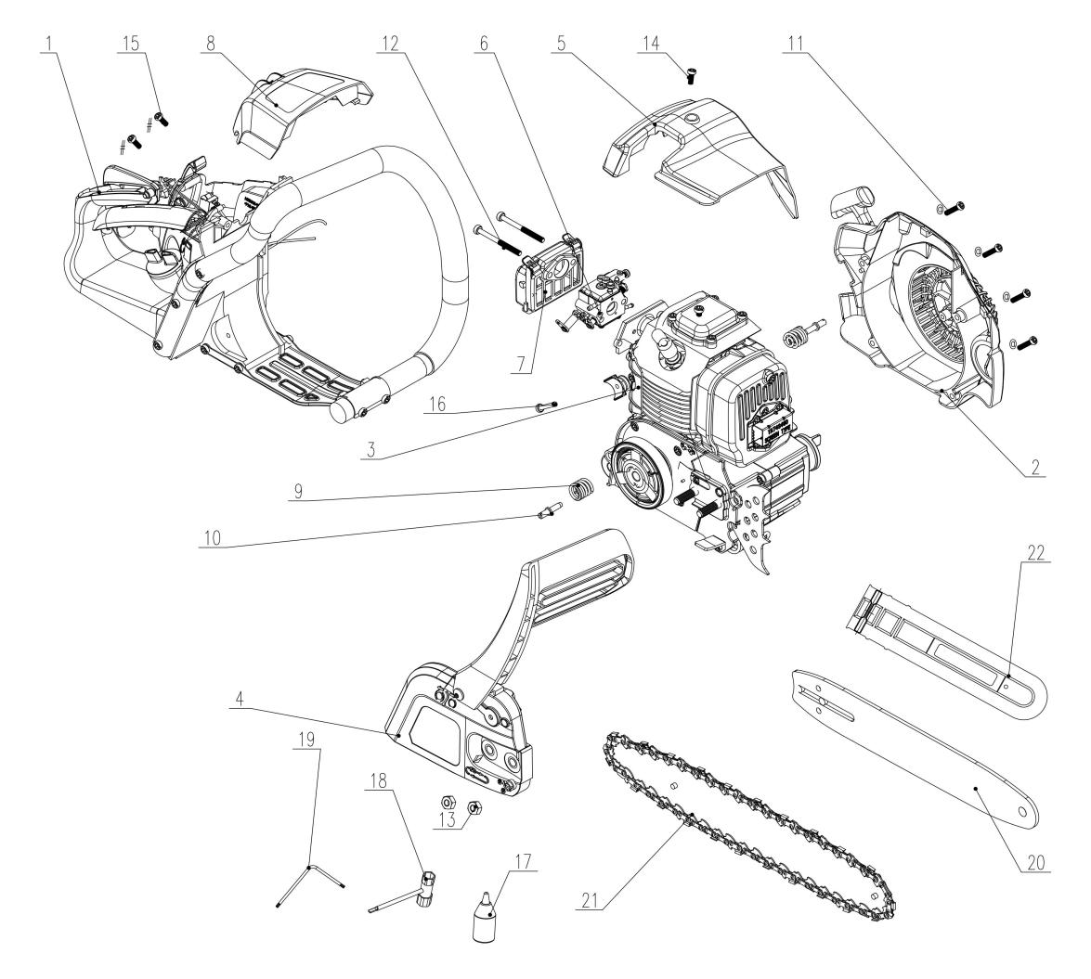
NO. | PART# | Description | Qty. | Model No. Applied
1 | 199004000716 | Rear handle assembly | 1 | CS4QL-L3,CS4QL-L1
2 | 199096000175 | Starter assembly | 1 | CS4QL-L3,CS4QL-L1
3 | 103001000353 | Engine assembly | 1 | CS4QL-L1
4 | 199001000548 | Chain brake assembly | 1 | CS4QL-L3,CS4QL-L1
5 | 202030001847 | Cylinder cover | 1 | CS4QL-L3,CS4QL-L1
6 | 199064000065 | Carburetor | 1 | CS4QL-L1,CS4QL-L3
7 | 199077000019 | Air filter | 1 | CS4QL-L1,CS4QL-L3
8 | 202030001848 | Air filter cover | 1 | CS4QL-L3,CS4QL-L1
9 | 8342-966004-0000000 | Back handle vibration damping spring | 1 | CS4QL-L1,CS4QL-L3
10 | 8206-965105-0000000 | Screw | 1 | CS4QL-L1,CS4QL-L3
11 | 8SJJD05-20D | Screw | 14 | GTS4QL-M2,GTBCU4QL-M,CSP4QL-L,GTC4QL-L,GTS4QL-L,HT4QL-L,GTBCX6-M-0,CS4QL-L1,CS4QL-L3,BL4QL-L,BLV4QL-M
12 | 8SJJD05-40D | Screw | 2 | CS4QL-L1,CS4QL-L3
13 | 8NG-08D | Nut | 1 | CSE15-M,CS4QL-L3,HT4QL-L,CS4QL-L1,CSE12-M,CSX2-M1-0,HTX6-M-0,CSE10-L,ACSP01,CSPE6.5-M
14 | 8SJJD05-12D | Screw | 9 | BLV4QL-M,GTS4QL-M2,GTBCU4QL-M,CSP4QL-L,CS4QL-L3,BL4QL-L,HT4QL-L,CS4QL-L1,TL4QL-L1,BLB4QL-M,GTC4QL-L,GTS4QL-L
15 | 8SJJB50-12D | Self-tapping screw | 4 | HT4QL-L,GTS4QL-L,GTS4QL-M2,CS4QL-L1,CS4QL-L3,STMG-L,GTC4QL-L,GTBCU4QL-M
16 | 8SJJB50-30D | Screw | 3 | CS4QL-L1,BL4QL-L,CS4QL-L3,BLV4QL-M
17 | 208043000002 | Oil bottle | 1 | CS4QL-L3,TL4QL-L1,CS4QL-L1
18 | 8261-966001-0000000 | Wrench | 1 | BLB4QL-M,CS4QL-L1,CS4QL-L3
19 | 8261-902101-0000000 | Wrench | 1 | CS4QL-L1,CS4QL-L3,BL4QL-L,HT4QL-L,BLB4QL-M,GTBCU4QL-M,BLV4QL-M,GTC4QL-L,GTS4QL-L,GTS4QL-M2,CSP4QL-L,GTBCX6-M-0
20 | 199140000074 | Bar | 1 | CS4QL-L1,CSE15-M
21 | 8344-464104-0000000 | Chain | 1 | CS4QL-L1,CSE15-M
22 | 202009000227 | Bar cover | 1 | CS4QL-L1
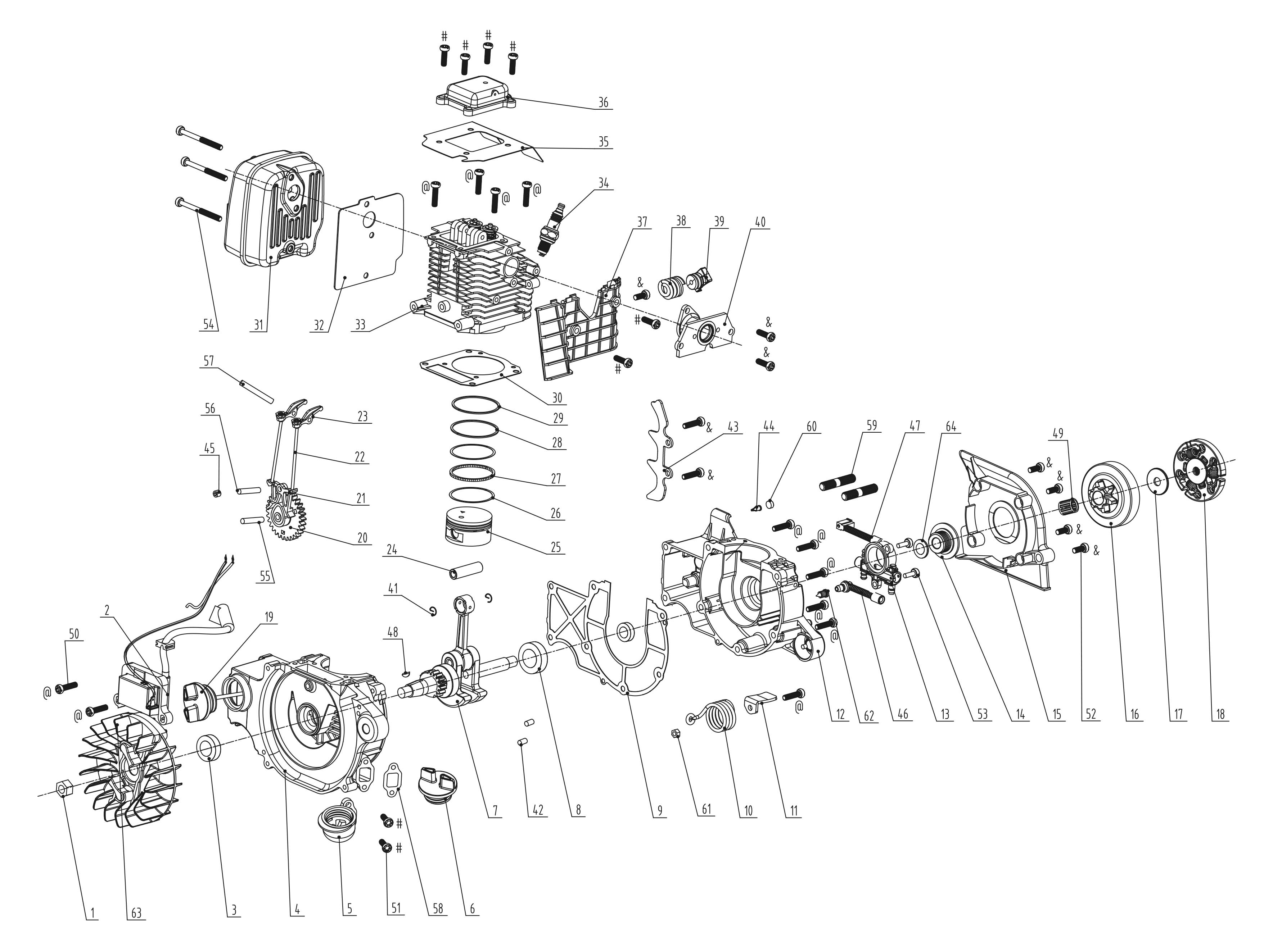
NO. | PART# | Description | Qty. | Model No. Applied
1 | 8NG-10D01 | Nut M10 | 1 | CS4QL-L1,BLB4QL-M,TL4QL-L1,CS4QL-L3
2 | 199146000001 | Ignition coil | 1 | CS4QL-L3,CS4QL-L1
3 | 8208-981503-0100020 | Oil seal | 2 | BL4QL-L,HT4QL-L,BLV4QL-M,CS4QL-L3,CS4QL-L1,TL4QL-L1,BLB4QL-M,CSP4QL-L,GTC4QL-L,GTS4QL-L,GTS4QL-M2,GTBCU4QL-M
4 | 201126000074 | Crankcase | 1 | CS4QL-L3,CS4QL-L1
5 | 202094000271 | Oil pipe port assembly | 1 | CS4QL-L3,CS4QL-L1
6 | 202083001157 | Fuel cap | 1 | CS4QL-L1,CS4QL-L3
7 | 201038000011 | Crank shaft | 1 | CS4QL-L1,CS4QL-L3
8 | 8BC-321509-WG02 | Bearing 6002 | 1 | CS4QL-L3,BLB4QL-M,CS4QL-L1
9 | 202183000012 | Crankcase gasket | 1 | CS4QL-L3,CS4QL-L1
10 | 8342-966001-0000000 | Front handle vibration damping spring | 1 | CS4QL-L1,CS4QL-L3
11 | 201043000043 | Baffle plate | 1 | CS4QL-L1,CS4QL-L3
12 | 201126000075 | Crankcase | 1 | CS4QL-L3,CS4QL-L1
13 | 8336-966001-0000000 | Oil pump | 1 | CS4QL-L1,CS4QL-L3
14 | 201009000007 | Worm gear | 1 | CS4QL-L1,CS4QL-L3
15 | 202083001139 | Cover | 1 | CS4QL-L1,CS4QL-L3
16 | 201160000016 | Chain sprocket | 1 | CS4QL-L3,CS4QL-L1
17 | 8202-965602-0000000 | Clutch adjusting washer | 1 | CS4QL-L1,CS4QL-L3
18 | 8440-965605-0000000 | Clutch assembly | 1 | CS4QL-L1,CS4QL-L3
19 | 202083001142 | Oil cover | 1 | CS4QL-L3,CS4QL-L1
20 | 202002000047 | Timing gear assembly | 1 | HT4QL-L,BLB4QL-M,GTC4QL-L,GTS4QL-L,GTS4QL-M2,GTBCU4QL-M,CSP4QL-L,CS4QL-L3,BLV4QL-M,BL4QL-L,CS4QL-L1
21 | 8188-981501-0000000 | Lower rocker arm | 2 | TL4QL-L1,BLB4QL-M,CS4QL-L1,CS4QL-L3,BL4QL-L,CSP4QL-L,HT4QL-L,BLV4QL-M,GTC4QL-L,GTS4QL-L,GTS4QL-M2,GTBCU4QL-M
22 | 201091000057 | Tappet | 2 | BLB4QL-M,CS4QL-L1,CS4QL-L3
23 | 8188-981503-0000000 | Rocker arm assembly | 2 | TL4QL-L1,CS4QL-L3,CS4QL-L1,BLB4QL-M,CSP4QL-L,GTS4QL-M2,GTBCU4QL-M,HT4QL-L,GTC4QL-L,GTS4QL-L,BLV4QL-M,BL4QL-L
24 | 8605-966001-0000000 | Pin | 1 | TL4QL-L1,CS4QL-L1,BLB4QL-M,CS4QL-L3
25 | 201109000049 | Piston | 1 | CS4QL-L1,CS4QL-L3,BLB4QL-M
26 | 8604-966001-0000000 | Scraper ring | 2 | BLB4QL-M,TL4QL-L1,CS4QL-L1,CS4QL-L3
27 | 8604-966002-0000000 | Backing ring | 1 | CS4QL-L1,CS4QL-L3,TL4QL-L1,BLB4QL-M
28 | 8604-966004-0000000 | Piston ring one | 1 | BLB4QL-M,CS4QL-L1,CS4QL-L3
29 | 8604-966003-0000000 | Piston ring two | 1 | CS4QL-L1,CS4QL-L3,TL4QL-L1,BLB4QL-M
30 | 299999000428 | Cylinder gasket | 1 | CS4QL-L1,CS4QL-L3,BLB4QL-M
31 | 199114000007 | Muffler | 1 | CS4QL-L3,CS4QL-L1
32 | 202183000014 | Muffler gasket | 1 | CS4QL-L1,CS4QL-L3
33 | 201163000047 | Cylinder | 1 | BLB4QL-M,CS4QL-L1,CS4QL-L3
34 | CMR5H | Spark plug | 1 | CS4QL-L1,CS4QL-L3,BLB4QL-M
35 | 202183000015 | Valve cover gasket | 1 | CS4QL-L1,CS4QL-L3
36 | 201181000001 | Valve cover | 1 | CS4QL-L3,CS4QL-L1
37 | 202035000003 | Plate | 1 | CS4QL-L1,CS4QL-L3
38 | 8342-966002-0000000 | Cylinder vibration damping spring | 1 | CS4QL-L1,CS4QL-L3
39 | 8301-966001-0000110 | Spring locating block | 1 | CS4QL-L3,CS4QL-L1
40 | 202094000270 | Rubber intake pipe | 1 | CS4QL-L1,CS4QL-L3
41 | 8204-966001-0000000 | E-clip | 2 | BLB4QL-M,TL4QL-L1,CS4QL-L1,CS4QL-L3
42 | 8PC40-08D | Locating pin | 4 | CS4QL-L1,CS4QL-L3,TL4QL-L1,BLB4QL-M
43 | 202094000243 | Bucking spike | 1 | CS4QL-L1,CS4QL-L3
44 | 8335-965103-0000010 | Duck bill valve | 1 | CS4QL-L1,CS4QL-L3
45 | 8SHCD06-05D | Screw M6*5 | 1 | BLB4QL-M,TL4QL-L1,HT4QL-L,CS4QL-L3,BL4QL-L,GTC4QL-L,GTS4QL-L,CS4QL-L1,BLV4QL-M,GTS4QL-M2,GTBCU4QL-M,CSP4QL-L
46 | 202999001974 | Oil pump Oil inlet pipe | 1 | CS4QL-L3,CS4QL-L1
47 | 202999001975 | Oil pump Oil out pipe | 1 | CS4QL-L1,CS4QL-L3
48 | 8DJE-00008 | Flywheel key | 1 | CS4QL-L1,CS4QL-L3,BLB4QL-M,TL4QL-L1
49 | 8BE-151214.5-WG | Bearing | 1 | CS4QL-L1,CS4QL-L3
50 | 8SJJD05-20D | Screw T25 M5*20, | 14 | GTS4QL-M2,GTBCU4QL-M,CSP4QL-L,GTC4QL-L,GTS4QL-L,HT4QL-L,GTBCX6-M-0,CS4QL-L1,CS4QL-L3,BL4QL-L,BLV4QL-M
51 | 8SJJD05-16D | Screw T25 M5*16 | 12 | CS4QL-L1,CS4QL-L3,BLB4QL-M
52 | 8SJJD05-12D | Screw T25 M5*12 | 9 | BLV4QL-M,GTS4QL-M2,GTBCU4QL-M,CSP4QL-L,CS4QL-L3,BL4QL-L,HT4QL-L,CS4QL-L1,TL4QL-L1,BLB4QL-M,GTC4QL-L,GTS4QL-L
53 | 8SJJD04-12D | Screw M4*12 | 2 | CS4QL-L1,CS4QL-L3
54 | 207421000019 | Screw M5*65 | 3 | CS4QL-L3,CS4QL-L1
55 | 201026000355 | Shaft | 1 | CS4QL-L1,CS4QL-L3,BLV4QL-M,GTS4QL-M2,GTBCU4QL-M
56 | 8086-981503-0000000 | Pin Shaft | 1 | BL4QL-L,HT4QL-L,BLV4QL-M,TL4QL-L1,CS4QL-L3,CS4QL-L1,BLB4QL-M,GTC4QL-L,GTS4QL-L,GTS4QL-M2,GTBCU4QL-M,CSP4QL-L
57 | 8086-966001-0000000 | Upper rocker arm pin | 1 | CS4QL-L1,CS4QL-L3,TL4QL-L1,BLB4QL-M
58 | 202183000005 | Gasket | 1 | CS4QL-L1,CS4QL-L3
59 | 8216-965601-0000000 | Guide plate bolt M8X40 | 2 | CS4QL-L1,CS4QL-L3
60 | 8339-965101-0000000 | Filter element | 1 | CS4QL-L3,CS4QL-L1
61 | 8NG-05D | Nut | 1 | BLAGTX5-M,BLAX6-M-0,CS4QL-L1,CS4QL-L3,GTSX5-M,GTSX5-M-0
62 | 207010200001 | Conical compression spring | 1 | CS4QL-L3,CS4QL-L1,CSX2-M-0,CSX2-M1-0,CSPX2-M-0,ACSP01,CSX5-M-0,CSE10-L,CSE12-M,CSE15-M
63 | 201088000021 | Flywheel | 1 | CS4QL-L3,CS4QL-L1
64 | 207050100005 | Flat Washer | 1 | CS4QL-L1,CS4QL-L3,LSPG-L3
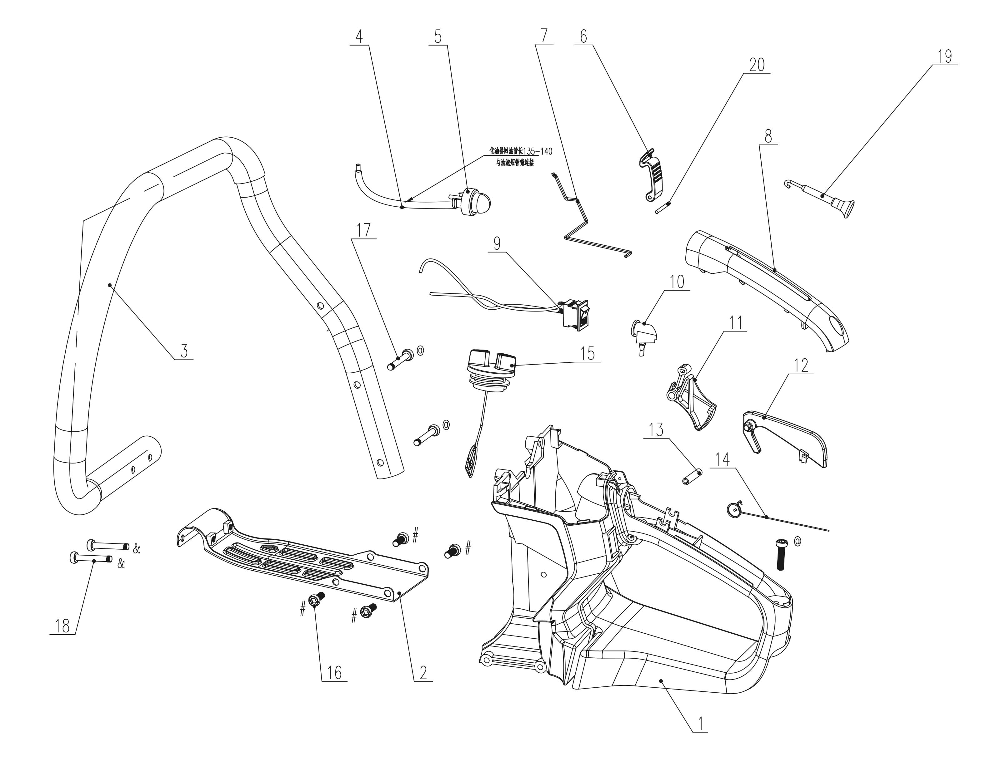
NO. | PART# | Description | Qty. | Model No. Applied
1 | 199004000717 | Rear handle | 1 | CS4QL-L3,CS4QL-L1
2 | 201080000063 | Base plate | 1 | CS4QL-L3,CS4QL-L1
3 | 199004000701 | Front handle | 1 | CS4QL-L1,CS4QL-L3
4 | 234-1005 | Oil pipe | 0.14m | TL4QL-L1,BLB4QL-M,CS4QL-L1,CS4QL-L3,HT4QL-L,GTS4QL-M2,GTBCU4QL-M,GTC4QL-L,GTS4QL-L,CSP4QL-L,BLV4QL-M,BL4QL-L
5 | 199121000011 | Primer bulb | 1 | CS4QL-L3,CS4QL-L1,HT4QL-L
6 | 202999002009 | Clasp | 1 | CS4QL-L3,CS4QL-L1
7 | 201999001485 | Throttle wire | 1 | CS4QL-L1,CS4QL-L3
8 | 202025000126 | Handle cover | 1 | CS4QL-L1,CS4QL-L3
9 | 207180200046 | Kill switch | 1 | GTS4QL-L,HT4QL-L,BLV4QL-M,BL4QL-L,BLB4QL-M,CSP4QL-L,GTC4QL-L,TL4QL-L1,GTS4QL-M2,CS4QL-L1,CS4QL-L3
10 | 202178000029 | Rubber plug | 1 | CS4QL-L1,CS4QL-L3
11 | 202004001100 | Trigger | 1 | CS4QL-L3,CS4QL-L1
12 | 202999002008 | Control arm | 1 | CS4QL-L3,CS4QL-L1
13 | 8PB50-24B | Pin | 1 | CS4QL-L1,CS4QL-L3
14 | 207010300060 | Trigger Torsional spring | 1 | CS4QL-L1,CS4QL-L3
15 | 202083001142 | Fuel cap | 1 | CS4QL-L3,CS4QL-L1
16 | 8SJJB50-12D | Self-tapping screw ST5*12 | 4 | HT4QL-L,GTS4QL-L,GTS4QL-M2,CS4QL-L1,CS4QL-L3,STMG-L,GTC4QL-L,GTBCU4QL-M
17 | 8SJJB50-30D | Screw ST5*30 | 3 | CS4QL-L1,BL4QL-L,CS4QL-L3,BLV4QL-M
18 | 207429900004 | Screw M5*30 | 2 | CS4QL-L1,CS4QL-L3
19 | 202021000062 | Choke pull rod | 1 | CS4QL-L3,CS4QL-L1
20 | 8086-730101-0000000 | Cylindrical Pin | 1 | CS4QL-L1,CS4QL-L3

