Model：GTC4QL-L
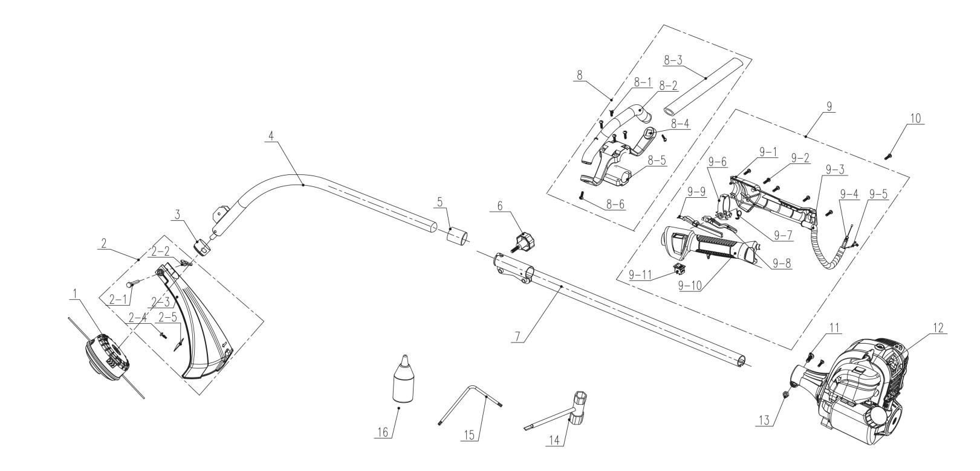
NO. | PART# | Description | Qty. | Model No. Applied
1 | 199023000091 | Trimmer head | 1 | GTC4QL-L
2 | 199048000147 | Debris shield assembly | 1 | GTC4QL-L
2-1 | 8SFDD06-40D | Screw M6*40 | 1 | GTBCX6-M-0、GTC4QL-L
2-2 | 8NB-06D | Nut M6 | 1 | GTC4QL-L
2-3 | 202012000418 | Debris shield | 1 | GTC4QL-L
2-4 | 8SJJB50-12D | Screw ST5*12 | 1 | CS4QL-L1、CS4QL-L3、GTBCU4QL-M、GTC4QL-L、GTS4QL-L、GTS4QL-M2、HT4QL-L、STMG-L
2-5 | 201045000165 | Line cutter | 1 | GTBCU4QL-M、GTC4QL-L、GTS4QL-L、GTS4QL-M2
3 | 202015000344 | Holder | 1 | GTC4QL-L
4 | 199999001325 | Lower tube assembly | 1 | GTC4QL-L
5 | 202023000078 | Pipe plug | 1 | CSP4QL-L、GTBCU4QL-M、GTC4QL-L、GTS4QL-L、GTS4QL-M2
6 | 202028000136 | Knob | 1 | GTC4QL-L、GTS4QL-L、GTS4QL-M2
7 | 199999001314 | Upper pipe assembly | 1 | GTC4QL-L、GTS4QL-L、GTS4QL-M2
8 | 199004000573 | Front handle assembly | 1 | CSP4QL-L、GTC4QL-L、GTS4QL-L
8-1 | 8SJJB50-25D | Screw ST5*25 | 4 | CSP4QL-L、GTC4QL-L、GTS4QL-L、HT4QL-L
8-2 | 202024002293 | Handle | 1 | CSP4QL-L、GTC4QL-L、GTS4QL-L
8-3 | 299009000006 | Protective sleeve | 1 | CSP4QL-L、GTC4QL-L、GTS4QL-L
8-4 | 202031000550 | Handle base | 1 | CSP4QL-L、GTC4QL-L、GTS4QL-L
8-5 | 202029000200 | Handle clamp | 1 | CSP4QL-L、GTC4QL-L、GTS4QL-L
8-6 | 8SJJB50-20D | Screw ST5*20 | 2 | CSP4QL-L、GTC4QL-L、GTS4QL-L、LSSG-M1
9 | 199004000574 | Throttle assembly | 1 | CSP4QL-L、GTC4QL-L
9-1 | 8001-902102-0000120 | Handle | 1 | CSP4QL-L、GTC4QL-L、GTS4QL-L
9-2 | 8SJEB40-14D | Screw T20 ST4* | 5 | CSP4QL-L、GTBCU4QL-M、GTC4QL-L、GTS4QL-L、GTS4QL-M2
9-3 | 235-2001 | Protective tube | 0.3 | CSP4QL-L、GTC4QL-L、GTS4QL-L、GTS4QL-M2、TL4QL-L1
9-4 | 199081000107 | Throttle cable | 1 | CSP4QL-L、GTC4QL-L、GTS4QL-L、GTS4QL-M2
9-5 | 8440-902104-0000010 | Kill wires | 1 | CSP4QL-L、GTC4QL-L、GTS4QL-L、GTS4QL-M2
9-6 | 8204-902101-0000110 | Control circle | 1 | CSP4QL-L、GTC4QL-L、GTS4QL-L、GTS4QL-M2
9-7 | 207010300082 | Trigger Assy | 1 | CSP4QL-L、GTC4QL-L、GTS4QL-L、GTS4QL-M2
9-8 | 202004000882 | Trigger | 1 | CSP4QL-L、GTC4QL-L、GTS4QL-L
9-9 | 202042000207 | Toggle rod | 1 | CSP4QL-L、GTC4QL-L、GTS4QL-L、GTS4QL-M2
9-10 | 8001-902101-0000120 | Handle | 1 | CSP4QL-L、GTC4QL-L、GTS4QL-L
9-11 | 207180200046 | Kill switch | 1 | BL4QL-L、BLB4QL-M、BLV4QL-M、CS4QL-L1、CS4QL-L3、CSP4QL-L、GTC4QL-L、GTS4QL-L、GTS4QL-M2、HT4QL-L、TL4QL-L1
10 | 8SJJD05-10D | Screw T25 M5*10 | 2 | CSP4QL-L、GTBCU4QL-M、GTBCX6-M-0、GTC4QL-L、GTS4QL-L、GTS4QL-M2
11 | 8SJJD06-20D | Screw T25 M6*20 | 1 | CSP4QL-L、GTBCU4QL-M、GTBCX6-M-0、GTC4QL-L、GTS4QL-L、GTS4QL-M2、STE15-M、STE15-M1
12 | 103001000293 | 26.5cc engine | 1 | GTC4QL-L、GTS4QL-L
13 | 8NA-06D | Nut M6 | 1 | BLB4QL-M、CSP4QL-L、GTBCU4QL-M、GTBCX6-M-0、GTC4QL-L、GTS4QL-L、GTS4QL-M2、STX2-L、TL4QL-L1
14 | 8261-901802-0000000 | Wrench | 1 | BL4QL-L、BLV4QL-M、GTBCU4QL-M、GTC4QL-L、GTS4QL-L、GTS4QL-M2
15 | 8261-902101-0000000 | Wrench | 1 | BL4QL-L、BLB4QL-M、BLV4QL-M、CS4QL-L1、CS4QL-L3、CSP4QL-L、GTBCU4QL-M、GTBCX6-M-0、GTC4QL-L、GTS4QL-L、GTS4QL-M2、HT4QL-L
16 | 202999001666 | Oil bottle | 1 | BL4QL-L、BLV4QL-M、CSP4QL-L、GTBCU4QL-M、GTC4QL-L、GTS4QL-L、GTS4QL-M2、HT4QL-L
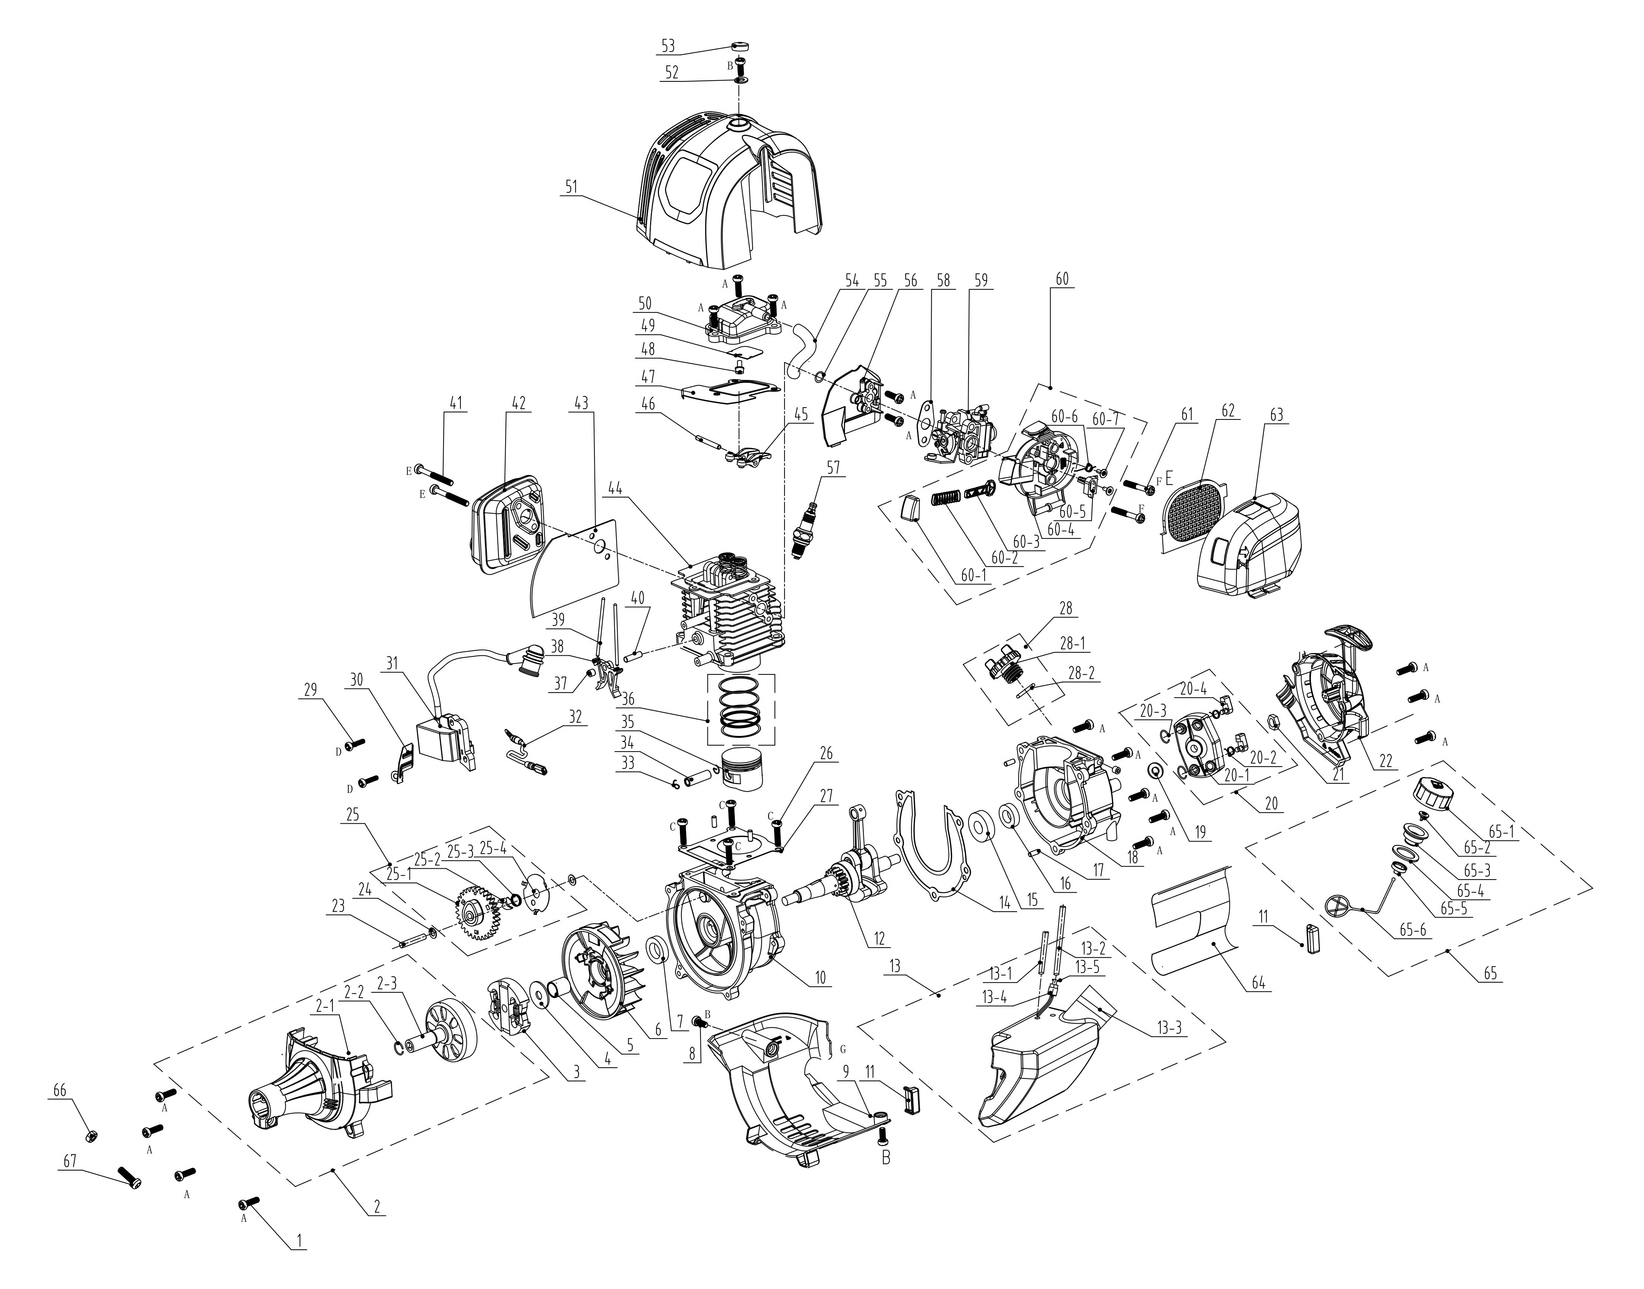
NO. | PART# | Description | Qty. | Model No. Applied
1 | 207421000003 | Screw M5*16, | 17 | HT4QL-L、ACSP01、HT4QL-L、HT4QL-L、BLV4QL-M、BL4QL-L、CSP4QL-L、ACSP01、GTC4QL-L、GTS4QL-L、GTS4QL-M2、GTBCU4QL-M
2 | 199057000076 | Fan cover assembly | 1 | GTS4QL-L、GTC4QL-L、CSP4QL-L
2-1 | 202090000164 | Fan cover | 1 | GTC4QL-L、GTS4QL-L、CSP4QL-L
2-2 | 8CD-12B | Retaining ring | 1 | CSP4QL-L、GTS4QL-M2、GTC4QL-L、GTS4QL-L、GTBCU4QL-M
2-3 | 8136-982001-0000000 | Clutch drum | 1 | GTC4QL-L、GTS4QL-L、CSP4QL-L、GTS4QL-M2、GTBCU4QL-M
3 | 199999001575 | Clutch assembly | 1 | GTC4QL-L、GTS4QL-L、GTS4QL-M2、GTBCU4QL-M、CSP4QL-L
4 | 8202-967402-0000000 | Flat Washer | 1 | BL4QL-L、GTS4QL-M2、GTBCU4QL-M、CSP4QL-L、HT4QL-L、BLV4QL-M、GTC4QL-L、GTS4QL-L
5 | 8334-982001-0000000 | Shaft sleeve | 1 | BL4QL-L、BLV4QL-M、CSP4QL-L、GTC4QL-L、GTS4QL-L、GTS4QL-M2、GTBCU4QL-M
6 | 201088000018 | Flywheel | 1 | GTC4QL-L、GTS4QL-L、GTS4QL-M2、GTBCU4QL-M、CSP4QL-L、BLV4QL-M、BL4QL-L
7 | 8208-981503-0100020 | Oil seal | 1 | BL4QL-L、CS4QL-L1、BLV4QL-M、CS4QL-L3、TL4QL-L1、BLB4QL-M、GTS4QL-M2、GTBCU4QL-M、GTC4QL-L、GTS4QL-L、CSP4QL-L、HT4QL-L
8 | 8SJJD05-12D | Screw T25 M5*12 | 3 | CS4QL-L1、HT4QL-L、HT4QL-L、GTC4QL-L、GTS4QL-L、CSP4QL-L、BL4QL-L、TL4QL-L1、CS4QL-L3、GTS4QL-M2、GTBCU4QL-M、CS4QL-L1、CS4QL-L3、BLB4QL-M、BLV4QL-M
9 | 202030002057 | Crankcase cover | 1 | CSP4QL-L、GTC4QL-L、GTS4QL-L
10 | 201126000107 | Crankcase | 1 | GTC4QL-L、BL4QL-L、HT4QL-L、GTS4QL-L、CSP4QL-L
11 | 202017000069 | A/V rubber | 2 | HT4QL-L、BL4QL-L、GTC4QL-L、GTS4QL-L、GTS4QL-M2、GTBCU4QL-M、CSP4QL-L、BLV4QL-M
12 | 8606-982002-0000000 | Crank shaft | 1 | GTC4QL-L、GTS4QL-L、GTBCU4QL-M、CSP4QL-L、GTS4QL-M2
13 | 199124000253 | Fuel tank assembly | 1 | CSP4QL-L、BLV4QL-M、BL4QL-L、GTC4QL-L、GTS4QL-L
13-1 | 234-1005 | Fuel line | 1 | CS4QL-L1、CS4QL-L3、BLB4QL-M、CS4QL-L1、CS4QL-L3、TL4QL-L1、GTC4QL-L、GTS4QL-L、CSP4QL-L、BLV4QL-M、BL4QL-L、HT4QL-L、GTS4QL-M2、GTBCU4QL-M
13-2 | 234-1004 | Fuel line | 1 | GTBCU4QL-M、CS4QL-L1、CS4QL-L3、BL4QL-L、HT4QL-L、GTS4QL-M2、GTC4QL-L、GTS4QL-L、CSP4QL-L、BLV4QL-M、TL4QL-L1、HT4QL-L、BLB4QL-M
13-3 | 202164000154 | Fuel tank | 1 | CSP4QL-L、BLV4QL-M、BL4QL-L、GTC4QL-L、GTS4QL-L
13-4 | 8615-966001-0000000 | Fuel filter | 1 | GTBCU4QL-M、GTS4QL-M2、GTC4QL-L、GTS4QL-L、CSP4QL-L、BLV4QL-M、BL4QL-L
13-5 | 201999001563 | Primer bulb | 1 | TL4QL-L1、GTC4QL-L、GTS4QL-L、CSP4QL-L、BLV4QL-M、BL4QL-L、HT4QL-L、GTS4QL-M2、GTBCU4QL-M
14 | 299999000483 | Crankcase gasket | 1 | HT4QL-L、BL4QL-L、GTC4QL-L、GTS4QL-L、GTS4QL-M2、GTBCU4QL-M、CSP4QL-L、BLV4QL-M
15 | 207390200006 | Bearing 6001 | 1 | GTC4QL-L、GTS4QL-L、GTS4QL-M2、GTBCU4QL-M、HT4QL-L、CSP4QL-L、BL4QL-L
16 | 8208-982001-0000010 | Oil seal | 1 | GTC4QL-L、GTS4QL-L、GTS4QL-M2、GTBCU4QL-M、CSP4QL-L、BL4QL-L、BLV4QL-M、HT4QL-L
17 | 8PC40-10D | Cylindrical Pin | 4 | GTC4QL-L、GTS4QL-L、CSP4QL-L、HT4QL-L、BLV4QL-M、GTS4QL-M2、GTBCU4QL-M、BL4QL-L
18 | 201126000108 | Crankcase | 1 | GTC4QL-L、GTS4QL-L、CSP4QL-L、BL4QL-L
19 | 8321-931302-0000000 | Washer | 1 | BL4QL-L、BLV4QL-M、GTS4QL-M2、GTBCU4QL-M、CSP4QL-L、HTX2-M-0、HTX2-M、S2K3B2-01、HTPX2-M-0、HTX5-M-0、GTC4QL-L、GTS4QL-L
20 | 9440-987104-0000010 | Starter pawl assembly | 1 | BL4QL-L、GTC4QL-L、GTS4QL-L、GTS4QL-M2、GTBCU4QL-M、CSP4QL-L
20-1 | 9623-987102-0100000 | Starting cup | 1 | BLV4QL-M、GTC4QL-L、GTS4QL-L、GTS4QL-M2、GTBCU4QL-M、CSP4QL-L、BL4QL-L
20-2 | 9342-987102-0000000 | Torsional spring | 2 | GTC4QL-L、GTS4QL-L、GTS4QL-M2、GTBCU4QL-M、CSP4QL-L、BL4QL-L、BLV4QL-M
20-3 | 8CE-04B | Circlip | 2 | BLV4QL-M、GTC4QL-L、GTS4QL-L、GTS4QL-M2、GTBCU4QL-M、CSP4QL-L、BL4QL-L
20-4 | 202999001675 | Pawl | 2 | BLV4QL-M、BL4QL-L、GTS4QL-M2、GTBCU4QL-M、CSP4QL-L、GTC4QL-L、GTS4QL-L
21 | 8NA-08D03 | Nut M8 | 1 | GTC4QL-L、GTS4QL-L、GTS4QL-M2、GTBCU4QL-M、CSP4QL-L、BLV4QL-M、TL4QL-L1、BL4QL-L
22 | 199096000128 | Starter assembly | 1 | GTC4QL-L、GTS4QL-L、CSP4QL-L、BLV4QL-M、BL4QL-L
23 | 201026000354 | Shaft | 1 | BL4QL-L、TL4QL-L1、HT4QL-L、GTC4QL-L、GTS4QL-L、CSP4QL-L
24 | 8208-981502-0000000 | Cam washer | 2 | TL4QL-L1、BL4QL-L、CSP4QL-L、GTC4QL-L、GTS4QL-L、HT4QL-L、BLV4QL-M、GTS4QL-M2、GTBCU4QL-M
25 | 199999001280 | Timing gear assembly | 1 | GTC4QL-L、GTS4QL-L、GTS4QL-M2、GTBCU4QL-M、CSP4QL-L、HT4QL-L
25-1 | 202002000047 | Timing gear | 1 | GTC4QL-L、GTS4QL-L、GTS4QL-M2、GTBCU4QL-M、CSP4QL-L、BLV4QL-M、BL4QL-L、HT4QL-L、BLB4QL-M、CS4QL-L1、CS4QL-L3
25-2 | 201999001334 | Pressure relief block | 1 | HT4QL-L、GTC4QL-L、GTS4QL-L、GTS4QL-M2、GTBCU4QL-M、CSP4QL-L
25-3 | 207010300018 | Torsional spring | 1 | GTS4QL-M2、GTBCU4QL-M、CSP4QL-L、GTC4QL-L、GTS4QL-L、HT4QL-L
25-4 | 201999001338 | Timing gear Cover plate | 1 | GTC4QL-L、GTS4QL-L、GTS4QL-M2、GTBCU4QL-M、CSP4QL-L、HT4QL-L
26 | 8SJJD05-20D | Screw T25 M5*20 | 4 | BLV4QL-M、HT4QL-L、CSP4QL-L、GTC4QL-L、GTS4QL-L、GTS4QL-M2、GTBCU4QL-M、HT4QL-L、GTBCU4QL-M、GTS4QL-M2、GTBCX6-M-0、CS4QL-L1、CS4QL-L3、BL4QL-L、CS4QL-L1、CS4QL-L3
27 | 8341-981501-0000010 | Cylinder gasket | 1 | GTC4QL-L、GTS4QL-L、GTS4QL-M2、GTBCU4QL-M、CSP4QL-L、BL4QL-L、HT4QL-L、BLV4QL-M
28 | 199999001396 | Oil dipstick assembly | 1 | GTC4QL-L、GTS4QL-L、GTS4QL-M2、GTBCU4QL-M、CSP4QL-L、HT4QL-L、BLV4QL-M、BL4QL-L
28-1 | 202165000585 | Fuel tank cap | 1 | GTC4QL-L、GTS4QL-L、CSP4QL-L、BLB4QL-M、HT4QL-L、BLV4QL-M、BL4QL-L、GTS4QL-M2、GTBCU4QL-M
28-2 | 8208-340105-0000020 | O-ring | 1 | TL4QL-L1、GTS4QL-M2、GTBCU4QL-M、CSP4QL-L、HT4QL-L、BLV4QL-M、BL4QL-L、GTC4QL-L、GTS4QL-L、BLB4QL-M
29 | 8SJJD04-16D | Screw T20 M4*16 | 2 | CSP4QL-L、HT4QL-L、BLV4QL-M、BL4QL-L、GTBCU4QL-M、BLB4QL-M、GTC4QL-L、GTS4QL-L、GTS4QL-M2
30 | 8181-950204-0000000 | Draught board | 1 | BL4QL-L、HT4QL-L、BLV4QL-M、GTC4QL-L、GTS4QL-L、GTS4QL-M2、GTBCU4QL-M、CSP4QL-L
31 | 199037000050 | Ignition coil | 1 | GTS4QL-L、CSP4QL-L、HT4QL-L、BL4QL-L、GTC4QL-L
32 | 199999001317 | Kill wire | 1 | HT4QL-L、GTC4QL-L、GTS4QL-L、GTS4QL-M2、GTBCU4QL-M、CSP4QL-L
33 | 8204-981001-0000000 | Piston pin Retaining ring | 2 | BL4QL-L、HT4QL-L、BLV4QL-M、GTC4QL-L、GTS4QL-L、GTS4QL-M2、GTBCU4QL-M、CSP4QL-L
34 | 8605-982001-0000000 | Piston pin | 1 | BL4QL-L、GTC4QL-L、GTS4QL-L、CSP4QL-L、HT4QL-L
35 | 201109000039 | Piston | 1 | GTC4QL-L、GTS4QL-L、CSP4QL-L、HT4QL-L、BL4QL-L
36 | 201110000044 | Piston ring | 1 | GTC4QL-L、GTS4QL-L、CSP4QL-L、HT4QL-L、BL4QL-L
37 | 8SHCD06-05D | Screw M6*5 | 1 | GTC4QL-L、GTS4QL-L、BLB4QL-M、TL4QL-L1、CS4QL-L3、CS4QL-L1、BL4QL-L、HT4QL-L、BLV4QL-M、GTS4QL-M2、GTBCU4QL-M、CSP4QL-L
38 | 8188-981501-0000000 | Lower rocker arm | 2 | GTC4QL-L、GTS4QL-L、GTS4QL-M2、GTBCU4QL-M、HT4QL-L、CSP4QL-L、TL4QL-L1、BLB4QL-M、BL4QL-L、BLV4QL-M、CS4QL-L3、CS4QL-L1
39 | 8087-981501-0000000 | Tappet | 2 | BL4QL-L、HT4QL-L、BLV4QL-M、GTC4QL-L、GTS4QL-L、GTS4QL-M2、GTBCU4QL-M、CSP4QL-L
40 | 8086-981503-0000000 | Pin Shaft | 1 | BLB4QL-M、HT4QL-L、CS4QL-L1、TL4QL-L1、BLV4QL-M、BL4QL-L、CS4QL-L3、CSP4QL-L、GTC4QL-L、GTS4QL-L、GTS4QL-M2、GTBCU4QL-M
41 | 8SJJD05-45D | Screw T25 M5*45 | 2 | BLV4QL-M、BL4QL-L、GTC4QL-L、GTS4QL-L、GTS4QL-M2、GTBCU4QL-M、HT4QL-L、CSP4QL-L
42 | 8614-982001-0000000 | Muffler | 1 | CSP4QL-L、GTC4QL-L、GTS4QL-L、GTS4QL-M2、GTBCU4QL-M
43 | 202183000029 | Muffler gasket | 1 | GTC4QL-L、GTS4QL-L、CSP4QL-L
44 | 199999001376 | Cylinder assembly | 1 | CSP4QL-L、GTC4QL-L、GTS4QL-L、HT4QL-L、BL4QL-L
45 | 8188-981503-0000000 | Rocker arm assembly | 1 | GTC4QL-L、GTS4QL-L、GTS4QL-M2、GTBCU4QL-M、CSP4QL-L、HT4QL-L、BLV4QL-M、BL4QL-L、CS4QL-L1、CS4QL-L3、TL4QL-L1、BLB4QL-M
46 | 8086-981502-0000000 | Pin Shaft | 1 | HT4QL-L、BLV4QL-M、BL4QL-L、GTS4QL-L、GTS4QL-M2、GTBCU4QL-M、CSP4QL-L、GTC4QL-L
47 | 201043000035 | Valve cover gasket | 1 | GTC4QL-L、GTS4QL-L、GTS4QL-M2、GTBCU4QL-M、CSP4QL-L
48 | 8SJJD05-08D | Screw T25 M5*8 | 1 | HT4QL-L、GTC4QL-L、GTS4QL-L、CSP4QL-L
49 | 8181-981503-0000010 | Oil baffle | 1 | GTC4QL-L、GTS4QL-L、CSP4QL-L、HT4QL-L
50 | 8602-981503-0000000 | Valve cover | 1 | BLV4QL-M、BL4QL-L、HT4QL-L、GTBCU4QL-M、CSP4QL-L、GTC4QL-L、GTS4QL-L、GTS4QL-M2
51 | 202030001706 | Engine cover | 1 | CSP4QL-L、GTS4QL-L、GTC4QL-L
52 | 9341-923002-0000000 | Flat Washer M5 | 1 | BL4QL-L、BLV4QL-M、GTS4QL-M2、GTBCU4QL-M、CSP4QL-L、GTC4QL-L、GTS4QL-L
53 | 8208-982003-0000020 | Rubber plug | 1 | TL4QL-L1、BL4QL-L、BLV4QL-M、GTBCU4QL-M、CSP4QL-L、GTC4QL-L、GTS4QL-L、GTS4QL-M2、HT4QL-L
54 | 202094000222 | Pipe | 1 | TL4QL-L1、BL4QL-L、BLV4QL-M、GTC4QL-L、GTS4QL-L、GTS4QL-M2、GTBCU4QL-M、CSP4QL-L、HT4QL-L
55 | 299999000412 | Gasket | 1 | HT4QL-L、BLV4QL-M、BL4QL-L、GTC4QL-L、GTS4QL-L、GTS4QL-M2、GTBCU4QL-M、CSP4QL-L
56 | 202189000003 | Insulator | 1 | CSP4QL-L、GTC4QL-L、GTS4QL-L
57 | CMR5H | Spark plug | 1 | GTC4QL-L、GTS4QL-L、GTS4QL-M2、GTBCU4QL-M、CSP4QL-L、HT4QL-L、BLV4QL-M、BL4QL-L、TL4QL-L1
58 | 202183000030 | Carb gasket | 1 | GTC4QL-L、GTS4QL-L、CSP4QL-L
59 | 199064000073 | Carburetor | 1 | GTC4QL-L、GTS4QL-L、CSP4QL-L、BL4QL-L
60 | 199999001401 | Choke assembly | 1 | GTC4QL-L、GTS4QL-L、CSP4QL-L
60-1 | 202003001673 | Choke button | 1 | GTC4QL-L、GTS4QL-L、CSP4QL-L
60-2 | 8324-981503-0000000 | Button Spring | 1 | GTS4QL-M2、GTBCU4QL-M、HT4QL-L、GTC4QL-L、GTS4QL-L、CSP4QL-L
60-3 | 8615-903003-0000110 | Choke door | 1 | HT4QL-L、CSP4QL-L、GTC4QL-L、GTS4QL-L、GTS4QL-M2、GTBCU4QL-M、TL4QL-L1
60-4 | 202999001674 | Air filter seat | 1 | CSP4QL-L、GTC4QL-L、GTS4QL-L
60-5 | 8615-903004-0000120 | Control slide | 1 | GTS4QL-L、CSP4QL-L、GTC4QL-L、HT4QL-L
60-6 | 201999001544 | Sliding block spring | 1 | GTS4QL-M2、GTBCU4QL-M、CSP4QL-L、HT4QL-L、BLV4QL-M、BL4QL-L、GTC4QL-L、GTS4QL-L、TL4QL-L1
60-7 | 207310600002 | Self-Tapping screw ST2.9*8 | 2 | GTS4QL-M2、GTBCU4QL-M、TL4QL-L1、BLAX2-M3、HT4QL-L、GTC4QL-L、GTS4QL-L、CSP4QL-L、BLV4QL-M、BL4QL-L
61 | 8SJJD05-55D | Screw T25 M5*55 | 2 | GTC4QL-L、GTS4QL-L、GTS4QL-M2、GTBCU4QL-M、CSP4QL-L、TL4QL-L1、BLV4QL-M、BL4QL-L、HT4QL-L、BLB4QL-M
62 | 299999000407 | Air filter | 1 | HT4QL-L、GTC4QL-L、GTS4QL-L、CSP4QL-L
63 | 202030001632 | Air filter cover | 1 | CSP4QL-L、GTC4QL-L、GTS4QL-L
64 | 8322-982001-0000010 | Fuel tank Insulation film | 1 | BLV4QL-M、BL4QL-L、GTC4QL-L、GTS4QL-L、CSP4QL-L、HT4QL-L
65 | 199123000525 | Fuel tank cap assembly | 1 | HT4QL-L、BLV4QL-M、BL4QL-L、BLB4QL-M、GTS4QL-M2、GTBCU4QL-M、GTC4QL-L、GTS4QL-L、CSP4QL-L
65-1 | 202083001180 | Fuel cap | 1 | BLV4QL-M、GTC4QL-L、GTS4QL-L、CSP4QL-L、HT4QL-L、BLB4QL-M、GTS4QL-M2、GTBCU4QL-M、BL4QL-L
65-2 | 202999002115 | Duck bill valve | 1 | BLB4QL-M、GTS4QL-M2、BLV4QL-M、GTBCU4QL-M、HT4QL-L、BL4QL-L、GTC4QL-L、GTS4QL-L、CSP4QL-L
65-3 | 202077000007 | Seat | 1 | TL4QL-L1、GTC4QL-L、GTS4QL-L、CSP4QL-L、BLV4QL-M、BL4QL-L、BLB4QL-M、GTS4QL-M2、GTBCU4QL-M、HT4QL-L
65-4 | 202183000034 | Gasket | 1 | HT4QL-L、GTS4QL-M2、GTBCU4QL-M、BLB4QL-M、BLV4QL-M、BL4QL-L、GTC4QL-L、GTS4QL-L、CSP4QL-L、TL4QL-L1
65-5 | 202999002094 | Hook seat | 1 | TL4QL-L1、CSP4QL-L、BLV4QL-M、GTC4QL-L、GTS4QL-L、BL4QL-L、GTS4QL-M2、GTBCU4QL-M、HT4QL-L、BLB4QL-M
65-6 | 202014000161 | Hook | 1 | GTS4QL-M2、TL4QL-L1、BLB4QL-M、HT4QL-L、BLV4QL-M、BL4QL-L、GTBCU4QL-M、GTC4QL-L、GTS4QL-L、CSP4QL-L
66 | 8NA-06D | Nut M6 | 1 | CSP4QL-L、GTBCU4QL-M、CSP4QL-L、GTBCU4QL-M、GTBCX6-M-0、CSP4QL-L、GTBCU4QL-M、CSP4QL-L、GTBCX6-M-0、CSP4QL-L、GTC4QL-L、GTS4QL-L、BLB4QL-M、GTS4QL-L、GTS4QL-M2、TL4QL-L1、GTBCU4QL-M、STX2-L、GTS4QL-M2
67 | 8SJJD06-20D | Screw T25 M6*20 | 1 | GTBCU4QL-M、GTS4QL-L、GTS4QL-M2、GTC4QL-L、GTS4QL-L、CSP4QL-L、GTBCX6-M-0、GTS4QL-M2、STE15-M、STE15-M1、GTBCU4QL-M

