Model：GTS4QL-M2
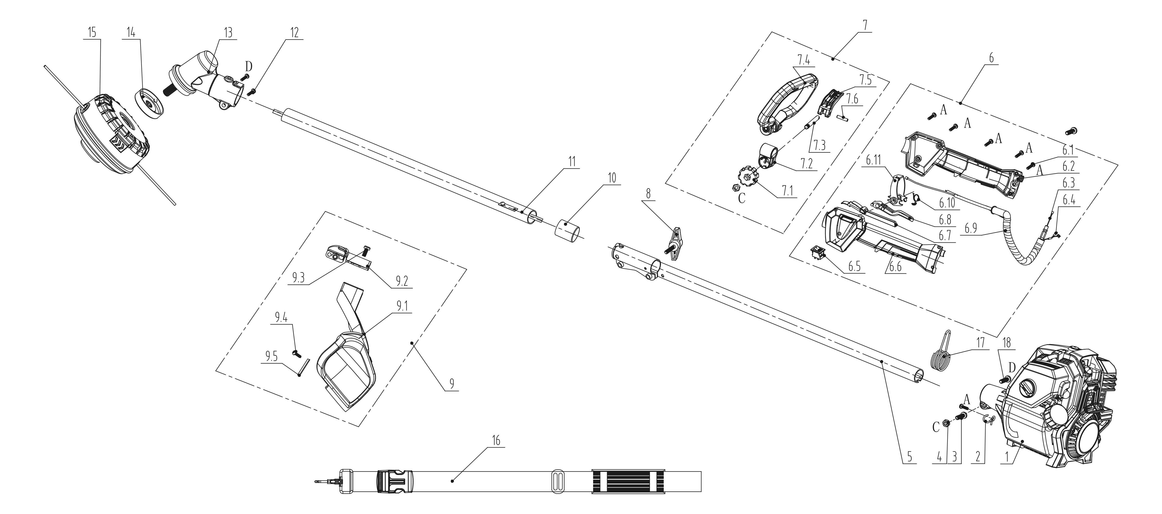
NO. | PART# | Description | Qty. | Model No. Applied
1 | 103001000297 | Engine 31cc | 1 | GTBCU4QL-M、GTS4QL-M2
2 | 201999001337 | Fixed ring | 1 | GTBCU4QL-M、GTS4QL-M2
3 | 8SJJD06-20D | Screw T25 M6*20 | 1 | CSP4QL-L、GTBCU4QL-M、GTBCX6-M-0、GTC4QL-L、GTS4QL-L、GTS4QL-M2、STE15-M、STE15-M1
4 | 8NA-06D | Nut M6 | 2 | BLB4QL-M、CSP4QL-L、GTBCU4QL-M、GTBCX6-M-0、GTC4QL-L、GTS4QL-L、GTS4QL-M2、STX2-L、TL4QL-L1
5 | 199999001314 | Upper outer pipe assembly | 1 | GTC4QL-L、GTS4QL-L、GTS4QL-M2
6 | 199004000604 | Throttle assembly | 1 | GTS4QL-M2
6.1 | 8SJEB40-14D | Screw T20 ST4*14 | 6 | CSP4QL-L、GTBCU4QL-M、GTC4QL-L、GTS4QL-L、GTS4QL-M2
6.2 | 202024002516 | Handle | 1 | GTS4QL-M2
6.3 | 199081000107 | Throttle cable | 1 | CSP4QL-L、GTC4QL-L、GTS4QL-L、GTS4QL-M2
6.4 | 8440-902104-0000010 | Kill wire | 1 | CSP4QL-L、GTC4QL-L、GTS4QL-L、GTS4QL-M2
6.5 | 207180200046 | Kill switch | 1 | BL4QL-L、BLB4QL-M、BLV4QL-M、CS4QL-L1、CS4QL-L3、CSP4QL-L、GTC4QL-L、GTS4QL-L、GTS4QL-M2、HT4QL-L、TL4QL-L1
6.6 | 202024002517 | Handle | 1 | GTS4QL-M2
6.7 | 202042000207 | Toggle rod | 1 | CSP4QL-L、GTC4QL-L、GTS4QL-L、GTS4QL-M2
6.8 | 202004000959 | Trigger | 1 | GTS4QL-M2
6.9 | 235-2001 | Protective tube | 0.2m | CSP4QL-L、GTC4QL-L、GTS4QL-L、GTS4QL-M2、TL4QL-L1
6.1 | 207010300082 | Torsional spring | 1 | CSP4QL-L、GTC4QL-L、GTS4QL-L、GTS4QL-M2
6.11 | 8204-902101-0000110 | Control circle | 1 | CSP4QL-L、GTC4QL-L、GTS4QL-L、GTS4QL-M2
7 | 199004000605 | Front handle assembly | 1 | GTS4QL-M2
7.1 | 202028000142 | Knob | 1 | GTS4QL-M2
7.2 | 202999001665 | Front handle seat | 1 | GTS4QL-M2
7.3 | 201026000343 | Shaft | 1 | GTS4QL-M2
7.4 | 202024002114 | Handle | 1 | GTS4QL-M2
7.5 | 202004000970 | Trigger | 1 | GTS4QL-M2
7.6 | 8091-410206-0100000 | Center bracket pin | 1 | GTS4QL-M2
8 | 202028000136 | Knob | 1 | GTC4QL-L、GTS4QL-L、GTS4QL-M2
9 | 199048000132 | Debris shield assembly | 1 | GTS4QL-L、GTS4QL-M2
9.1 | 8185-902101-0000110 | Debris shield | 1 | GTS4QL-L、GTS4QL-M2
9.2 | 201057000219 | Bracket | 1 | GTS4QL-L、GTS4QL-M2
9.3 | 8SJJD06-20D | Screw T25 M6*20 | 1 | CSP4QL-L、GTBCU4QL-M、GTBCX6-M-0、GTC4QL-L、GTS4QL-L、GTS4QL-M2、STE15-M、STE15-M1
9.4 | 8SJJB50-12D | Screw ST5*12 | 1 | CS4QL-L1、CS4QL-L3、GTBCU4QL-M、GTC4QL-L、GTS4QL-L、GTS4QL-M2、HT4QL-L、STMG-L
9.5 | 201045000165 | Line cutter | 1 | GTBCU4QL-M、GTC4QL-L、GTS4QL-L、GTS4QL-M2
10 | 202023000078 | Plug | 1 | CSP4QL-L、GTBCU4QL-M、GTC4QL-L、GTS4QL-L、GTS4QL-M2
1 1 | 199999001284 | Lower outer pipe assembly | 1 | GTBCU4QL-M、GTS4QL-L、GTS4QL-M2
12 | 8SJJD05-20D | Screw T25 M5*20 | 1 | BL4QL-L、BLV4QL-M、CS4QL-L1、CS4QL-L3、CSP4QL-L、GTBCU4QL-M、GTBCX6-M-0、GTC4QL-L、GTS4QL-L、GTS4QL-M2、HT4QL-L
13 | 199999001283 | Gear Box assembly | 1 | GTBCU4QL-M、GTS4QL-L、GTS4QL-M2
14 | 201999001416 | Holder | 1 | GTBCU4QL-M、GTBCX6-M-0、GTS4QL-L、GTS4QL-M2
15 | 199023000092 | Trimmer head | 1 | GTS4QL-L、GTS4QL-M2
16 | 208008000051 | Strap | 1 | CSP4QL-L、GTBCU4QL-M、GTBCX6-M-0、GTS4QL-L、GTS4QL-M2
17 | 201024000010 | Strap ring | 1 | CSP4QL-L、GTBCU4QL-M、GTS4QL-L、GTS4QL-M2
18 | 8SJJD05-10D | Screw T25 M5*10 | 3 | CSP4QL-L、GTBCU4QL-M、GTBCX6-M-0、GTC4QL-L、GTS4QL-L、GTS4QL-M2
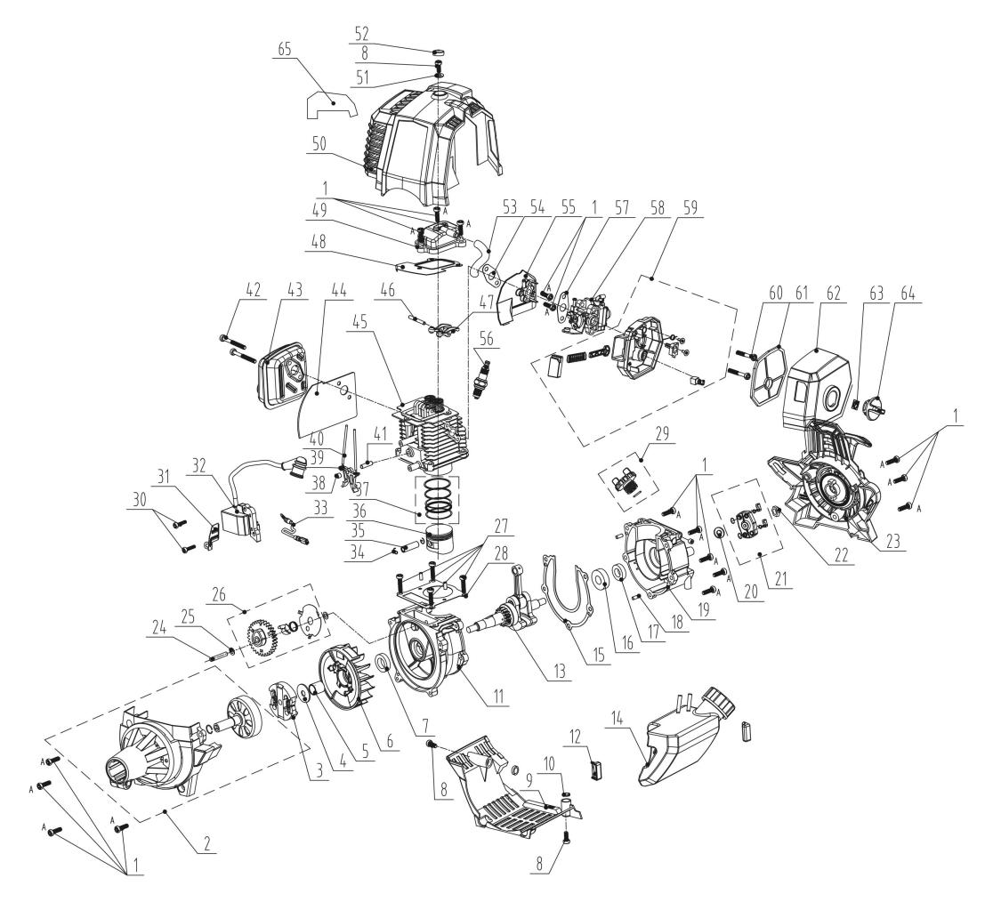
NO. | PART# | Description | Qty. | Model No. Applied
1 | 207421000003 | Screw M5*16, | 17 | ACSP01、BL4QL-L、BLV4QL-M、CSP4QL-L、GTBCU4QL-M、GTC4QL-L、GTS4QL-L、GTS4QL-M2、HT4QL-L
2 | 199999001278 | Fan housing assembly | 1 | GTBCU4QL-M、GTS4QL-M2
3 | 199999001575 | Clutch assembly | 1 | CSP4QL-L、GTBCU4QL-M、GTC4QL-L、GTS4QL-L、GTS4QL-M2
4 | 8202-967402-0000000 | Flat Washer | 1 | BL4QL-L、BLV4QL-M、CSP4QL-L、GTBCU4QL-M、GTC4QL-L、GTS4QL-L、GTS4QL-M2、HT4QL-L
5 | 8334-982001-0000000 | Shaft sleeve | 1 | BL4QL-L、BLV4QL-M、CSP4QL-L、GTBCU4QL-M、GTC4QL-L、GTS4QL-L、GTS4QL-M2
6 | 201088000018 | Flywheel | 1 | BL4QL-L、BLV4QL-M、CSP4QL-L、GTBCU4QL-M、GTC4QL-L、GTS4QL-L、GTS4QL-M2
7 | 8208-981503-0100020 | Oil seal | 1 | BL4QL-L、BLB4QL-M、BLV4QL-M、CS4QL-L1、CS4QL-L3、CSP4QL-L、GTBCU4QL-M、GTC4QL-L、GTS4QL-L、GTS4QL-M2、HT4QL-L、TL4QL-L1
8 | 8SJJD05-12D | Screw T25 M5*12 | 3 | BL4QL-L、BLB4QL-M、BLV4QL-M、CS4QL-L1、CS4QL-L3、CSP4QL-L、GTBCU4QL-M、GTC4QL-L、GTS4QL-L、GTS4QL-M2、HT4QL-L、TL4QL-L1
9 | 202999001656 | Crankcase cover | 1 | GTBCU4QL-M、GTS4QL-M2
10 | 8208-982002-0000010 | Red steel paper mat | 2 | CS4QL-L1、CS4QL-L3、GTBCU4QL-M、GTS4QL-M2、HT4QL-L
11 | 201126000109 | Crankcase | 1 | BLV4QL-M、GTBCU4QL-M、GTS4QL-M2
12 | 202017000069 | A/V rubber | 2 | BL4QL-L、BLV4QL-M、CSP4QL-L、GTBCU4QL-M、GTC4QL-L、GTS4QL-L、GTS4QL-M2、HT4QL-L
13 | 8606-982002-0000000 | Crank shaft | 1 | CSP4QL-L、GTBCU4QL-M、GTC4QL-L、GTS4QL-L、GTS4QL-M2
14 | 199999001878 | Fuel tank assembly | 1 | GTBCU4QL-M、GTS4QL-M2
15 | 299999000483 | Crankcase gasket | 1 | BL4QL-L、BLV4QL-M、CSP4QL-L、GTBCU4QL-M、GTC4QL-L、GTS4QL-L、GTS4QL-M2、HT4QL-L
16 | 207390200006 | Bearing 6001 | 1 | BL4QL-L、CSP4QL-L、GTBCU4QL-M、GTC4QL-L、GTS4QL-L、GTS4QL-M2、HT4QL-L
17 | 8208-982001-0000010 | Oil seal | 1 | BL4QL-L、BLV4QL-M、CSP4QL-L、GTBCU4QL-M、GTC4QL-L、GTS4QL-L、GTS4QL-M2、HT4QL-L
18 | 8PC40-10D | Cylindrical Pin | 4 | BL4QL-L、BLV4QL-M、CSP4QL-L、GTBCU4QL-M、GTC4QL-L、GTS4QL-L、GTS4QL-M2、HT4QL-L
19 | 201126000110 | Crankcase | 1 | BLV4QL-M、GTBCU4QL-M、GTS4QL-M2
20 | 8321-931302-0000000 | Wearing pad | 1 | BL4QL-L、BLV4QL-M、CSP4QL-L、GTBCU4QL-M、GTC4QL-L、GTS4QL-L、GTS4QL-M2、HTPX2-M-0、HTX2-M、HTX2-M-0、HTX5-M-0、S2K3B2-01
21 | 9440-987104-0000010 | Starter pawl assembly | 1 | BL4QL-L、CSP4QL-L、GTBCU4QL-M、GTC4QL-L、GTS4QL-L、GTS4QL-M2
22 | 8NA-08D03 | Nut M8 | 1 | BL4QL-L、BLV4QL-M、CSP4QL-L、GTBCU4QL-M、GTC4QL-L、GTS4QL-L、GTS4QL-M2、TL4QL-L1
23 | 199096000156 | Starter | 1 | GTBCU4QL-M、GTS4QL-M2
24 | 201026000355 | Shaft | 1 | BLV4QL-M、CS4QL-L1、CS4QL-L3、GTBCU4QL-M、GTS4QL-M2
25 | 8208-981502-0000000 | CAM washer | 2 | BL4QL-L、BLV4QL-M、CSP4QL-L、GTBCU4QL-M、GTC4QL-L、GTS4QL-L、GTS4QL-M2、HT4QL-L、TL4QL-L1
26 | 199999001280 | Timing gear assembly | 1 | CSP4QL-L、GTBCU4QL-M、GTC4QL-L、GTS4QL-L、GTS4QL-M2、HT4QL-L
27 | 8SJJD05-20D | Screw T25 M5*20 | 4 | BL4QL-L、BLV4QL-M、CS4QL-L1、CS4QL-L3、CSP4QL-L、GTBCU4QL-M、GTBCX6-M-0、GTC4QL-L、GTS4QL-L、GTS4QL-M2、HT4QL-L
28 | 8341-981501-0000010 | Cylinder gasket | 1 | BL4QL-L、BLV4QL-M、CSP4QL-L、GTBCU4QL-M、GTC4QL-L、GTS4QL-L、GTS4QL-M2、HT4QL-L
29 | 199999001396 | Oil dipstick assembly | 1 | BL4QL-L、BLV4QL-M、CSP4QL-L、GTBCU4QL-M、GTC4QL-L、GTS4QL-L、GTS4QL-M2、HT4QL-L
30 | 8SJJD04-16D | Screw T20 M4*16 | 2 | BL4QL-L、BLB4QL-M、BLV4QL-M、CSP4QL-L、GTBCU4QL-M、GTC4QL-L、GTS4QL-L、GTS4QL-M2、HT4QL-L
31 | 8181-950204-0000000 | Draught board | 1 | BL4QL-L、BLV4QL-M、CSP4QL-L、GTBCU4QL-M、GTC4QL-L、GTS4QL-L、GTS4QL-M2、HT4QL-L
32 | 199037000031 | Ignition coil | 1 | GTBCU4QL-M、GTS4QL-M2
33 | 199999001317 | Kill wire | 1 | CSP4QL-L、GTBCU4QL-M、GTC4QL-L、GTS4QL-L、GTS4QL-M2、HT4QL-L
34 | 8204-981001-0000000 | Piston pin retaining ring | 2 | BL4QL-L、BLV4QL-M、CSP4QL-L、GTBCU4QL-M、GTC4QL-L、GTS4QL-L、GTS4QL-M2、HT4QL-L
35 | 8605-981501-0000000 | Piston pin | 1 | BLV4QL-M、GTBCU4QL-M、GTS4QL-M2
36 | 201109000041 | Piston | 1 | BLV4QL-M、GTBCU4QL-M、GTS4QL-M2
37 | 201110000045 | Piston ring | 1 | BLV4QL-M、GTBCU4QL-M、GTS4QL-M2
38 | 8SHCD06-05D | Screw M6*5 | 1 | BL4QL-L、BLB4QL-M、BLV4QL-M、CS4QL-L1、CS4QL-L3、CSP4QL-L、GTBCU4QL-M、GTC4QL-L、GTS4QL-L、GTS4QL-M2、HT4QL-L、TL4QL-L1
39 | 8188-981501-0000000 | Lower rocker arm | 2 | BL4QL-L、BLB4QL-M、BLV4QL-M、CS4QL-L1、CS4QL-L3、CSP4QL-L、GTBCU4QL-M、GTC4QL-L、GTS4QL-L、GTS4QL-M2、HT4QL-L、TL4QL-L1
40 | 8087-981501-0000000 | Tappet | 2 | BL4QL-L、BLV4QL-M、CSP4QL-L、GTBCU4QL-M、GTC4QL-L、GTS4QL-L、GTS4QL-M2、HT4QL-L
41 | 8086-981503-0000000 | Pin Shaft | 1 | BL4QL-L、BLB4QL-M、BLV4QL-M、CS4QL-L1、CS4QL-L3、CSP4QL-L、GTBCU4QL-M、GTC4QL-L、GTS4QL-L、GTS4QL-M2、HT4QL-L、TL4QL-L1
42 | 8SJJD05-45D | Screw T25 M5*45 | 2 | BL4QL-L、BLV4QL-M、CSP4QL-L、GTBCU4QL-M、GTC4QL-L、GTS4QL-L、GTS4QL-M2、HT4QL-L
43 | 8614-982001-0000000 | Muffler | 1 | CSP4QL-L、GTBCU4QL-M、GTC4QL-L、GTS4QL-L、GTS4QL-M2
44 | 202999001658 | Muffler gasket | 1 | GTBCU4QL-M、GTS4QL-M2
45 | 199999001377 | Cylinder head | 1 | BLV4QL-M、GTBCU4QL-M、GTS4QL-M2
46 | 8086-981502-0000000 | Pin Shaft | 1 | BL4QL-L、BLV4QL-M、CSP4QL-L、GTBCU4QL-M、GTC4QL-L、GTS4QL-L、GTS4QL-M2、HT4QL-L
47 | 8188-981503-0000000 | Rocker arm assembly | 2 | BL4QL-L、BLB4QL-M、BLV4QL-M、CS4QL-L1、CS4QL-L3、CSP4QL-L、GTBCU4QL-M、GTC4QL-L、GTS4QL-L、GTS4QL-M2、HT4QL-L、TL4QL-L1
48 | 201043000035 | Valve cover gasket | 1 | CSP4QL-L、GTBCU4QL-M、GTC4QL-L、GTS4QL-L、GTS4QL-M2
49 | 8602-981503-0000000 | Valve cover | 1 | BL4QL-L、BLV4QL-M、CSP4QL-L、GTBCU4QL-M、GTC4QL-L、GTS4QL-L、GTS4QL-M2、HT4QL-L
50 | 202012000501 | Cylinder cover | 1 | GTBCU4QL-M、GTS4QL-M2
51 | 9341-923002-0000000 | Flat Washer M5 | 1 | BL4QL-L、BLV4QL-M、CSP4QL-L、GTBCU4QL-M、GTC4QL-L、GTS4QL-L、GTS4QL-M2
52 | 8208-982003-0000020 | Rubber plug | 1 | BL4QL-L、BLV4QL-M、CSP4QL-L、GTBCU4QL-M、GTC4QL-L、GTS4QL-L、GTS4QL-M2、HT4QL-L、TL4QL-L1
53 | 202094000222 | Pipe | 1 | BL4QL-L、BLV4QL-M、CSP4QL-L、GTBCU4QL-M、GTC4QL-L、GTS4QL-L、GTS4QL-M2、HT4QL-L、TL4QL-L1
54 | 299999000412 | Intake gasket | 1 | BL4QL-L、BLV4QL-M、CSP4QL-L、GTBCU4QL-M、GTC4QL-L、GTS4QL-L、GTS4QL-M2、HT4QL-L
55 | 202999002002 | Insulator | 1 | GTBCU4QL-M、GTS4QL-M2
56 | CMR5H | Spark plug | 1 | BL4QL-L、BLV4QL-M、CSP4QL-L、GTBCU4QL-M、GTC4QL-L、GTS4QL-L、GTS4QL-M2、HT4QL-L、TL4QL-L1
57 | 8341-981503-0000010 | Carb gasket | 1 | BL4QL-L、BLV4QL-M、GTBCU4QL-M、GTS4QL-M2、HT4QL-L
58 | 8613-982001-0000001 | Carburetor | 1 | BLV4QL-M、GTBCU4QL-M、GTS4QL-M2
59 | 199077000012 | Choke assembly | 1 | GTBCU4QL-M、GTS4QL-M2
60 | 8SJJD05-55D | Screw T25 M5*55 | 2 | BL4QL-L、BLB4QL-M、BLV4QL-M、CSP4QL-L、GTBCU4QL-M、GTC4QL-L、GTS4QL-L、GTS4QL-M2、HT4QL-L、TL4QL-L1
61 | 202999001663 | Air filter | 1 | GTBCU4QL-M、GTS4QL-M2
62 | 202012000479 | Air filter Cover | 1 | GTBCU4QL-M、GTS4QL-M2
63 | 201999001336 | Air filter nut | 1 | GTBCU4QL-M、GTS4QL-M2
64 | 202999001789 | Air filter Knob | 1 | GTBCU4QL-M、GTS4QL-M2
65 | 202999001669 | Heat insulation film | 1 | GTBCU4QL-M、GTS4QL-M2

