Model：HT4QL-L
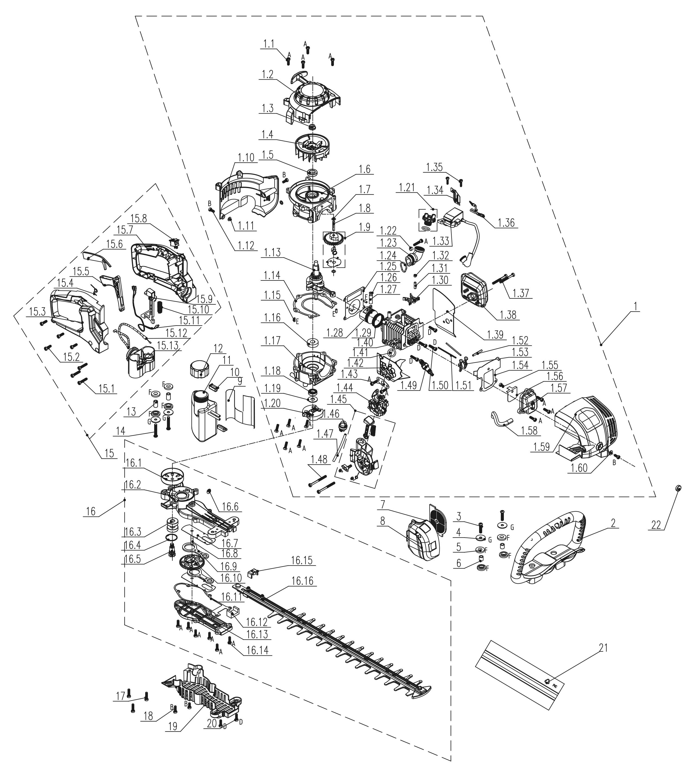
NO. | PART# | Description | Qty. | Model No. Applied
1 | 103001000330 | Engine 26.5CC | 1 | HT4QL-L
1.1 | 207421000003 | Screw M5*16 | 15 | GTC4QL-L、GTS4QL-L、GTS4QL-M2、GTBCU4QL-M、BLV4QL-M、CSP4QL-L、ACSP01、HT4QL-L、BL4QL-L、HT4QL-L、ACSP01、HT4QL-L
1.2 | 199096000123 | Recoil assembly | 1 | HT4QL-L
1.3 | 8NG-08D | Nut M8 | 1 | HT4QL-L、CS4QL-L1、CS4QL-L3、CSE15-M、CSE12-M、CSX2-M1-0、HTX6-M-0、CSE10-L、CSPE6.5-M、ACSP01
1.4 | 201088000017 | Flywheel | 1 | HT4QL-L
1.5 | 8208-981503-0100020 | Oil seal | 1 | CSP4QL-L、GTS4QL-M2、GTBCU4QL-M、GTC4QL-L、GTS4QL-L、TL4QL-L1、CS4QL-L1、BLB4QL-M、BL4QL-L、HT4QL-L、BLV4QL-M、CS4QL-L3
1.6 | 201126000107 | Crankcase | 1 | GTC4QL-L、GTS4QL-L、HT4QL-L、CSP4QL-L、BL4QL-L
1.7 | 8208-981502-0000000 | Cam washer | 2 | HT4QL-L、BLV4QL-M、BL4QL-L、TL4QL-L1、GTC4QL-L、GTS4QL-L、GTS4QL-M2、GTBCU4QL-M、CSP4QL-L
1.8 | 201026000354 | Shaft | 1 | GTC4QL-L、GTS4QL-L、CSP4QL-L、BL4QL-L、TL4QL-L1、HT4QL-L
1.9 | 199999001280 | Timing gear assembly | 1 | GTC4QL-L、GTS4QL-L、GTS4QL-M2、GTBCU4QL-M、CSP4QL-L、HT4QL-L
1.10 | 202030001421 | Shroud cover | 1 | HT4QL-L
1.11 | 8208-982002-0000010 | Red steel paper mat | 2 | HT4QL-L、GTS4QL-M2、GTBCU4QL-M、CS4QL-L1、CS4QL-L3
1.12 | 8SJJD05-12D | Screw T25 M5*12 | 3 | HT4QL-L、CSP4QL-L、CS4QL-L1、BLV4QL-M、CS4QL-L3、BL4QL-L、TL4QL-L1、CS4QL-L1、CS4QL-L3、BLB4QL-M、HT4QL-L、GTS4QL-M2、GTBCU4QL-M、GTC4QL-L、GTS4QL-L
1.13 | 8606-930501-0000000 | Crank shaft | 1 | HT4QL-L
1.14 | 299999000483 | Crankcase gasket | 1 | GTC4QL-L、GTS4QL-L、GTS4QL-M2、GTBCU4QL-M、CSP4QL-L、HT4QL-L、BLV4QL-M、BL4QL-L
1.15 | 8PC40-10D | Pin | 4 | GTS4QL-M2、GTC4QL-L、GTS4QL-L、GTBCU4QL-M、CSP4QL-L、HT4QL-L、BL4QL-L、BLV4QL-M
1.16 | 207390200006 | Bearing 6001 | 1 | GTBCU4QL-M、CSP4QL-L、BL4QL-L、HT4QL-L、GTS4QL-M2、GTC4QL-L、GTS4QL-L
1.17 | 201126000111 | Crankcase | 1 | HT4QL-L
1.18 | 8208-982001-0000010 | Oil seal | 1 | BL4QL-L、CSP4QL-L、HT4QL-L、BLV4QL-M、GTS4QL-L、GTS4QL-M2、GTBCU4QL-M、GTC4QL-L
1.19 | 8202-967402-0000000 | Flat Washer | 1 | BL4QL-L、BLV4QL-M、HT4QL-L、GTS4QL-M2、GTBCU4QL-M、CSP4QL-L、GTC4QL-L、GTS4QL-L
1.20 | 199999001578 | Clutch assembly | 1 | HT4QL-L
1.21 | 199999001396 | Oil dipstick | 1 | HT4QL-L、BLV4QL-M、BL4QL-L、GTC4QL-L、GTS4QL-L、GTS4QL-M2、GTBCU4QL-M、CSP4QL-L
1.22 | 8066-903201-0000000 | Air filter bushing | 1 | BLV4QL-M、BL4QL-L、CS4QL-L3、BLV4QL-M、CS4QL-L1、GTC4QL-L、GTS4QL-L、BL4QL-L、BLB4QL-M、CSP4QL-L、CS4QL-L1、CS4QL-L3、HT4QL-L、HT4QL-L
1.23 | 202019000223 | Connector | 1 | HT4QL-L
1.24 | 207270200006 | O Ring | 1 | HT4QL-L
1.25 | 8341-981501-0000010 | Cylinder gasket | 1 | BLV4QL-M、BL4QL-L、HT4QL-L、GTS4QL-M2、GTBCU4QL-M、CSP4QL-L、GTC4QL-L、GTS4QL-L
1.26 | 8204-981001-0000000 | Piston pin Retaining ring | 2 | BL4QL-L、BLV4QL-M、HT4QL-L、CSP4QL-L、GTC4QL-L、GTS4QL-L、GTS4QL-M2、GTBCU4QL-M
1.27 | 8605-982001-0000000 | Piston pin 25.5mm | 1 | GTC4QL-L、GTS4QL-L、CSP4QL-L、BL4QL-L、HT4QL-L
1.28 | 201109000039 | Piston 26CC | 1 | CSP4QL-L、BL4QL-L、HT4QL-L、GTC4QL-L、GTS4QL-L
1.29 | 201110000044 | Piston ring 26cc | 1 | GTC4QL-L、GTS4QL-L、CSP4QL-L、BL4QL-L、HT4QL-L
1.30 | 8188-981501-0000000 | Lower rocker arm | 2 | BLB4QL-M、CSP4QL-L、GTS4QL-M2、GTBCU4QL-M、CS4QL-L3、TL4QL-L1、BL4QL-L、CS4QL-L1、HT4QL-L、BLV4QL-M、GTC4QL-L、GTS4QL-L
1.31 | 8086-981503-0000000 | Pin Shaft | 1 | GTC4QL-L、GTS4QL-L、GTS4QL-M2、GTBCU4QL-M、CSP4QL-L、HT4QL-L、BLV4QL-M、CS4QL-L1、CS4QL-L3、TL4QL-L1、BL4QL-L、BLB4QL-M
1.32 | 8SHCD06-05D | Screw M6*5 | 1 | BLB4QL-M、TL4QL-L1、CS4QL-L3、HT4QL-L、BLV4QL-M、CS4QL-L1、BL4QL-L、GTC4QL-L、GTS4QL-L、GTS4QL-M2、GTBCU4QL-M、CSP4QL-L
1.33 | 199037000050 | Ignition coil | 1 | BL4QL-L、GTC4QL-L、GTS4QL-L、CSP4QL-L、HT4QL-L
1.34 | 8181-950204-0000000 | Draught board | 1 | BLV4QL-M、BL4QL-L、GTC4QL-L、GTS4QL-L、GTS4QL-M2、GTBCU4QL-M、CSP4QL-L、HT4QL-L
1.35 | 8SJJD04-16D | Screw T20 M4*16 | 2 | BLV4QL-M、GTS4QL-M2、GTBCU4QL-M、GTC4QL-L、GTS4QL-L、BL4QL-L、BLB4QL-M、CSP4QL-L、HT4QL-L
1.36 | 199999001317 | Kill wire | 1 | CSP4QL-L、HT4QL-L、GTC4QL-L、GTS4QL-L、GTS4QL-M2、GTBCU4QL-M
1.37 | 8SJJD05-45D | Screw T25 M5*45 | 2 | GTS4QL-M2、GTBCU4QL-M、CSP4QL-L、GTC4QL-L、GTS4QL-L、BL4QL-L、HT4QL-L、BLV4QL-M
1.38 | 8614-930501-0000000 | Muffler | 1 | HT4QL-L
1.39 | 8341-930501-0000000 | Muffler gasket | 1 | HT4QL-L
1.40 | 199999001376 | Cylinder head | 1 | BL4QL-L、CSP4QL-L、HT4QL-L、GTC4QL-L、GTS4QL-L
1.41 | 299999000412 | Gasket | 1 | CSP4QL-L、BL4QL-L、GTS4QL-M2、GTBCU4QL-M、GTC4QL-L、GTS4QL-L、HT4QL-L、BLV4QL-M
1.42 | 202999001713 | Insulator | 1 | HT4QL-L
1.43 | 8341-981503-0000010 | Insulator gasket | 1 | GTS4QL-M2、GTBCU4QL-M、HT4QL-L、BLV4QL-M、BL4QL-L
1.44 | 199064000079 | Carburetor | 1 | HT4QL-L
1.45 | 199999001415 | Choke assembly | 1 | HT4QL-L
1.46 | 199121000011 | Primer bulb | 1 | CS4QL-L3、HT4QL-L、CS4QL-L1
1.47 | 234-1004 | Fuel pipe | 0.09 | CSP4QL-L、BLV4QL-M、BL4QL-L、CS4QL-L1、CS4QL-L3、HT4QL-L、BLB4QL-M、TL4QL-L1、HT4QL-L、GTS4QL-M2、GTBCU4QL-M、GTC4QL-L、GTS4QL-L
1.48 | 8SJJD05-55D | Screw T25 M5*55 | 2 | TL4QL-L1、BLB4QL-M、BL4QL-L、GTBCU4QL-M、HT4QL-L、BLV4QL-M、GTC4QL-L、GTS4QL-L、GTS4QL-M2、CSP4QL-L
1.49 | CMR5H | Spark plug | 1 | GTBCU4QL-M、BL4QL-L、HT4QL-L、BLV4QL-M、TL4QL-L1、GTS4QL-M2、GTC4QL-L、GTS4QL-L、CSP4QL-L
1.50 | 8SJJD05-20D | Screw T25 M5*20 | 4 | GTBCU4QL-M、CS4QL-L3、GTC4QL-L、GTS4QL-L、GTS4QL-M2、GTS4QL-M2、GTBCX6-M-0、CS4QL-L1、CS4QL-L1、CS4QL-L3、HT4QL-L、CSP4QL-L、GTBCU4QL-M、BL4QL-L、HT4QL-L、BLV4QL-M
1.51 | 8087-981501-0000000 | Tappet | 2 | HT4QL-L、GTS4QL-M2、GTBCU4QL-M、BLV4QL-M、CSP4QL-L、GTC4QL-L、GTS4QL-L、BL4QL-L
1.52 | 8086-981502-0000000 | Pin Shaft | 1 | HT4QL-L、GTC4QL-L、GTS4QL-L、GTS4QL-M2、GTBCU4QL-M、BLV4QL-M、BL4QL-L、CSP4QL-L
1.53 | 8188-981503-0000000 | Rocker arm assembly | 2 | GTC4QL-L、GTS4QL-L、GTS4QL-M2、GTBCU4QL-M、CSP4QL-L、HT4QL-L、BLV4QL-M、BL4QL-L、CS4QL-L1、CS4QL-L3、TL4QL-L1、BLB4QL-M
1.54 | 299999000406 | Cylinder head gasket | 1 | HT4QL-L
1.55 | 8SJJD05-08D | Screw T25 M5*8 | 1 | HT4QL-L、GTC4QL-L、GTS4QL-L、CSP4QL-L
1.56 | 8181-981503-0000010 | Oil baffle | 1 | GTC4QL-L、GTS4QL-L、CSP4QL-L、HT4QL-L
1.57 | 8602-981503-0000000 | Valve cover | 1 | GTS4QL-M2、GTBCU4QL-M、CSP4QL-L、GTC4QL-L、GTS4QL-L、BL4QL-L、HT4QL-L、BLV4QL-M
1.58 | 202094000222 | Pipe | 1 | TL4QL-L1、GTS4QL-M2、GTBCU4QL-M、CSP4QL-L、BL4QL-L、HT4QL-L、BLV4QL-M、GTC4QL-L、GTS4QL-L
1.59 | 202030001559 | Cylinder cover | 1 | HT4QL-L
1.60 | 8202-000004-0000000 | Gasket | 1 | GTSX5-M、GTSX5-M-0、BLAGTX5-M、HT4QL-L、HT4QL-L
2 | 202024002122 | Handle | 1 | HT4QL-L
3 | 8SJJD06-25D | Screw T25 M6*25 | 2 | HT4QL-L
4 | 207050100035 | Flat Washer | 4 | HT4QL-L
5 | 202017000068 | Damping gasket | 8 | HT4QL-L
6 | 8066-930501-0000000 | Tube | 2 | HT4QL-L
7 | 299999000407 | Air filter | 1 | HT4QL-L、GTC4QL-L、GTS4QL-L、CSP4QL-L
8 | 202030001422 | Air filter cover | 1 | HT4QL-L
9 | 8322-982001-0000010 | Fuel tank Insulation film | 1 | BLV4QL-M、CSP4QL-L、GTC4QL-L、GTS4QL-L、BL4QL-L、HT4QL-L
10 | 202017000069 | A/V rubber | 1 | HT4QL-L、GTBCU4QL-M、CSP4QL-L、BL4QL-L、BLV4QL-M、GTS4QL-M2、GTC4QL-L、GTS4QL-L
11 | 199124000267 | Fuel tank assembly | 1 | HT4QL-L
12 | 199123000525 | Fuel tank cap assembly | 1 | BLV4QL-M、BL4QL-L、GTBCU4QL-M、GTS4QL-M2、HT4QL-L、GTC4QL-L、GTS4QL-L、CSP4QL-L、BLB4QL-M
13 | 201999001343 | Tube | 2 | HT4QL-L
14 | 207421000002 | Screw M6*30 | 2 | HT4QL-L
15 | 199004000664 | Handle assembly | 1 | HT4QL-L
15.1 | 8SJJB50-25D | Self-tapping screw ST5*25 | 3 | GTC4QL-L、GTS4QL-L、HT4QL-L、CSP4QL-L
15.2 | 8SJJB50-16D | Self-tapping screw ST5*16 | 4 | BL4QL-L、HT4QL-L、BLB4QL-M、BLV4QL-M
15.3 | 202024002123 | Handle | 1 | HT4QL-L
15.4 | 8342-930502-0000000 | Trigger Torsional spring | 1 | HT4QL-L
15.5 | 202004000966 | Trigger | 1 | HT4QL-L
15.6 | 202999001759 | Control arm | 1 | HT4QL-L
15.7 | 202024001933 | Handle | 1 | HT4QL-L
15.8 | 207180200046 | Kill switch | 1 | GTS4QL-L、GTS4QL-M2、TL4QL-L1、HT4QL-L、BLV4QL-M、BL4QL-L、CS4QL-L1、CS4QL-L3、BLB4QL-M、CSP4QL-L、GTC4QL-L
15.9 | 202071000032 | Locating block | 1 | HT4QL-L
15.10 | 8342-930501-0000000 | Trigger Assy | 1 | HT4QL-L
15.11 | 8413-930501-0000010 | Kill wire | 1 | HT4QL-L
15.12 | 8413-930502-0000010 | Throttle Assy | 1 | HT4QL-L
15.13 | 202090000172 | Fixed seat | 1 | HT4QL-L
16 | 199999001569 | Blade assembly | 1 | HT4QL-L
16.1 | 8136-930501-0000000 | Clutch drum | 1 | HT4QL-L
16.2 | 201006000076 | Gear Box | 1 | HT4QL-L
16.3 | 8BC-281208-ST | 6001Z Bearing | 2 | HT4QL-L
16.4 | 8CA-28B | Retaining Ring | 1 | GTBCU4QL-M、GTS4QL-L、GTS4QL-M2、HT4QL-L、GTBCX6-M-0
16.5 | 201004000491 | Gear | 1 | HT4QL-L
16.6 | 8065-931302-0000000 | Grease zerk M6 | 1 | ACSP01、HT4QL-L
16.7 | 8181-930501-0000000 | Anti-friction pad | 2 | HT4QL-L
16.8 | 8086-930501-0000000 | Countershaft | 1 | HT4QL-L
16.9 | 201053000123 | Connecting Rod | 2 | HT4QL-L
16.10 | 201004000492 | Gear | 1 | HT4QL-L
16.11 | 8208-930501-0000010 | Gear Box Gasket | 1 | HT4QL-L
16.12 | 8349-930501-0000010 | Felt | 1 | HT4QL-L
16.13 | 8020-930501-0000000 | Gear Box cover | 1 | HT4QL-L
16.14 | 207421000003 | Screw M5*16 | 6 | GTC4QL-L、GTS4QL-L、GTS4QL-M2、GTBCU4QL-M、BLV4QL-M、CSP4QL-L、ACSP01、HT4QL-L、BL4QL-L、HT4QL-L、ACSP01、HT4QL-L
16.15 | 8301-930501-0001710 | Oil block | 1 | HT4QL-L
16.16 | 199029000279 | Blade assembly | 1 | HT4QL-L
17 | 8SJEP05-23D | Screw and Flat Washer assembly M5*23 | 3 | HT4QL-L
18 | 8SJJD05-20D | Screw T25 M5*20 | 2 | GTBCU4QL-M、CS4QL-L3、GTC4QL-L、GTS4QL-L、GTS4QL-M2、GTS4QL-M2、GTBCX6-M-0、CS4QL-L1、CS4QL-L1、CS4QL-L3、HT4QL-L、CSP4QL-L、GTBCU4QL-M、BL4QL-L、HT4QL-L、BLV4QL-M
19 | 202030001354 | Shroud cover | 1 | HT4QL-L
20 | 8SJJD05-12D | Screw T25 M5*12 | 2 | HT4QL-L、CSP4QL-L、CS4QL-L1、BLV4QL-M、CS4QL-L3、BL4QL-L、TL4QL-L1、CS4QL-L1、CS4QL-L3、BLB4QL-M、HT4QL-L、GTS4QL-M2、GTBCU4QL-M、GTC4QL-L、GTS4QL-L
21 | 202009000217 | Cutter sleeve | 1 | HT4QL-L
22 | 8208-982003-0000020 | Rubber plug | 1 | GTC4QL-L、GTS4QL-L、GTS4QL-M2、GTBCU4QL-M、CSP4QL-L、HT4QL-L、BLV4QL-M、BL4QL-L、TL4QL-L1

