Model：LSPG-L2
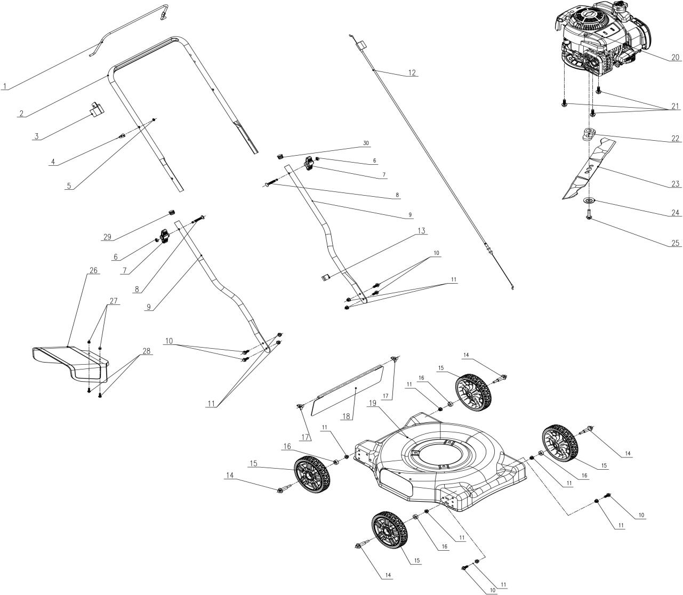
NO. | PART# | Description | Qty. | Model No. Applied
1 | 201120000095 | Bail | 1 | LSPG-L2、LSPG-L3、LSPG-M3、LSPG-M4、LSPG-M5、LSPG-M6、LSPG-M7
2 | 201139000137 | Upper handle | 1 | LSPG-L2、LSPG-L3、LSPG-M3、LSPG-M4、LSPG-M5、LSPG-M6、LSPG-M7
3 | 202090000303 | Bail holder | 1 | LSPG-L2、LSPG-L3、LSPG-M3、LSPG-M4、LSPG-M5、LSPG-M6、LSPG-M7
4 | 201096000013 | Rope guide | 1 | LSPG-L2、LSPG-L3、LSPG-M3、LSPG-M4、LSPG-M5、LSPG-M6、LSPG-M7、LSSG-M1、STMG-L
5 | 8NE-05D01 | Nut M5 | 1 | LPPX5-L、LPPX5-M、LSPG-L2、LSPG-L3、LSPG-M3、LSPG-M4、LSPG-M5、LSPG-M6、LSPG-M7、LSSG-M1、STMG-L
6 | 8NA-08D | Nut M8 | 2 | BLB4QL-M、LSPG-L2、LSPG-L3、LSPG-M3、LSPG-M4、LSPG-M5、LSPG-M6、LSPG-M7、LSSG-M1、SDE15-L、STE15-M、STE15-M1、STMG-L、STX2-M
7 | 207220200007 | Bolt 3/8" | 1 | LSPG-L2、LSPG-L3、LSPG-M3、LSPG-M4、LSPG-M5、LSPG-M6、LSPG-M7、LSSG-M1
8 | 207221100011 | Bolt M8*60.5 | 2 | LSPG-L2、LSPG-L3、LSPG-M3、LSPG-M4、LSPG-M5、LSPG-M6、LSPG-M7、LSSG-M1
9 | 201139000133 | Lower handle | 2 | LSPG-L2
10 | 8SQDD08-20D | Bolt M8*20 | 6 | LSPG-L2
11 | 8NE-08D01 | Nut M8 | 10 | LSPG-L2、LSPG-L3、LSPG-M3、LSPG-M4、LSPG-M5、LSPG-M6、LSPG-M7、LSSG-M1、STMG-L
12 | 199081000149 | Stop cable | 1 | LSPG-L2、LSPG-L3、LSPG-M3、LSPG-M4、LSPG-M5、LSPG-M6、LSPG-M7
13 | 8204-915401-0000120 | Cable holder | 1 | LSPG-L2、LSPG-L3、LSPG-M3、LSPG-M4、LSPG-M5、LSPG-M6、LSPG-M7、LSSG-M1
14 | 201026000495 | Wheel bolt M8 | 4 | LSPG-L2
15 | 207150100035 | Wheel | 4 | LSPG-L2、LSPG-L3
16 | 207280100072 | Spacer | 4 | LSPG-L2
17 | 201117000013 | Clasp | 2 | LSPG-L2、LSPG-L3
18 | 202006000119 | Rear Flap | 1 | LSPG-L2、LSPG-L3
19 | 201050000165 | Mower deck | 1 | LSPG-L2
20 | 103001000418 | Engine BS125cc | 1 | LSPG-L2、LSPG-L3
21 | 207220200003 | Bolt 3/8" | 3 | LSPG-L2、LSPG-L3、LSPG-M3、LSPG-M4、LSPG-M5、LSPG-M6、LSPG-M7、LSSG-M1
22 | 201101000076 | Blade adapter | 1 | LSPG-L2、LSPG-L3、LSPG-M3、LSPG-M4、LSPG-M5、LSPG-M6、LSPG-M7
23 | 201045000350 | Blade | 1 | LSPG-L2、LSPG-L3
24 | 207059900318 | Cupped washer | 1 | LSPG-L2、LSPG-L3、LSPG-M3、LSPG-M4、LSPG-M5、LSPG-M6、LSPG-M7、LSSG-M1
25 | 207250400033 | Knob M8 | 2 | LSPG-L2、LSPG-L3、LSPG-M3、LSPG-M4、LSPG-M5、LSPG-M6、LSPG-M7、LSSG-M1、STMG-L
26 | 202012000598 | Discharge chute | 1 | LSPG-L2
27 | 8207-981701-0000000 | Nut M6 | 2 | LSPG-L2
28 | 207430500002 | Bolt M6X18 | 2 | LSPG-L2
29 | 202015000343 | Pipe plug | 2 | LSPG-L2、LSPG-M3、LSPG-M4、LSPG-M5、LSPG-M6、LSPG-M7、LSSG-M1

