Model：LSPG-M4
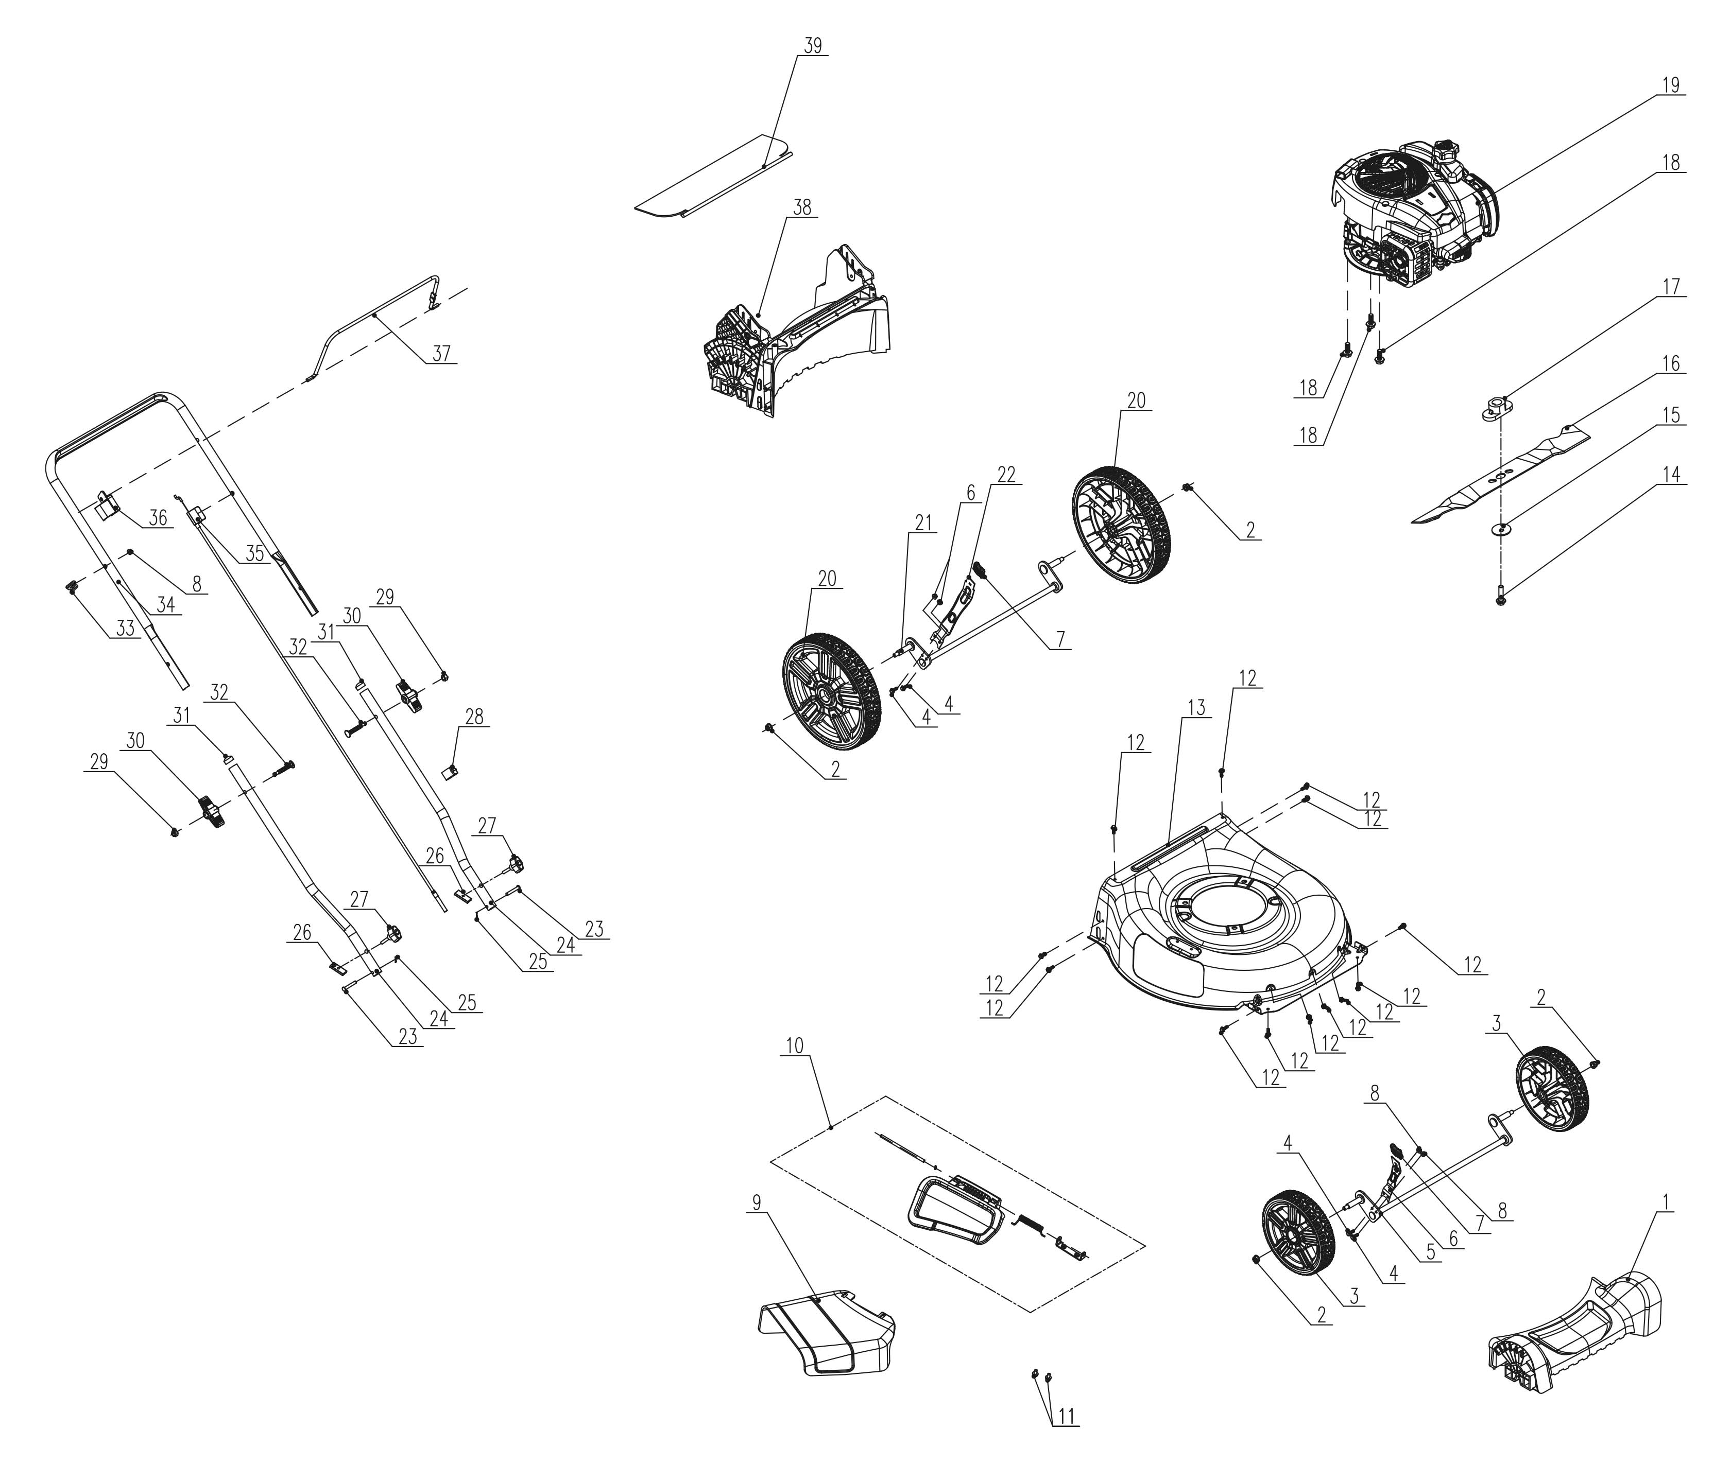
NO. | PART# | Description | Qty. | Model No. Applied
1 | 202033000530 | Front axle cover | 1 | LSPG-M3、LSPG-M4、LSPG-M5、LSPG-M6、LSPG-M7
2 | 8NE-08D01 | Nut M8 | 4 | LSPG-L2、LSPG-L3、LSPG-M3、LSPG-M4、LSPG-M5、LSPG-M6、LSPG-M7、LSSG-M1、STMG-L
3 | 207150100037 | Front wheel | 2 | LSPG-M3、LSPG-M4、LSPG-M5、LSPG-M6、LSPG-M7
4 | 8SQDD05-16D | Bolt M5*16 | 4 | LPPX5-L、LPPX5-M、LSPG-M3、LSPG-M4、LSPG-M5、LSPG-M6、LSPG-M7、LSSG-M1
5 | 199086000248 | Wheel Shaft assembly | 1 | LSPG-M3、LSPG-M4、LSPG-M5、LSPG-M6、LSPG-M7
6 | 201132000035 | Height adjusting lever | 1 | LSPG-M3、LSPG-M4、LSPG-M5、LSPG-M6、LSPG-M7、LSSG-M1
7 | 202024003070 | Handle | 2 | LSPG-L3、LSPG-M3、LSPG-M4、LSPG-M5、LSPG-M6、LSPG-M7、LSSG-M1
8 | 8NE-05D01 | Nut M5 | 5 | LPPX5-L、LPPX5-M、LSPG-L2、LSPG-L3、LSPG-M3、LSPG-M4、LSPG-M5、LSPG-M6、LSPG-M7、LSSG-M1、STMG-L
9 | 202006000120 | Discharge chute | 1 | LSPG-M3、LSPG-M4、LSPG-M5、LSPG-M6、LSPG-M7、LSSG-M1
10 | S202308345 | Mulch cover assembly | 1 | LSPG-M3、LSPG-M4、LSPG-M5、LSPG-M6、LSPG-M7、LSSG-M1、LSPG-M8
11 | 8SQDD06-10D | Bolt M6x10 | 2 | LSPG-M3、LSPG-M4、LSPG-M5、LSPG-M6、LSPG-M7、LSSG-M1
12 | 207229900294 | Screw ST6*20 | 13 | LSPG-M3、LSPG-M4、LSPG-M5、LSPG-M6、LSPG-M7、LSSG-M1
13 | 201050000169 | Mower deck | 1 | LSPG-M3、LSPG-M4、LSPG-M5、LSPG-M6、LSPG-M7
14 | 207220200007 | Bolt 3/8" | 1 | LSPG-L2、LSPG-L3、LSPG-M3、LSPG-M4、LSPG-M5、LSPG-M6、LSPG-M7、LSSG-M1
15 | 207059900318 | Cupped washer | 1 | LSPG-L2、LSPG-L3、LSPG-M3、LSPG-M4、LSPG-M5、LSPG-M6、LSPG-M7、LSSG-M1
16 | 201045000381 | Blade | 1 | LSPG-M3、LSPG-M4、LSPG-M5、LSPG-M6、LSPG-M7
17 | 201101000076 | Blade adapter | 1 | LSPG-L2、LSPG-L3、LSPG-M3、LSPG-M4、LSPG-M5、LSPG-M6、LSPG-M7
18 | 207220200003 | Bolt 3/8" | 3 | LSPG-L2、LSPG-L3、LSPG-M3、LSPG-M4、LSPG-M5、LSPG-M6、LSPG-M7、LSSG-M1
19 | 103001000399 | Engine BS,125cc | 1 | LSPG-M3、LSPG-M4
20 | 207150100038 | Rear wheel | 2 | LSPG-M4、LSPG-M6、LSPG-M7、LSSG-M1
21 | 199086000249 | Wheel Shaft assembly | 1 | LSPG-M4、LSPG-M6、LSPG-M7、LSSG-M1
22 | 201132000036 | Height adjusting lever | 1 | LSPG-M4、LSPG-M6、LSPG-M7、LSSG-M1
23 | 207199900240 | Pin | 2 | LSPG-M3、LSPG-M4、LSPG-M5、LSPG-M6、LSPG-M7、LSSG-M1
24 | 201139000136 | Lower handle | 2 | LSPG-M3、LSPG-M4、LSPG-M5、LSPG-M6、LSPG-M7、LSSG-M1
25 | 8091-911601-0100000 | R Pin | 2 | LPPX5-L、LPPX5-M、LSPG-M3、LSPG-M4、LSPG-M5、LSPG-M6、LSPG-M7、LSSG-M1
26 | 201047000179.00 | Fixed plate | 2 | SPG-M5,LSPG-M3,LSPG-M4,LSPG-M6,LSPG-M7
27 | 207250400034 | Knob | 2 | LSPG-M3、LSPG-M4、LSPG-M5、LSPG-M6、LSPG-M7、LSSG-M1
28 | 8204-915401-0000120 | Cable holder | 1 | LSPG-L2、LSPG-L3、LSPG-M3、LSPG-M4、LSPG-M5、LSPG-M6、LSPG-M7、LSSG-M1
29 | 8NA-08D | Nut M8 | 2 | BLB4QL-M、LSPG-L2、LSPG-L3、LSPG-M3、LSPG-M4、LSPG-M5、LSPG-M6、LSPG-M7、LSSG-M1、SDE15-L、STE15-M、STE15-M1、STMG-L、STX2-M
30 | 207250400033 | Knob | 2 | LSPG-L2、LSPG-L3、LSPG-M3、LSPG-M4、LSPG-M5、LSPG-M6、LSPG-M7、LSSG-M1、STMG-L
31 | 202015000343 | Pipe plug | 2 | LSPG-L2、LSPG-M3、LSPG-M4、LSPG-M5、LSPG-M6、LSPG-M7、LSSG-M1
32 | 207221100011 | Bolt M8 | 2 | LSPG-L2、LSPG-L3、LSPG-M3、LSPG-M4、LSPG-M5、LSPG-M6、LSPG-M7、LSSG-M1
33 | 201096000013 | Rope guide | 1 | LSPG-L2、LSPG-L3、LSPG-M3、LSPG-M4、LSPG-M5、LSPG-M6、LSPG-M7、LSSG-M1、STMG-L
34 | 201139000137 | Upper handle | 1 | LSPG-L2、LSPG-L3、LSPG-M3、LSPG-M4、LSPG-M5、LSPG-M6、LSPG-M7
35 | 199081000149 | Stop cable | 1 | LSPG-L2、LSPG-L3、LSPG-M3、LSPG-M4、LSPG-M5、LSPG-M6、LSPG-M7
36 | 202090000303 | Baul holder | 1 | LSPG-L2、LSPG-L3、LSPG-M3、LSPG-M4、LSPG-M5、LSPG-M6、LSPG-M7
37 | 201120000095 | bail | 1 | LSPG-L2、LSPG-L3、LSPG-M3、LSPG-M4、LSPG-M5、LSPG-M6、LSPG-M7
38 | 202031000889 | Rear baffle | 1 | LSPG-M4、LSPG-M6
39 | 202006000121 | Rear flap | 1 | LSPG-M3、LSPG-M4、LSPG-M5、LSPG-M6、LSPG-M7、LSSG-M1

