Model：LSPG-M5
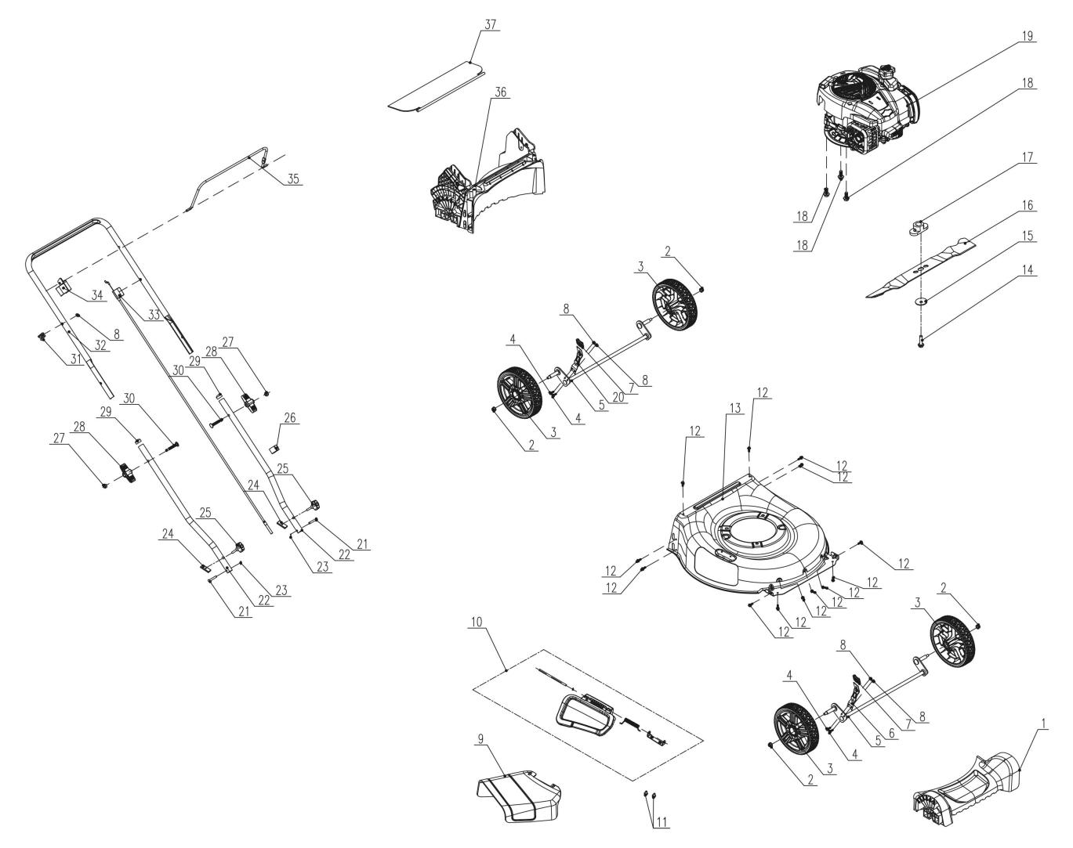
NO. | PART# | Description | Qty. | Model No. Applied
1 | 202033000530 | Front axle cover | 1 | LSPG-M5,LSPG-M6,LSPG-M3,LSPG-M7,LSPG-M8,LSPG-M4
2 | 8NE-08D01 | Nut M8 | 4 | LSSG-H1
3 | 207150100037 | Wheel | 4 | LSPG-M8,LSPG-M5,LSPG-M3,LSPG-M6,LSPG-M4,LSPG-M7
4 | 8SQDD05-16D | Bolt M5*16 | 4 | LSPG-M7,LSPG-M4,LSPG-M6,LSPG-M3,LSPG-M5,LSPG-M8,LPPX5-L,LPPX5-M,LSSG-M1
5 | 199086000248 | Wheel Shaft assembly | 2 | LSPG-M7,LSPG-M4,LSPG-M6,LSPG-M3,LSPG-M5,LSPG-M8
6 | 201132000035 | Height adjusting lever | 1 | LSSG-M1,LSPG-M7,LSPG-M4,LSPG-M6,LSPG-M3,LSPG-M5,LSPG-M8
7 | 202024003070 | Handle | 2 | LSPG-M8,LSPG-M5,LSPG-M3,LSPG-M6,LSSG-M1,LSPG-L3,LSPG-M7,LSPG-M4
8 | 8NE-05D01 | Nut M5 | 5 | LSSG-M1,LPPX5-L,LPPX5-M,LSPG-L3,LSPG-L2,LSPG-M7,LSPG-M4,LSPG-M6,LSPG-M3,LSPG-M5,STMG-L,LSPG-M8
9 | 202006000120 | Discharge chute | 1 | LSPG-M8,LSPG-M5,LSPG-M3,LSPG-M6,LSPG-M4,LSPG-M7,LSSG-M1
10 | S202308345 | Mulch cover assembly | 1 | LSSG-M1,LSPG-M4,LSPG-M7,LSPG-M3,LSPG-M5,LSPG-M6,LSPG-M8
11 | 8SQDD06-10D | Bolt M6x10 | 2 | LSSG-H2
12 | 207229900294 | Screw ST6*20 | 13 | LSPG-M5,LSPG-M3,LSPG-M6,LSPG-M4,LSPG-M7,LSSG-M1,LSPG-M8
13 | 201050000169 | Mower deck | 1 | LSPG-M7,LSPG-M4,LSPG-M6,LSPG-M3,LSPG-M5,LSPG-M8
14 | 207220200007 | Bolt 3/8"-24UNF,35mm | 1 | LSPG-M3,LSPG-M5,LSPG-M8,LSPG-L3,LSPG-L2,LSSG-M1,LSPG-M7,LSPG-M4,LSPG-M6
15 | 207059900318 | Cupped washer | 1 | LSPG-M8,LSPG-M5,LSPG-M3,LSPG-M6,LSSG-M1,LSPG-M7,LSPG-M4,LSPG-L2,LSPG-L3
16 | 201045000381 | Blade | 1 | LSPG-M8,LSPG-M5,LSPG-M3,LSPG-M6,LSPG-M4,LSPG-M7
17 | 201101000076 | Blade adapter | 1 | LSPG-L3,LSPG-L2,LSPG-M7,LSPG-M4,LSPG-M6,LSPG-M3,LSPG-M5,LSPG-M8
18 | 207220200003 | Bolt 3/8"-16UNC,25 | 3 | LSSG-H2
19 | 103001000400 | Engine BS 140cc | 1 | LSPG-M5,LSPG-M6
20 | 201132000037 | Height adjusting lever | 1 | LSPG-M3,LSPG-M5
21 | 207199900240 | Pin | 2 | LSPG-M6,LSPG-M3,LSPG-M5,LSPG-M8,LSSG-M1,LSPG-M7,LSPG-M4
22 | 201139000136 | Lower handle | 2 | LSSG-M1,LSPG-M7,LSPG-M4,LSPG-M6,LSPG-M8,LSPG-M5,LSPG-M3
23 | 8091-911601-0100000 | R Pin | 2 | LSSG-M1,LSPG-M7,LSPG-M4,LSPG-M6,LSPG-M3,LSPG-M5,LSPG-M8,LPPX5-L,LPPX5-M
24 | 201047000179 | Fixed plate | 2 | LSSG-H2
25 | 207250400034 | Knob | 2 | LSSG-M1,LSPG-M7,LSPG-M4,LSPG-M6,LSPG-M3,LSPG-M5,LSPG-M8
26 | 8204-915401-0000120 | Cable holder | 1 | LSPG-L3,LSPG-L2,LSSG-M1,LSPG-M7,LSPG-M4,LSPG-M6,LSPG-M3,LSPG-M5,LSPG-M8
27 | 8NA-08D | Nut M8 | 2 | STE15-M,STE15-M1,LSPG-L3,LSPG-L2,LSSG-M1,LSPG-M7,LSPG-M4,LSPG-M6,LSPG-M3,LSPG-M5,STX2-M,STMG-L,LSPG-M8,SDE15-L,BLB4QL-M
28 | 207250400033 | Knob | 2 | LSPG-M4,LSPG-L3,LSPG-L2,LSSG-M1,LSPG-M7,LSPG-M6,LSPG-M3,LSPG-M5,STMG-L,LSPG-M8
29 | 202015000343 | Pipe plug | 2 | LSPG-M8,LSPG-L2,LSSG-M1,LSPG-M7,LSPG-M4,LSPG-M6,LSPG-M3,LSPG-M5
30 | 207221100011 | Bolt M8 | 2 | LSPG-L3,LSPG-L2,LSSG-M1,LSPG-M7,LSPG-M4,LSPG-M6,LSPG-M3,LSPG-M5,LSPG-M8
31 | 201096000013 | Rope loop | 1 | LSPG-L2,LSSG-M1,LSPG-M7,LSPG-M4,LSPG-M6,LSPG-M3,LSPG-M5,LSPG-L3,STMG-L,LSPG-M8
32 | 201139000137 | Push rod | 1 | LSPG-M8,LSPG-M7,LSPG-L2,LSPG-L3,LSPG-M4,LSPG-M6,LSPG-M3,LSPG-M5
33 | 199081000149 | Stop Cable assembly | 1 | LSPG-M7,LSPG-L2,LSPG-L3,LSPG-M8,LSPG-M5,LSPG-M3,LSPG-M6,LSPG-M4
34 | 202090000303 | Bail holder | 1 | LSPG-L3,LSPG-L2,LSPG-M7,LSPG-M4,LSPG-M6,LSPG-M3,LSPG-M5,LSPG-M8
35 | 201120000095 | Bail | 1 | LSPG-M8,LSPG-M5,LSPG-M3,LSPG-M6,LSPG-M4,LSPG-M7,LSPG-L3,LSPG-L2
36 | 202031000891 | Rear baffle | 1 | LSPG-M5,LSPG-M3
37 | 202006000121 | Rear flap | 1 | LSSG-M1,LSPG-M8,LSPG-M5,LSPG-M3,LSPG-M6,LSPG-M4,LSPG-M7

