Model：LSSG-H1
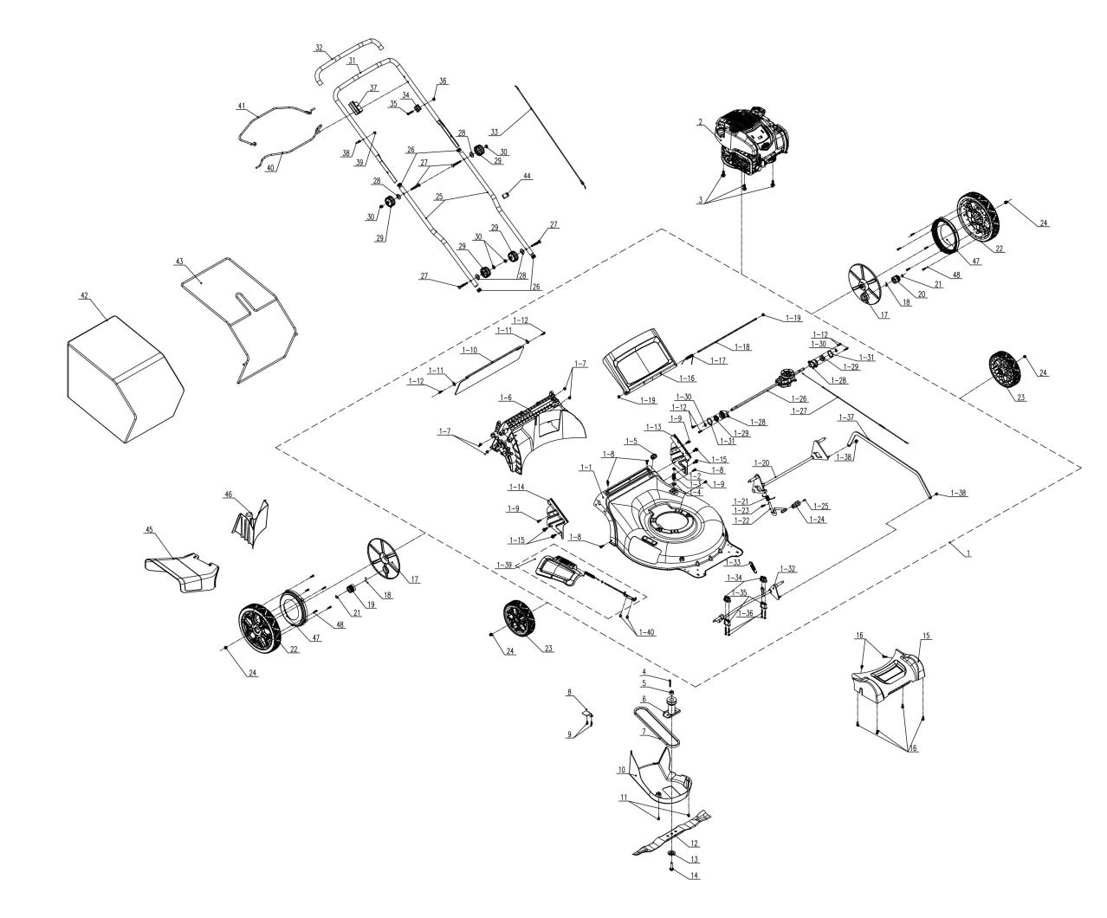
NO. | PART# | Description | Qty. | Model No. Applied
1 | 199002000959MX | 22"Deck assembly | 1 | LSSG-H1
1-1 | 201050000174MX | 22” Deck | 1 | LSSG-H1、LSSG-H2
1-2 | 8208-910101-0000020MX | Sealing ring | 1 | LSSG-H1、LSSG-H2
1-3 | 202019000258MX | Connector | 1 | LSSG-H1、LSSG-H2
1-4 | 207160200017MX | Nut M21 | 1 | LSSG-H1、LSSG-H2
1-5 | 8204-911810-0100120MX | Grommet | 1 | LSSG-H1、LSSG-H2
1-6 | 202065000174MX | Rear baffle | 1 | LSSG-H1、LSSG-H2
1-7 | 8NH-08DMX | Nut M8 | 4 | LSSG-H1、LSSG-H2
1-8 | 207229900294MX | Screw ST6*20 | 4 | LSSG-H1、LSSG-H2
1-9 | 207229900297MX | Screw ST6*12 | 3 | LSSG-H1、LSSG-H2
1-10 | 202006000124MX | Rear flap | 1 | LSSG-H1、LSSG-H2
1-11 | 207050100036MX | Flat Washer | 2 | LSSG-H1、LSSG-H2
1-12 | 8SJGB50-20DMX | Self-tapping screw ST5*20 | 6 | LSSG-H1、LSSG-H2
1-13 | 201084000055MX | Left lower handle bracket | 1 | LSSG-H1
1-14 | 201084000056MX | Right lower handle bracket | 1 | LSSG-H1
1-15 | 207319900010MX | Self-attack screw M8*20 | 4 | LSSG-H1、LSSG-H2
1-16 | 202033000534MX | Rear baffle cover | 1 | LSSG-H1、LSSG-H2
1-17 | 8342-517702-0000000MX | Rear cover Torsional spring | 1 | LSSG-H1、LSSG-H2
1-18 | 201026000503MX | Shaft | 1 | LSSG-H1、LSSG-H2
1-19 | 8NE-05D01MX | Nut M5 | 2 | LSSG-H1、LSSG-H2
1-20 | 199086000251MX | Wheel Shaft assembly | 1 | LSSG-H1、LSSG-H2
1-21 | 207010300086MX | Torsional spring | 1 | LSSG-H1、LSSG-H2
1-22 | 201132000038MX | Height adjusting lever | 1 | LSSG-H1、LSSG-H2
1-23 | 207190300001MX | Cotter pin | 1 | LSSG-H1、LSSG-H2
1-24 | 202024003076MX | Handle | 1 | LSSG-H1、LSSG-H2
1-25 | 8SJAD04-08DMX | Screw M4*8 | 1 | LSSG-H1、LSSG-H2
1-26 | 199134000015MX | Transmission | 1 | LSSG-H1
1-27 | 199081000154MX | Self-propel cable | 1 | LSSG-H1
1-28 | 202031000576MX | Bracket | 2 | LSSG-H1、LSSG-H2
1-29 | 8210-910602-0000000MX | Bearing | 2 | LSSG-H1、LSSG-H2
1-30 | 8CC-12BMX | Retaining ring | 2 | LSSG-H1、LSSG-H2
1-31 | 8CC-34BMX | Retaining ring | 2 | LSSG-H1、LSSG-H2
1-32 | 199086000252MX | Wheel Shaft assembly | 1 | LSSG-H1、LSSG-H2
1-33 | 207010500002MX | Spring | 1 | LSSG-H1、LSSG-H2
1-34 | 202090000304MX | Cable holder | 2 | LSSG-H1、LSSG-H2
1-35 | 202090000305MX | Screw | 2 | LSSG-H1、LSSG-H2
1-36 | 8SJGB50-45DMX | Self-tapping screw ST5*45 | 4 | LSSG-H1、LSSG-H2
1-37 | 201053000133MX | Connecting Rod | 1 | LSSG-H1、LSSG-H2
1-38 | 8NH-06DMX | Nut M6 | 2 | LSSG-H1、LSSG-H2
1-39 | S202308347 | Mulch cover assembly | 1 | LSSG-H2、LSSG-H1
1-40 | 8SQDD06-10DMX | Screw M6x10 | 2 | LSSG-H1、LSSG-H2
2 | 103001000403MX | Engine | 1 | LSSG-H1
3 | 207220200003MX | Bolt | 3 | LSSG-H1、LSSG-H2
4 | 8205-910803-0000000MX | Crankshaft key | 1 | LSSG-H1、LSSG-H2
5 | 8334-911602-0000000MX | Shaft sleeve | 1 | LSSG-H1、LSSG-H2
6 | 201101000078MX | Blade adapter | 1 | LSSG-H1、LSSG-H2
7 | 207130100002MX | Belt | 1 | LSSG-H1
8 | 201057000324MX | Plate | 1 | LSSG-H1
9 | 8SJGB50-20DMX | Self-tapping screw ST5*20 | 2 | LSSG-H1、LSSG-H2
10 | 202012000604MX | Belt Cover | 1 | LSSG-H1、LSSG-H2
11 | 8SJGN05-12DMX | Screw M5*12 | 2 | LSSG-H1、LSSG-H2
12 | 201045000365MX | Blade | 1 | LSSG-H1、LSSG-H2
13 | 207059900318MX | Cupped washer | 1 | LSSG-H1、LSSG-H2
14 | 8206-910601-0000000MX | Blade bolt (BS) | 1 | LSSG-H1、LSSG-H2
15 | 202033000535MX | Front axle cover | 1 | LSSG-H1、LSSG-H2
16 | 207229900294MX | Screw ST6*20, | 6 | LSSG-H1、LSSG-H2
17 | 202121000639MX | Wheel cover | 2 | LSSG-H1、LSSG-H2
18 | 8091-910101-0000000MX | Gear Pin | 2 | LSSG-H1、LSSG-H2
19 | 201004000439MX | Right self-propel gear | 1 | LSSG-H1
20 | 201004000438MX | Left self-propel gear | 1 | LSSG-H1
21 | 8CC-12BMX | Retaining ring for shaft | 2 | LSSG-H1、LSSG-H2
22 | 199088000186MX | Rear Wheel w/bearing | 2 | LSSG-H1、LSSG-H2
23 | 199088000187MX | Front Wheel w/bearing | 2 | LSSG-H1、LSSG-H2
24 | 8NE-08D01MX | Nut M8 | 4 | LSSG-H1、LSSG-H2
25 | 201139000140MX | Push plug | 2 | LSSG-H1
26 | 202015000343MX | Pipe plug | 4 | LSSG-H1、LSSG-H2
27 | 207221100011MX | Bolt M8 | 4 | LSSG-H1、LSSG-H2
28 | 8202-940304-0000002MX | Flat Washer | 4 | LSSG-H1、LSSG-H2
29 | 207259901014MX | Knob | 4 | LSSG-H1、LSSG-H2
30 | 8NA-08DMX | Nut M8 | 4 | LSSG-H1、LSSG-H2
31 | 201139000139MX | Push rod | 1 | LSSG-H1
32 | 8331-510502-0201020MX | Handle protective sleeve | 1 | LSSG-H1
33 | 199081000152MX | Stop cable assembly | 1 | LSSG-H1、LSSG-H2
34 | 8141-911602-0100120MX | Cable holder | 1 | LSSG-H1、LSSG-H2
35 | 8SFDD06-35DMX | Bolt M6*35 | 1 | LSSG-H1、LSSG-H2
36 | 8NH-06DMX | Nut M6 | 1 | LSSG-H1、LSSG-H2
37 | 202090000306MX | Bail holder | 1 | LSSG-H1、LSSG-H2
38 | 201096000013MX | Rope guide | 1 | LSSG-H1、LSSG-H2
39 | 8NE-05D01MX | Nut M5 | 1 | LSSG-H1、LSSG-H2
40 | 201120000101MX | Lower bail | 1 | LSSG-H1
41 | 201120000100MX | Upper bail | 1 | LSSG-H1
42 | 299001000146MX | Grass bag | 1 | LSSG-H1、LSSG-H2
43 | 201059000442MX | Grass bag frame | 1 | LSSG-H1、LSSG-H2
44 | 8204-915401-0000120MX | Cable holder | 1 | LSSG-H1、LSSG-H2
45 | 202006000123MX | Discharge chute | 1 | LSSG-H1、LSSG-H2
46 | 202072000025MX | Block | 1 | LSSG-H1、LSSG-H2
47 | 202050000008MX | Gear Ring | 2 | LSSG-H1
48 | 8SJGB40-20DMX | Self-tapping screw ST4*20 | 10 | LSSG-H1、LSSG-H2

