Model：LSSG-H2
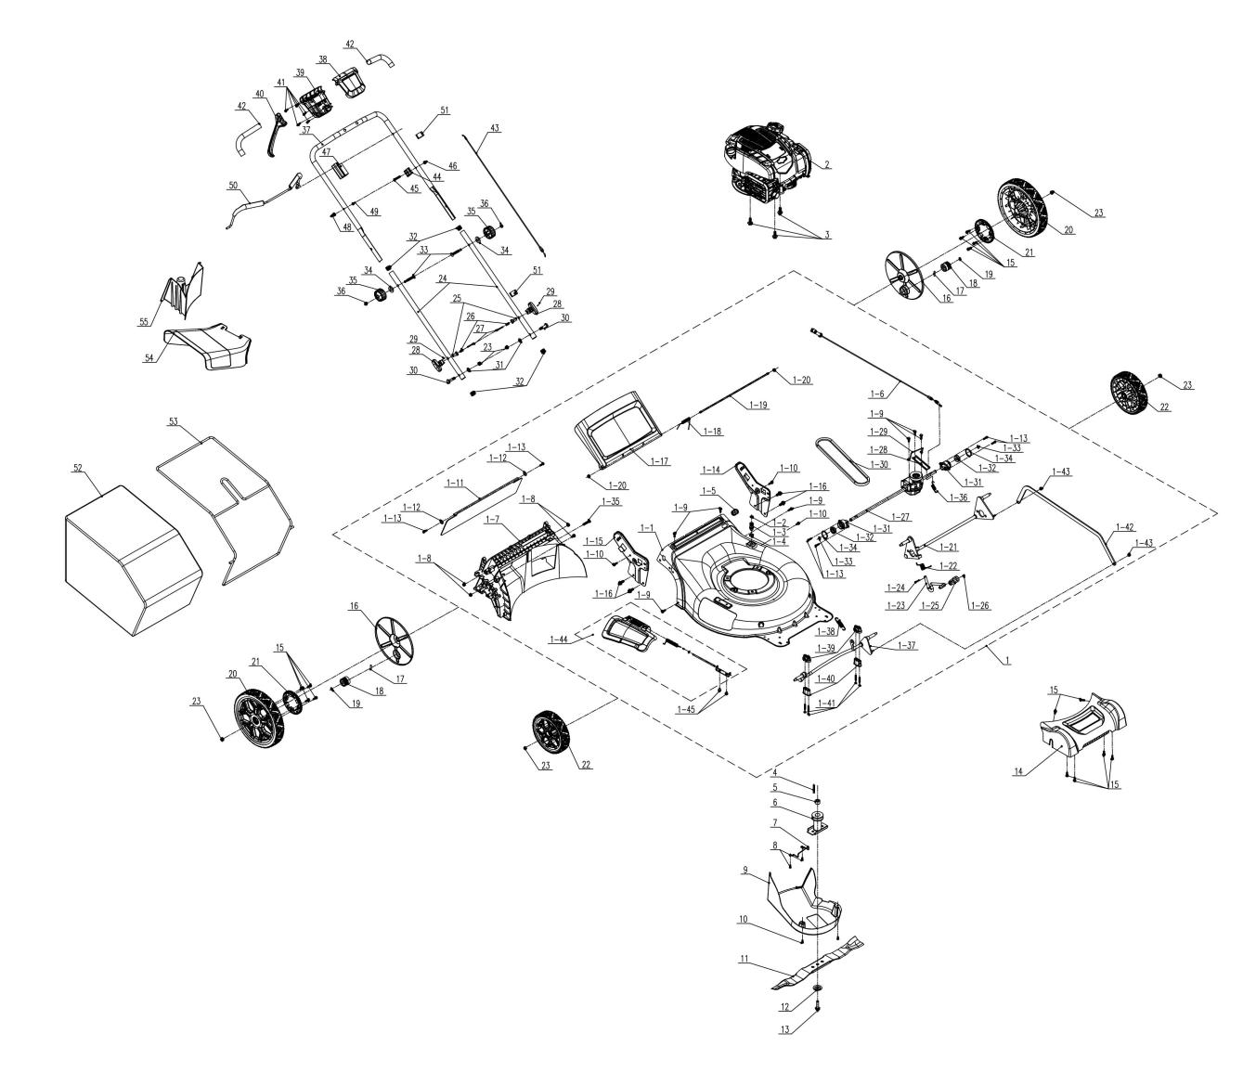
NO. | PART# | Description | Qty. | Model No. Applied
1 | 199002000958MX | Deck assembly 22" | 1 | LSSG-H2
1-1 | 201050000174MX | Deck | 1 | LSSG-H2,LSSG-H1
1-2 | 8208-910101-0000020MX | Sealing ring | 1 | LSSG-H1,LSSG-H2
1-3 | 202019000258MX | Connector | 1 | LSSG-H1,LSSG-H2
1-4 | 207160200017MX | Nut M21 | 1 | LSSG-H1,LSSG-H2
1-5 | 8204-911810-0100120MX | Grommet | 1 | LSSG-H1,LSSG-H2
1-6 | 199081000153MX | Self-propel cable | 1 | LSSG-H2
1-7 | 202065000174MX | Rear baffle | 1 | LSSG-H2,LSSG-H1
1-8 | 8NH-08DMX | Nut M8 | 4 | LSSG-H1,LSSG-H2
1-9 | 207229900294MX | Screw ST6*20 | 7 | LSSG-H1,LSSG-H2
1-10 | 207229900297MX | Screw ST6*12 | 3 | LSSG-H1,LSSG-H2
1-11 | 202006000124MX | Baffle plate | 1 | LSSG-H1,LSSG-H2
1-12 | 207050100036MX | Flat Washer | 2 | LSSG-H1,LSSG-H2
1-13 | 8SJGB50-20DMX | Self-tapping ST5*20 | 6 | LSSG-H1,LSSG-H2
1-14 | 201084000053MX | Left lower handle bracket | 1 | LSSG-H2
1-15 | 201084000054MX | Right lower handle bracket | 1 | LSSG-H2
1-16 | 207319900010MX | Self-tapping screw, M8*20 | 4 | LSSG-H1,LSSG-H2
1-17 | 202033000534MX | Rear baffle cover | 1 | LSSG-H1,LSSG-H2
1-18 | 8342-517702-0000000MX | Rear cover Torsional spring | 1 | LSSG-H1,LSSG-H2
1-19 | 201026000503MX | Shaft | 1 | LSSG-H1,LSSG-H2
1-20 | 8NE-05D01MX | Nut M5 | 2 | LSSG-H2,LSSG-H1
1-21 | 199086000251MX | Wheel Shaft assembly | 1 | LSSG-H1,LSSG-H2
1-22 | 207010300086MX | Torsional spring | 1 | LSSG-H2,LSSG-H1
1-23 | 201132000038MX | Height adjusting lever | 1 | LSSG-H1,LSSG-H2
1-24 | 207190300001MX | Cotter pin | 1 | LSSG-H2,LSSG-H1
1-25 | 202024003076MX | Handle | 1 | LSSG-H1,LSSG-H2
1-26 | 8SJAD04-08DMX | Screw M4*8 | 1 | LSSG-H2,LSSG-H1
1-27 | 199134000014MX | Transmission | 1 | LSSG-H2
1-28 | 201059000445MX | Bracket | 1 | LSSG-H2
1-29 | 201143000003MX | Limit wire | 1 | LSSG-H2
1-30 | 207130100004MX | Belt | 1 | LSSG-H2
1-31 | 202031000576MX | Bracket | 2 | LSSG-H2,LSSG-H1
1-32 | 8210-910602-0000000MX | Bearing | 2 | LSSG-H1,LSSG-H2
1-33 | 8CC-12BMX | Retaining ring | 2 | LSSG-H2,LSSG-H1
1-34 | 8CC-34BMX | Retaining ring | 2 | LSSG-H1,LSSG-H2
1-35 | 8SJGB60-35DMX | Self-tapping screw ST6*35 | 1 | LSSG-H2
1-36 | 207010500020MX | Spring | 1 | LSSG-H2
1-37 | 199086000252MX | Wheel Shaft assembly | 1 | LSSG-H2,LSSG-H1
1-38 | 207010500002MX | Spring | 1 | LSSG-H2,LSSG-H1
1-39 | 202090000304MX | Upper axle bearing | 2 | LSSG-H1,LSSG-H2
1-40 | 202090000305MX | Lower axle bearing | 2 | LSSG-H1,LSSG-H2
1-41 | 8SJGB50-45DMX | Self-tapping screw ST5*45 | 4 | LSSG-H2,LSSG-H1
1-42 | 201053000133MX | Connecting Rod | 1 | LSSG-H1,LSSG-H2
1-43 | 8NH-06DMX | Nut M6 | 2 | LSSG-H2,LSSG-H1
1-44 | S202308347 | Mulch cover assembly | 1 | LSSG-H2、LSSG-H1
1-45 | 8SQDD06-10DMX | Screw M6x10 | 2 | LSSG-H1,LSSG-H2
2 | 103001000422MX | Engine head assembly | 1 | LSSG-H2
3 | 207220200003MX | Bolt 3/8" | 1 | LSSG-H2,LSSG-H1
4 | 8205-910803-0000000MX | Crankshaft key | 1 | LSSG-H1,LSSG-H2
5 | 8334-911602-0000000MX | Shaft sleeve | 1 | LSSG-H1,LSSG-H2
6 | 201101000078MX | Blade adapter | 1 | LSSG-H1,LSSG-H2
7 | 201143000002MX | Limit wire | 1 | LSSG-H2
8 | 8SJGN05-10DMX | Screw M5*10 | 2 | LSSG-H2
9 | 202012000604MX | Protective Cover | 1 | LSSG-H2,LSSG-H1
10 | 8SJGN05-12DMX | Screw M5*12 | 2 | LSSG-H2,LSSG-H1
11 | 201045000365MX | Blade | 1 | LSSG-H1,LSSG-H2
12 | 207059900318MX | Blade washer | 1 | LSSG-H1,LSSG-H2
13 | 8206-910601-0000000MX | Blade bolt (BS) | 1 | LSSG-H2,LSSG-H1
14 | 202033000535MX | Front axle cover | 1 | LSSG-H1,LSSG-H2
15 | 207229900294MX | Screw ST6*20 | 14 | LSSG-H1,LSSG-H2
16 | 202121000639MX | Wheel cover | 2 | LSSG-H2,LSSG-H1
17 | 8091-910101-0000000MX | Gear Pin | 2 | LSSG-H2,LSSG-H1
18 | 201004000373MX | Gear | 2 | LSSG-H2
19 | 8CC-12BMX | Retaining ring | 2 | LSSG-H2,LSSG-H1
20 | 199088000186MX | Rear wheel | 2 | LSSG-H1,LSSG-H2
21 | 202002000076MX | Gear | 2 | LSSG-H2
22 | 199088000187MX | Front wheel | 2 | LSSG-H2,LSSG-H1
23 | 8NE-08D01MX | Nut M8 | 6 | LSSG-H1,LSSG-H2
24 | 201139000141MX | Lower handle | 2 | LSSG-H2
25 | 201101000079MX | Fixed seat | 2 | LSSG-H2
26 | 207010100110MX | Compression spring | 2 | LSSG-H2
27 | 207190400011MX | Pin Shaft | 2 | LSSG-H2
28 | 202028000199MX | Knob | 2 | LSSG-H2
29 | 207350300009MX | Pin | 2 | LSSG-H2
30 | 207220100027MX | Bolt M8 | 2 | LSSG-H2
31 | 8WF-08B-1802MX | Flat Washer Φ8 | 2 | LSSG-H2
32 | 202015000343MX | Pipe plug | 4 | LSSG-H2,LSSG-H1
33 | 207221100011MX | Bolt M8*60.5 | 2 | LSSG-H1,LSSG-H2
34 | 8202-940304-0000002MX | Flat Washer | 2 | LSSG-H2,LSSG-H1
35 | 207259901014MX | Knob M8 | 2 | LSSG-H1,LSSG-H2
36 | 8NA-08DMX | Nut M8 | 2 | LSSG-H1,LSSG-H2
37 | 201139000138MX | Upper Handle | 1 | LSSG-H2
38 | 202113000088MX | SP upper cover | 1 | LSSG-H2
39 | 202113000089MX | SP lower over | 1 | LSSG-H2
40 | 202004001223MX | Trigger | 1 | LSSG-H2
41 | 8SJGB40-20DMX | Self-tapping screw ST4*20 | 5 | LSSG-H1,LSSG-H2
42 | 207450100001MX | Protective sleeve | 2 | LSSG-H2
43 | 199081000152MX | Stop cable | 1 | LSSG-H1,LSSG-H2
44 | 8141-911602-0100120MX | Cable holder | 1 | LSSG-H1,LSSG-H2
45 | 8SFDD06-35DMX | Bolt M6*35 | 1 | LSSG-H1,LSSG-H2
46 | 8NH-06DMX | Nut M6 | 1 | LSSG-H2,LSSG-H1
47 | 202090000306MX | Bail Holder | 1 | LSSG-H2,LSSG-H1
48 | 201096000013MX | Fixed rod | 1 | LSSG-H2,LSSG-H1
49 | 8NE-05D01MX | Nut M5, | 1 | LSSG-H2,LSSG-H1
50 | 201120000098MX | Bail | 1 | LSSG-H2
51 | 8204-915401-0000120MX | Thread buckle | 2 | LSSG-H1,LSSG-H2
52 | 299001000146MX | Grass bag | 1 | LSSG-H1,LSSG-H2
53 | 201059000442MX | Grass bag frame | 1 | LSSG-H1,LSSG-H2
54 | 202006000123MX | Discharge chute | 1 | LSSG-H1,LSSG-H2
55 | 202072000025MX | Blocking block | 1 | LSSG-H1,LSSG-H2

