Model：LSSG-M1
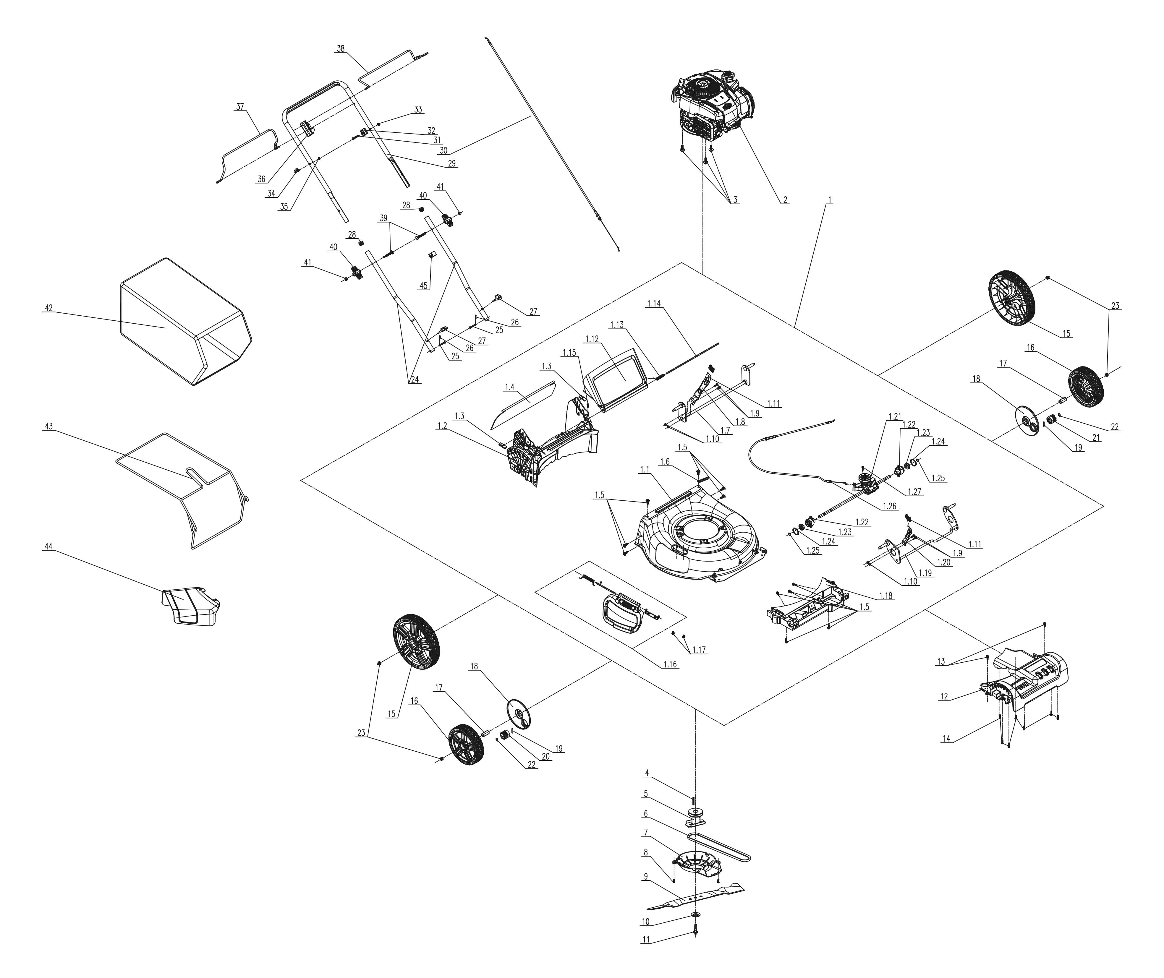
NO. | PART# | Description | Qty. | Model No. Applied
1 | 199002000951 | Mower deck assembly | 1 | LSSG-M1
1.1 | 201050000168 | Mower deck 21" | 1 | LSSG-M1
1.2 | 202031000890 | Rear baffle | 1 | LSSG-M1,LSPG-M7,LSPG-M8
1.3 | 201047000179 | Fixed plate | 2 | LSSG-H2
1.4 | 202006000121 | Rear flap | 1 | LSSG-M1,LSPG-M8,LSPG-M5,LSPG-M3,LSPG-M6,LSPG-M4,LSPG-M7
1.5 | 207229900294 | Self-tapping screw ST6*20 | 11 | LSPG-M5,LSPG-M3,LSPG-M6,LSPG-M4,LSPG-M7,LSSG-M1,LSPG-M8
1.6 | 8281-911801-0000100 | Winding clamp | 1 | LSSG-H2
1.7 | 199086000249 | Wheel Shaft assembly | 1 | LSPG-M6,LSPG-M7,LSPG-M4,LSSG-M1,LSPG-M8
1.8 | 201132000036 | Height adjusting lever | 1 | LSSG-M1,LSPG-M8,LSPG-M6,LSPG-M4,LSPG-M7
1.9 | 8SQDD05-16D | Bolt M5*16 | 4 | LSPG-M7,LSPG-M4,LSPG-M6,LSPG-M3,LSPG-M5,LSPG-M8,LPPX5-L,LPPX5-M,LSSG-M1
1.10 | 8NE-05D01 | Nut M5 | 4 | LSSG-M1,LPPX5-L,LPPX5-M,LSPG-L3,LSPG-L2,LSPG-M7,LSPG-M4,LSPG-M6,LSPG-M3,LSPG-M5,STMG-L,LSPG-M8
1.11 | 202024003070 | Handle ABS | 2 | LSPG-M8,LSPG-M5,LSPG-M3,LSPG-M6,LSSG-M1,LSPG-L3,LSPG-M7,LSPG-M4
1.12 | 202033000531 | Rear baffle cover | 1 | LSSG-M1,LSPG-M8,LSPG-M7
1.13 | 8342-517702-0000000 | Rear cover Torsional spring | 1 | LSSG-M1,LSPG-M7,LSPG-M8
1.14 | 201026000499 | Shaft | 1 | LSSG-M1,LSPG-M8,LSPG-M7
1.15 | 8SJAB40-14D | Self-tapping screw ST4*14 | 1 | CSPE6.5-M,LPPX5-L,LPPX5-M,LSPG-M7,LSPG-M8,GTSX5-M,BLAX5-M,CHX5,BLAGTX5-M,LSSG-M1
1.16 | S202308345 | Mulch cover assembly | 1 | LSSG-M1,LSPG-M4,LSPG-M7,LSPG-M3,LSPG-M5,LSPG-M6,LSPG-M8
1.17 | 8SQDD06-10D | Bolt M6x10 | 2 | LSSG-H2
1.18 | 202065000173 | Front axle holder | 1 | LSSG-M1
1.19 | 199086000247 | Wheel Shaft assembly | 1 | LSSG-M1
1.20 | 201132000035 | Height adjusting lever | 1 | LSSG-M1,LSPG-M7,LSPG-M4,LSPG-M6,LSPG-M3,LSPG-M5,LSPG-M8
1.22 | 202031000576 | Bracket | 2 | LSSG-M1
1.23 | 8210-910602-0000000 | Bearing | 2 | LSSG-M1
1.21 | 199134000013 | Transmission | 1 | LSSG-M1
1.24 | 8CC-34B | Retaining ring | 2 | LSSG-M1
1.25 | 8CC-12B | Retaining ring | 2 | LSSG-M1
1.26 | 199081000150 | Self-propel cable | 1 | LSSG-H2
1.27 | 8SJJB50-20D | Self-tapping screw | 1 | LSSG-H2
2 | 103001000402 | Engine BS150cc | 1 | LSSG-H2
3 | 207220200003 | Bolt 3/8" | 3 | LSSG-H2
4 | 8205-910803-0000000 | Crankshaft key | 1 | LSSG-H2
5 | 201101000077 | Blade holder | 1 | LSSG-H2
6 | 8345-911602-0000020 | Belt | 1 | LSSG-M1
7 | 202012000600 | Protective Cover | 1 | LSSG-H2
8 | 207429900011 | Self-tapping screw M5*16 | 2 | LSSG-H2
9 | 201045000382 | Blade | 1 | LSSG-M1
10 | 207059900318 | Washer | 1 | LSPG-M8,LSPG-M5,LSPG-M3,LSPG-M6,LSSG-M1,LSPG-M7,LSPG-M4,LSPG-L2,LSPG-L3
11 | 207220200007 | Bolt 3/8" | 1 | LSPG-M3,LSPG-M5,LSPG-M8,LSPG-L3,LSPG-L2,LSSG-M1,LSPG-M7,LSPG-M4,LSPG-M6
12 | 202030002074 | Shroud cover | 1 | LSSG-H2
13 | 207229900294 | Self-tapping screw ST6*20 | 2 | LSPG-M5,LSPG-M3,LSPG-M6,LSPG-M4,LSPG-M7,LSSG-M1,LSPG-M8
14 | 8SJJB50-20D | Self-tapping screw ST5*20 | 7 | LSSG-H2
15 | 207150100038 | Rear wheel | 2 | LSPG-L3
16 | 207150100036 | Front wheel | 2 | LSPG-L3
17 | 207280100073 | Shaft sleeve | 2 | LSPG-L3
18 | 202012000601 | Protective Cover | 2 | LSPG-L3
19 | 8091-910101-0000000 | Gear Pin | 2 | LSSG-H1
20 | 201004000438 | Gear | 1 | LSSG-H1
21 | 201004000439 | Gear | 1 | LSSG-H1
22 | 8CC-12B | Retaining ring | 2 | LSSG-M1
23 | 8NE-08D01 | Nut M8 | 4 | LSSG-H1
24 | 201139000136 | Lower handle | 2 | LSSG-M1,LSPG-M7,LSPG-M4,LSPG-M6,LSPG-M8,LSPG-M5,LSPG-M3
25 | 207199900240 | Pin | 2 | LSPG-M6,LSPG-M3,LSPG-M5,LSPG-M8,LSSG-M1,LSPG-M7,LSPG-M4
26 | 8091-911601-0100000 | R Pin | 2 | LSSG-M1,LSPG-M7,LSPG-M4,LSPG-M6,LSPG-M3,LSPG-M5,LSPG-M8,LPPX5-L,LPPX5-M
27 | 207250400034 | Knob | 2 | LSSG-M1,LSPG-M7,LSPG-M4,LSPG-M6,LSPG-M3,LSPG-M5,LSPG-M8
28 | 202015000343 | Pipe plug | 2 | LSPG-M8,LSPG-L2,LSSG-M1,LSPG-M7,LSPG-M4,LSPG-M6,LSPG-M3,LSPG-M5
29 | 201139000135 | Upper handle | 1 | LSSG-M1
30 | 199081000130 | Stop cable | 1 | LSSG-M1
32 | 8141-911602-0100120 | Cable holder | 1 | LSSG-M1
31 | 8SFDD06-35D | Bolt M6*35 | 1 | LSSG-M1
33 | 8NH-06D | Nut M6 | 1 | LSSG-M1,STE12-L,LPPX5-L,LPPX5-M,TL4QL-L1
34 | 201096000013 | Rope guide | 1 | LSPG-L2,LSSG-M1,LSPG-M7,LSPG-M4,LSPG-M6,LSPG-M3,LSPG-M5,LSPG-L3,STMG-L,LSPG-M8
35 | 8NE-05D01 | Nut M5 | 1 | LSSG-M1,LPPX5-L,LPPX5-M,LSPG-L3,LSPG-L2,LSPG-M7,LSPG-M4,LSPG-M6,LSPG-M3,LSPG-M5,STMG-L,LSPG-M8
36 | 8141-911601-0000120 | Bail holder | 1 | LSSG-M1
37 | 201120000097 | Lower bail | 1 | LSSG-M1
38 | 201120000096 | Upper bail | 1 | LSSG-M1
39 | 207221100011 | Bolt M8*60.5 | 2 | LSPG-L3,LSPG-L2,LSSG-M1,LSPG-M7,LSPG-M4,LSPG-M6,LSPG-M3,LSPG-M5,LSPG-M8
41 | 8NA-08D | Nut M8 | 2 | STE15-M,STE15-M1,LSPG-L3,LSPG-L2,LSSG-M1,LSPG-M7,LSPG-M4,LSPG-M6,LSPG-M3,LSPG-M5,STX2-M,STMG-L,LSPG-M8,SDE15-L,BLB4QL-M
40 | 207250400033 | Knob | 2 | LSPG-M4,LSPG-L3,LSPG-L2,LSSG-M1,LSPG-M7,LSPG-M6,LSPG-M3,LSPG-M5,STMG-L,LSPG-M8
42 | 299001000141 | Grass bag | 1 | LSPG-M8,LSPG-M7,LSSG-M1
43 | 201059000436 | Grass bag frame | 1 | LSSG-M1,LSPG-M7,LSPG-M8
44 | 202006000120 | Discharge chute | 1 | LSPG-M8,LSPG-M5,LSPG-M3,LSPG-M6,LSPG-M4,LSPG-M7,LSSG-M1
45 | 8204-915401-0000120 | Cable holder | 1 | LSPG-L3,LSPG-L2,LSSG-M1,LSPG-M7,LSPG-M4,LSPG-M6,LSPG-M3,LSPG-M5,LSPG-M8

