Model：STMG-L
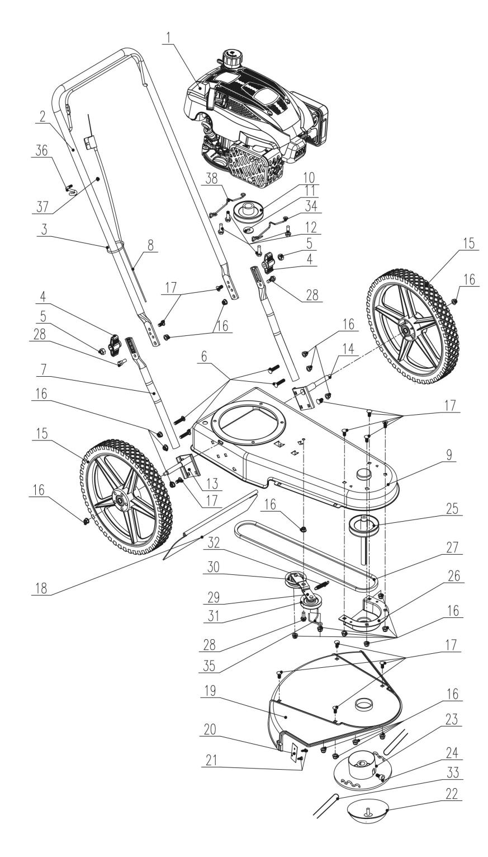
NO. | PART# | Description | Qty. | Model No. Applied
1 | 109001000246 | Engine | 1 | STMG-L
2 | 109001000247 | Upper Handle | 1 | STMG-L
3 | 236-1006 | Cable tie | 2 | PAX2125-M2-0、PAX2115-M2-0、PSRX2-M2-0、PSRX2-M2、CSX2-M1-0、CSX2-M-0、STMG-L、PDWX2-M2-0、SDE15-L、HPWE13-L、CSX5-M-0、LPPX5-L、GTBCX6-M-0、LPPX5-M、GTBCX6-M-0、BLAX2-M3、HPWX2-M1-0、BLAX5-M、BLAX5-M-0、BLAGTX5-M、BLAX6-M-0、CSPX5-M-0、HTX5-M-0、STX2-M
4 | 207250400033 | Knob M8 | 2 | LSPG-M5、LSPG-M3、STMG-L、LSPG-L3、LSPG-L2、LSSG-M1、LSPG-M7、LSPG-M4、LSPG-M6
5 | 8NA-08D | Nut M8 | 2 | SDE15-L、STE15-M、STE15-M1、STX2-M、LSPG-L3、LSPG-L2、LSSG-M1、LSPG-M7、LSPG-M4、LSPG-M6、LSPG-M3、LSPG-M5、STMG-L、BLB4QL-M
6 | 207430300002 | Bolt M8 | 4 | STMG-L
7 | 109001000224 | Lower handle | 1 | STMG-L
8 | 109001000234 | Stop cable | 1 | STMG-L
9 | 109001000248 | Frame | 1 | STMG-L
10 | 109001000235 | Pulley | 1 | STMG-L
11 | 8202-940303-0000002 | Flat washer | 1 | STMG-L
12 | 8206-911822-0000000 | Bolt M8X25 | 4 | STMG-L
13 | 109001000223 | Wheel shaft | 1 | STMG-L
14 | 109001000222 | Wheel shaft | 1 | STMG-L
15 | 109001000217 | 14” Wheel | 2 | STMG-L
16 | 8NE-08D01 | Nut M8 | 22 | STMG-L、LSPG-L3、LSPG-L2、LSSG-M1、LSPG-M7、LSPG-M4、LSPG-M6、LSPG-M3、LSPG-M5
17 | 207430300003 | Bolt M8*20 | 12 | STMG-L
18 | 109001000227 | Rear flap | 1 | STMG-L
19 | 202012000614 | Protective cover | 1 | STMG-L
20 | 109001000220 | Line cutter | 1 | STMG-L
21 | 8SJJB50-12D | Screw ST5*12 | 2 | STMG-L、GTBCU4QL-M、CS4QL-L1、CS4QL-L3、GTC4QL-L、HT4QL-L、CS4QL-L1、CS4QL-L3、GTS4QL-L、GTS4QL-M2
22 | 109001000232 | Guard | 1 | STMG-L
23 | 109001000233 | Spindle | 1 | STMG-L
24 | 207421300022 | Screw M6*10 | 2 | TL4QL-L1、STMG-L、TLX6-L-0
25 | 109001000236 | Wheel shaft | 1 | STMG-L
26 | 109001000228 | Belt cover | 1 | STMG-L
27 | 109001000237 | Belt | 1 | STMG-L
28 | 109001000218 | Screw shaft M8*20 | 3 | STMG-L
29 | 109001000221 | Tensioner pulley bracket | 1 | STMG-L
30 | 109001000229 | Flat pulley | 1 | STMG-L
31 | 109001000230 | V pulley | 1 | STMG-L
32 | 207010500019 | Spring | 1 | STMG-L
33 | 109001000238 | Trimmer line | 2 | STMG-L
34 | 109001000240 | Belt guide | 1 | STMG-L
35 | 109001000249 | Belt guide | 1 | STMG-L
36 | 201096000013 | Rope guide | 1 | LSPG-M5、LSPG-L2、LSSG-M1、LSPG-M7、LSPG-M4、STMG-L、LSPG-M6、LSPG-M3、LSPG-L3
37 | 8NE-05D01 | Nut M5 | 1 | LSPG-L3、LSPG-L2、LSSG-M1、LSPG-M7、LSPG-M4、LSPG-M6、LSPG-M3、LSPG-M5、STMG-L、LPPX5-L、LPPX5-M、LSSG-M1
38 | 109001000250 | Belt guide | 1 | STMG-L

