Model：TL4QL-L1
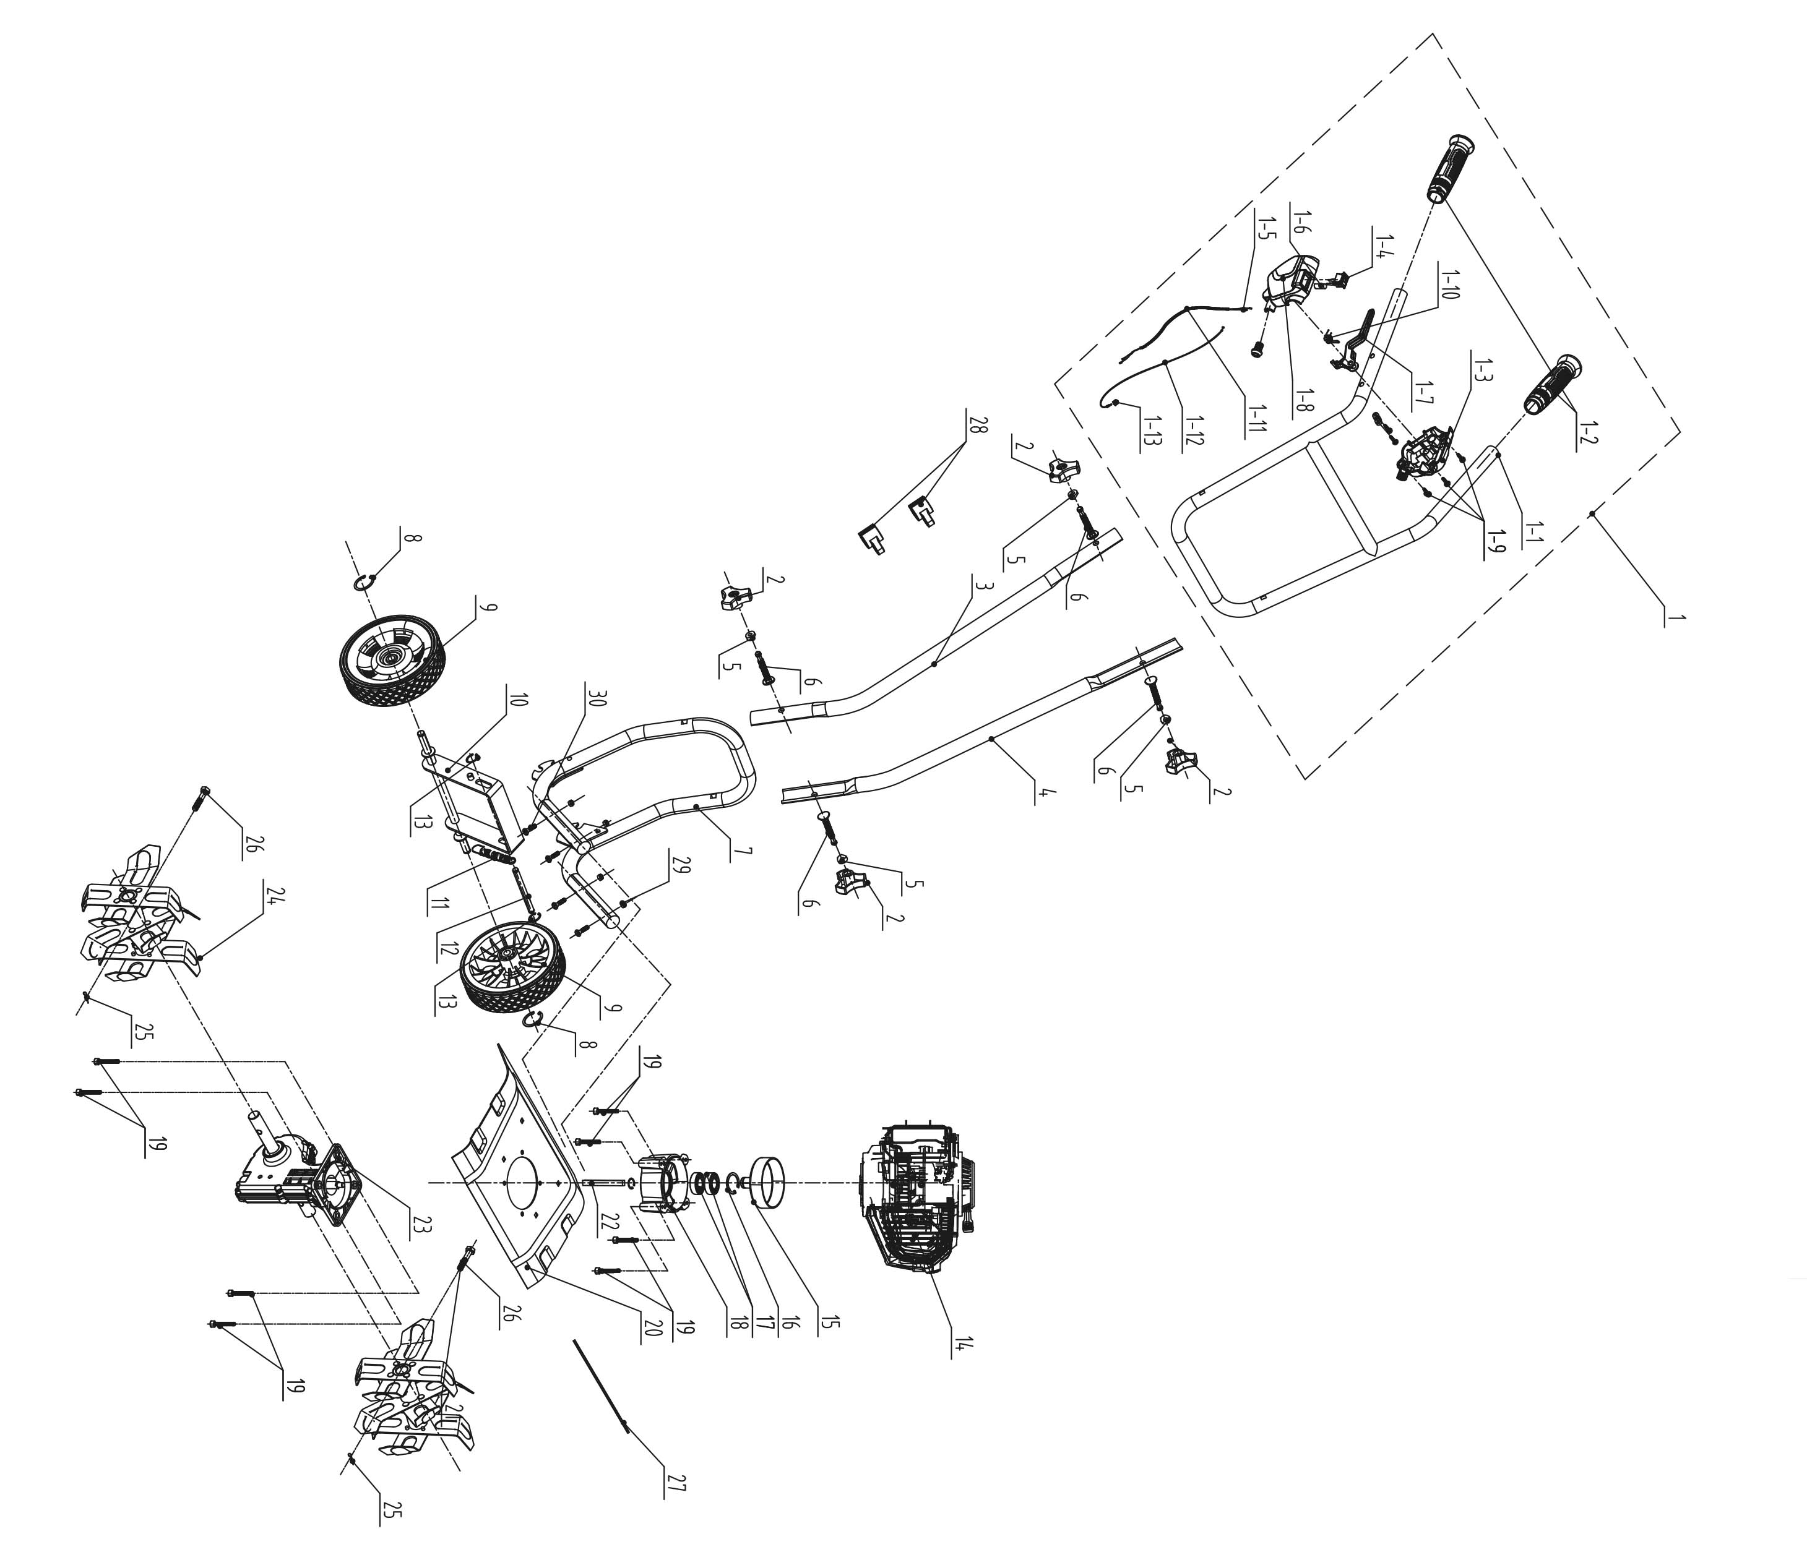
NO. | PART# | Description | Qty. | Model No. Applied
1 | 199075000453 | Upper handle assembly | 1 | TL4QL-L1
1-1 | 201139000118 | Upper handle | 1 | TL4QL-L1
1-2 | 202015000438 | Handle grips | 2 | TLX6-L-0、TLX6-L-0、TL4QL-L1
1-3 | 202113000071 | Right switch box | 1 | TL4QL-L1
1-4 | 207180200046 | Kill switch | 1 | GTS4QL-L、GTS4QL-M2、TL4QL-L1、HT4QL-L、BLV4QL-M、BL4QL-L、CS4QL-L1、CS4QL-L3、BLB4QL-M、CSP4QL-L、GTC4QL-L
1-5 | 199999001782 | Kill wires | 1 | TL4QL-L1
1-6 | 233-2004 | Heat shrink | 1 | TL4QL-L1、TLX6-L-0
1-7 | 202004001134 | Trigger | 1 | TL4QL-L1、TLX6-L-0
1-8 | 202113000063 | Left switch box | 1 | TL4QL-L1、TLX6-L-0
1-9 | 2073110000001 | Self-tapping screw ST4*16 | 3 | TL4QL-L1
1-10 | 207010400011 | Double torsion spring | 1 | TLX6-L-0、TL4QL-L1
1-11 | 235-2001 | Protective sleeve | 1.3m | TL4QL-L1、GTS4QL-M2、CSP4QL-L、GTC4QL-L、GTS4QL-L
1-12 | 199081000137 | Throttle cable | 1 | TL4QL-L1
1-13 | 202999002036 | Rubber sleeve | 1 | TL4QL-L1
2 | 207250100024 | Knob | 4 | TL4QL-L1
3 | 201139000126 | Middle handle (right) | 1 | TL4QL-L1
4 | 201139000127 | Middle handle (left) | 1 | TL4QL-L1
5 | 8341-514201-0000120 | Plastic pad | 4 | TLX6-L-0、TL4QL-L1
6 | 8206-517001-0000031 | Bolt | 4 | TL4QL-L1
7 | 201139000120 | Lower handle | 1 | TL4QL-L1
8 | 8CC-10B | Retaining Ring | 2 | CSPX5-M-0、TL4QL-L1
9 | 207150100029 | Wheel | 2 | TL4QL-L1
10 | 199130000048 | Wheel Shaft bracket | 1 | TL4QL-L1
11 | 8342-560301-0000000 | Spring | 1 | TL4QL-L1
12 | 201026000470 | Shaft | 1 | TL4QL-L1
13 | 8CC-08B | Retaining ring | 2 | TL4QL-L1、SDE15-L
14 | 103001000378 | Engine 46CC | 1 | TL4QL-L1
15 | 201160000017 | Clutch drum | 1 | TL4QL-L1
16 | 8CA-35B | Retaining Ring | 1 | TL4QL-L1、ACSP01
17 | 207390200094 | Bearing 6003-2RS | 2 | TL4QL-L1
18 | 201101000072 | Adapter | 1 | TL4QL-L1
19 | 8SACD06-40D8.8 | Bolt M6*40 | 8 | TL4QL-L1
20 | 201123000053 | Panel | 1 | TL4QL-L1
21 | 8CC-17B | Retaining Ring | 1 | TL4QL-L1
22 | 201022000051 | Flexible shaft | 1 | TL4QL-L1
23 | 199015000110 | Gear box | 1 | TL4QL-L1
24 | 8440-560301-0000000 | Tine | 2 | TL4QL-L1
25 | 207190300001 | Cotter pin | 2 | TL4QL-L1
26 | 207190400008 | Pin Shaft | 2 | TL4QL-L1
27 | 236-1016 | Cable tie | 1 | SDE15-L、TLX6-L-0、TL4QL-L1
28 | 202157000131 | Thread buckle | 2 | TL4QL-L1
29 | 8NH-06D | Nut M6 | 4 | LPPX5-L、LPPX5-M、TL4QL-L1、STE12-L、LSSG-M1
30 | 8206-660501-0000000 | Bolt | 4 | ACSP01、TL4QL-L1

